# Curso de Next.js 14

## Chapter 1 - Getting Started

### Creating a new project

To create a Next.js app, open your terminal, cd into the folder you'd like to keep your project, and run the following command:

npx create-next-app@latest nextjs-dashboard --use-npm --example "https://github.com/vercel/next-learn/tree/main/dashboard/starter-example"

This command uses create-next-app, a Command Line Interface (CLI) tool that sets up a Next.js application for you. In the command above, you're also using the --example flag with the starter example for this course.

### Exploring the project

Unlike tutorials that have you write code from scratch, much of the code for this course is already written for you. This better reflects real-world development, where you'll likely be working with existing codebases.

Our goal is to help you focus on learning the main features of Next.js, without having to write all the application code.

After installation, open the project in your code editor and navigate to nextjs-dashboard.

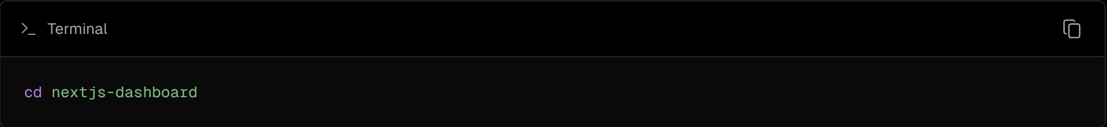

Let's spend some time exploring the project.

### Folder structure

You'll notice that the project has the following folder structure:

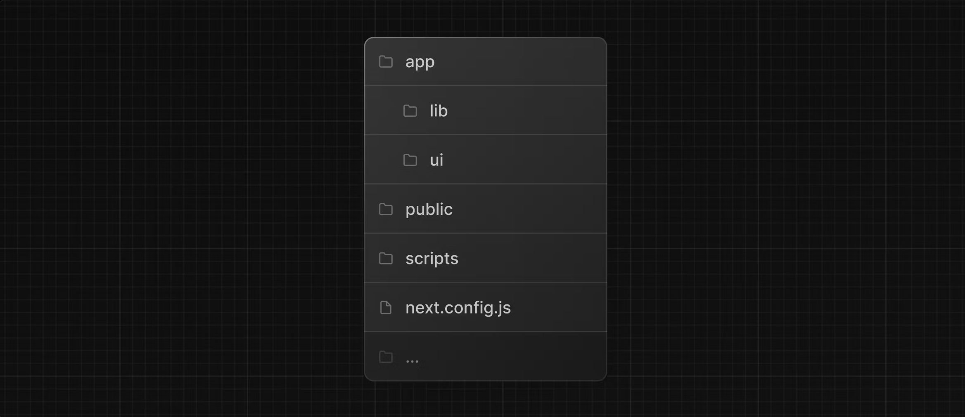

* /app: Contains all the routes, components, and logic for your application, this is where you'll be mostly working from.
* /app/lib: Contains functions used in your application, such as reusable utility functions and data fetching functions.
* /app/ui: Contains all the UI components for your application, such as cards, tables, and forms. To save time, we've pre-styled these components for you.
* /public: Contains all the static assets for your application, such as images.
* /scripts: Contains a seeding script that you'll use to populate your database in a later chapter.
* Config Files: You'll also notice config files such as next.config.js at the root of your application. Most of these files are created and pre-configured when you start a new project using create-next-app. You will not need to modify them in this course.

Feel free to explore these folders, and don't worry if you don't understand everything the code is doing yet.

### Placeholder data

When you're building user interfaces, it helps to have some placeholder data. If a database or API is not yet available, you can:

* Use placeholder data in JSON format or as JavaScript objects.
* Use a 3rd party service like mockAPI.

For this project, we've provided some placeholder data in app/lib/placeholder-data.js. Each JavaScript object in the file represents a table in your database. For example, for the invoices table:

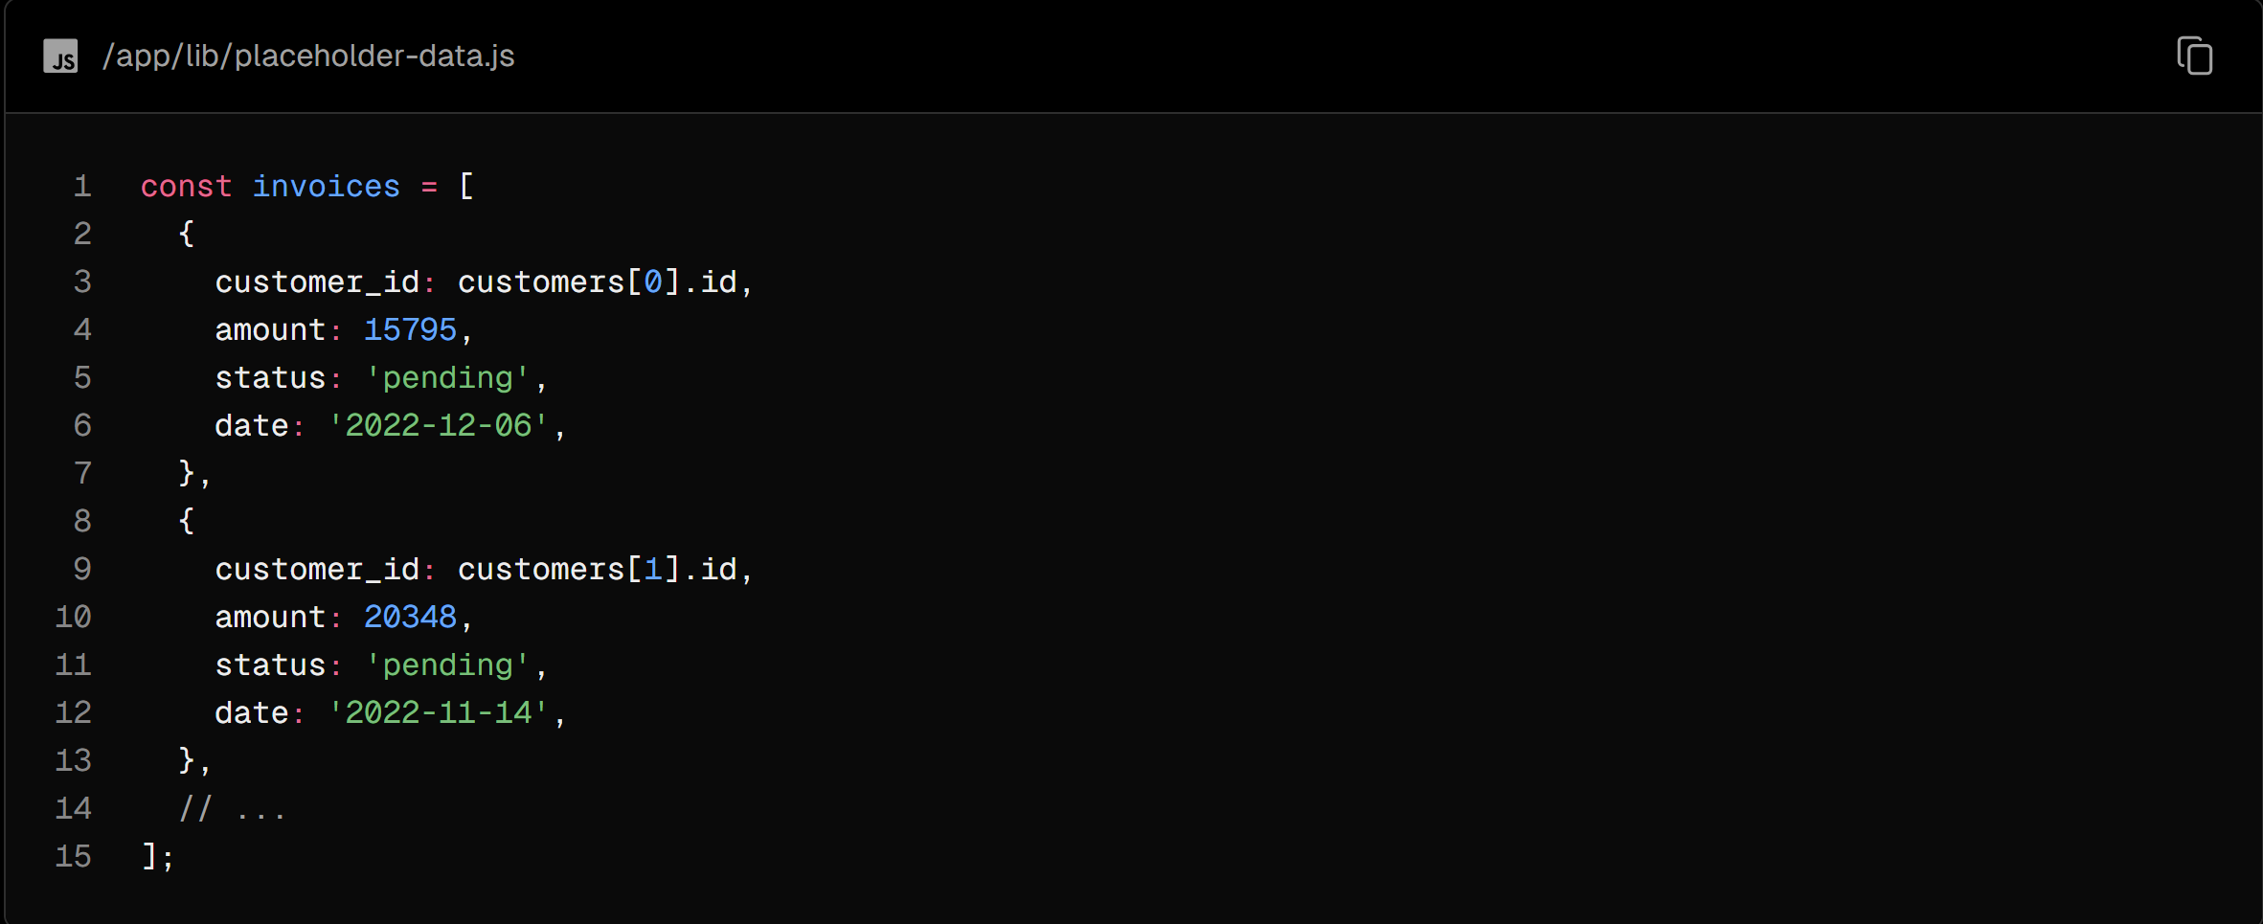

In the chapter on setting up your database, you'll use this data to seed your database (populate it with some initial data).

### TypeScript

You may also notice most files have a .ts or .tsx suffix. This is because the project is written in TypeScript. We wanted to create a course that reflects the modern web landscape.

It's okay if you don't know TypeScript - we'll provide the TypeScript code snippets when required.

For now, take a look at the /app/lib/definitions.ts file. Here, we manually define the types that will be returned from the database. For example, the invoices table has the following types:

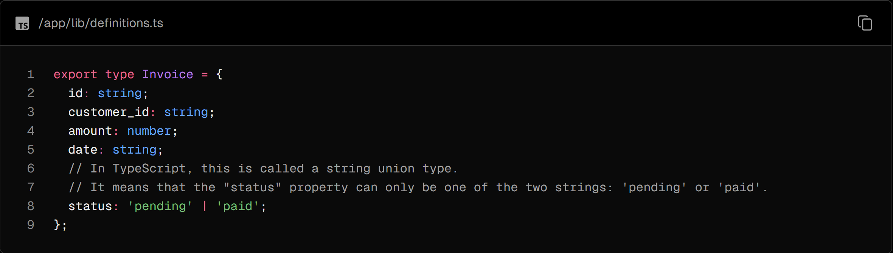

By using TypeScript, you can ensure you don't accidentally pass the wrong data format to your components or database, like passing a string instead of a number to invoice amount.

If you're a TypeScript developer:

* We're manually declaring the data types, but for better type-safety, we recommend Prisma, which automatically generates types based on your database schema.
* Next.js detects if your project uses TypeScript and automatically installs the necessary packages and configuration. Next.js also comes with a TypeScript plugin for your code editor, to help with auto-completion and type-safety.

### Running the development server

Run npm i to install the project's packages.

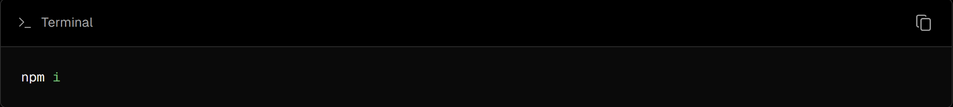

Followed by npm run dev to start the development server.

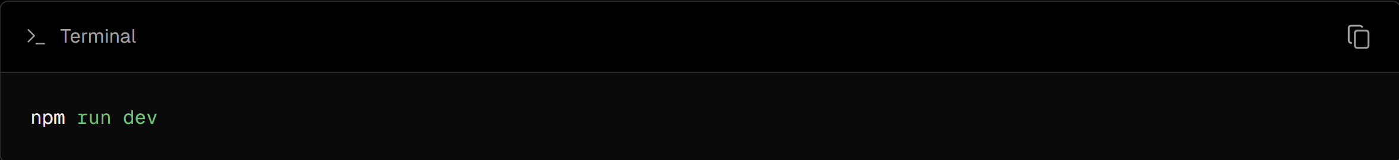

npm run dev starts your Next.js development server on port 3000. Let's check to see if it's working. Open [http://localhost:3000](http://localhost:3000%20) on your browser. Your home page should look like this:

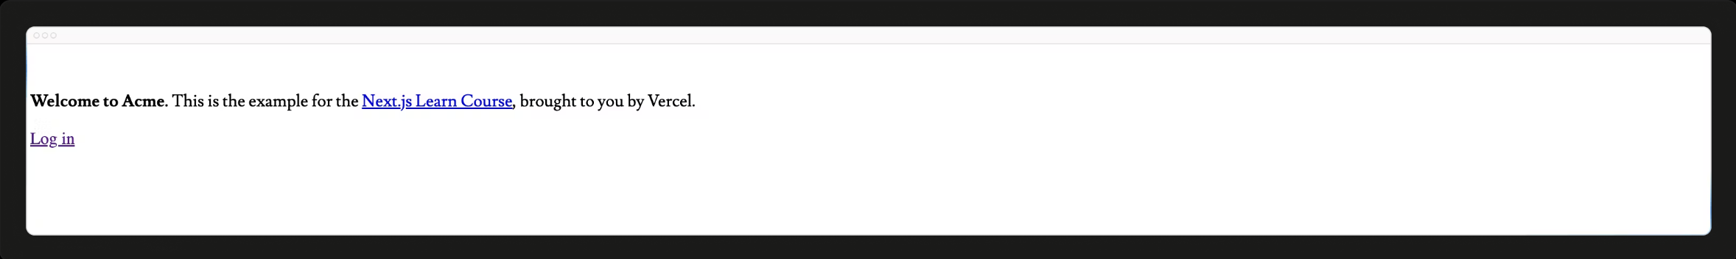

## Chapter 2 - CSS Styling

Currently, your home page doesn't have any styles. Let's look at the different ways you can style your Next.js application.

In this chapter...

Here are the topics we’ll cover

* How to add a global CSS file to your application.
* Two different ways of styling: Tailwind and CSS modules.
* How to conditionally add class names with the clsx utility package.

### Global styles

If you look inside the /app/ui folder, you'll see a file called global.css. You can use this file to add CSS rules to all the routes in your application - such as CSS reset rules, site-wide styles for HTML elements like links, and more.

You can import global.css in any component in your application, but it's usually good practice to add it to your top-level component. In Next.js, this is the root layout (more on this later).

Add global styles to your application by navigating to /app/layout.tsx and importing the global.css file:

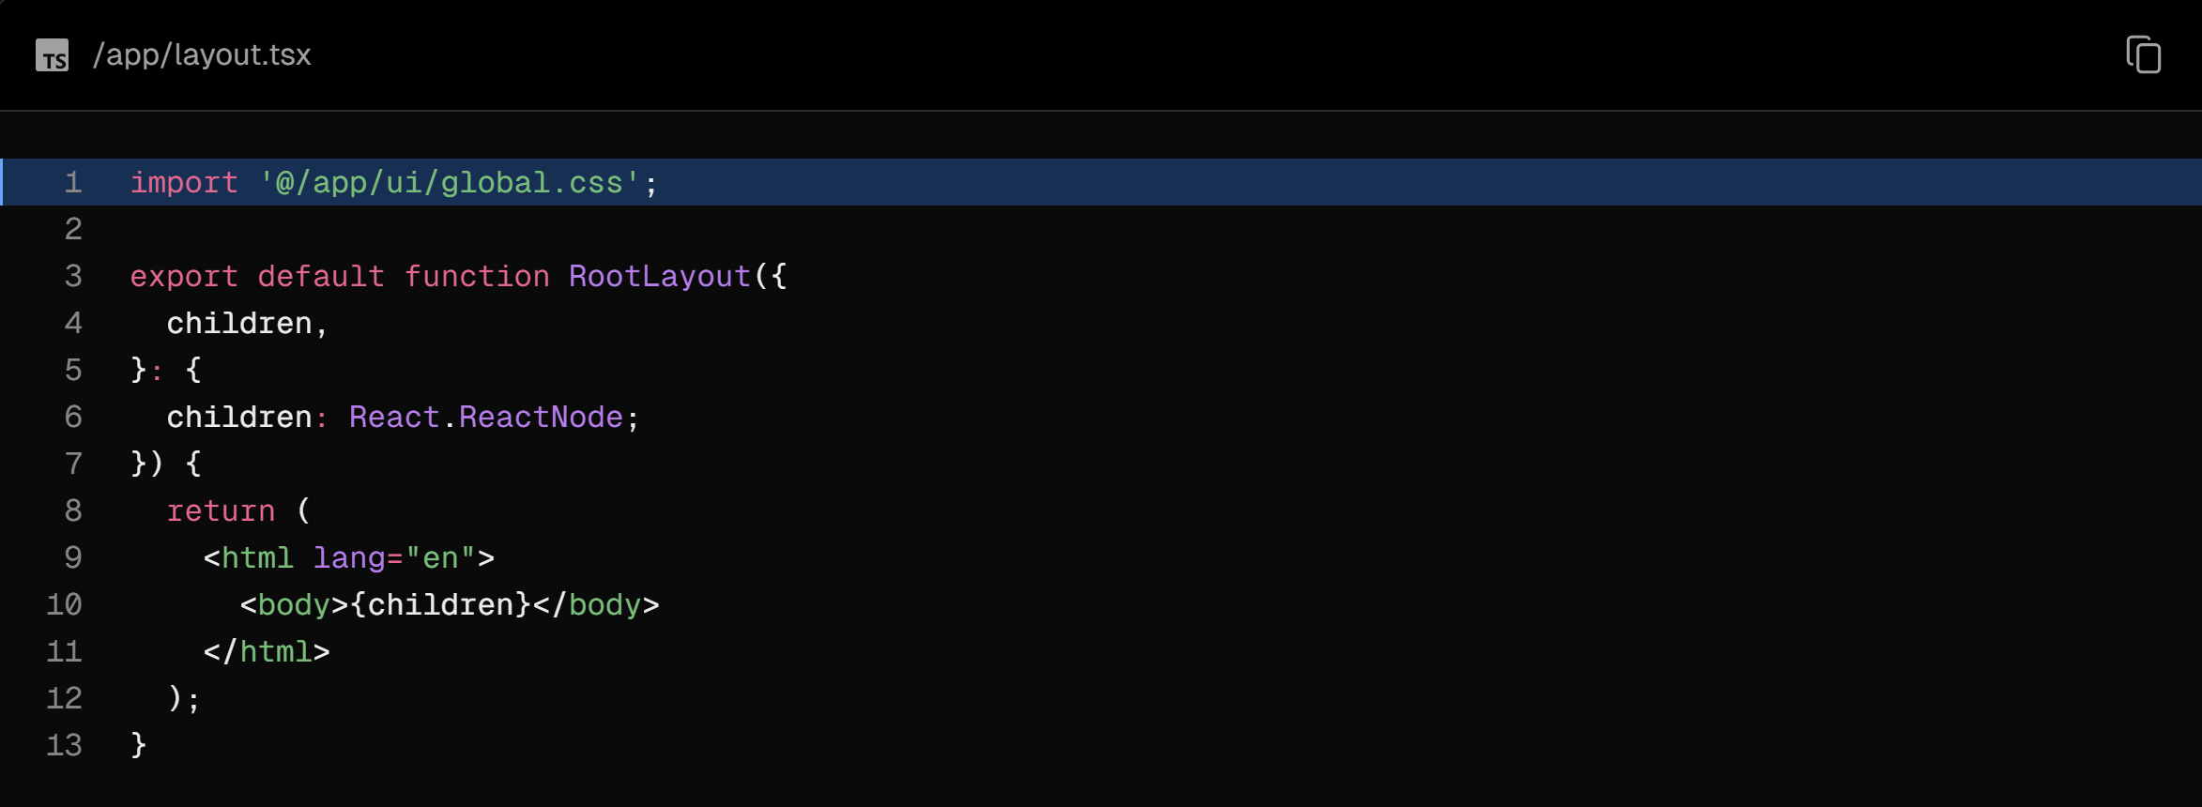

With the development server still running, save your changes and preview them in the browser. Your home page should now look like this:



But wait a second, you didn't add any CSS rules, where did the styles come from?

If you take a look inside global.css, you'll notice some @tailwind directives:

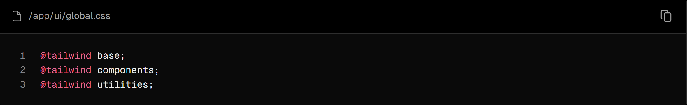

### Tailwind

[Tailwind](https://tailwindcss.com/) is a CSS framework that speeds up the development process by allowing you to quickly write utility classes directly in your TSX markup.

In Tailwind, you style elements by adding class names. For example, adding the class "text-blue-500" will turn the <h1> text blue:



Although the CSS styles are shared globally, each class is singularly applied to each element. This means if you add or delete an element, you don't have to worry about maintaining separate stylesheets, style collisions, or the size of your CSS bundle growing as your application scales.

When you use create-next-app to start a new project, Next.js will ask if you want to use Tailwind. If you select yes, Next.js will automatically install the necessary packages and configure Tailwind in your application.

If you look at /app/page.tsx, you'll see that we're using Tailwind classes in the example.

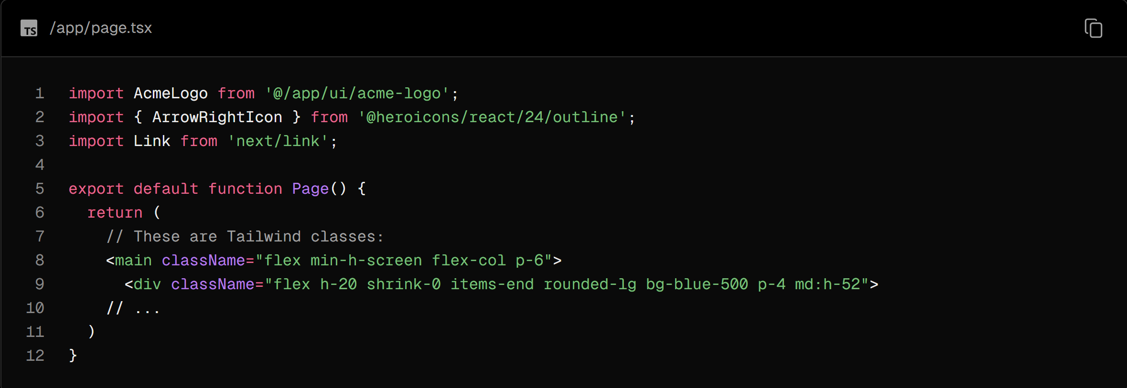

Don't worry if this is your first time using Tailwind. To save time, we've already styled all the components you'll be using.

Let's play with Tailwind! Copy the code below and paste it above the <p> element in /app/page.tsx:

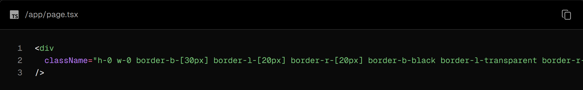

If you prefer writing traditional CSS rules or keeping your styles separate from your JSX - CSS Modules are a great alternative.

### CSS Modules

CSS Modules allow you to scope CSS to a component by automatically creating unique class names, so you don't have to worry about style collisions as well.

We'll continue using Tailwind in this course, but let's take a moment to see how you can achieve the same results from the quiz above using CSS modules.

Inside /app/ui, create a new file called home.module.css and add the following CSS rules:

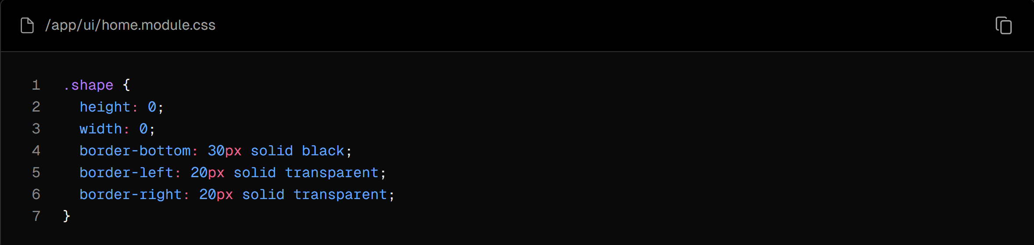

Then, inside your /app/page.tsx file import the styles and replace the tailwind class names from the <div> you've added with styles.shape:

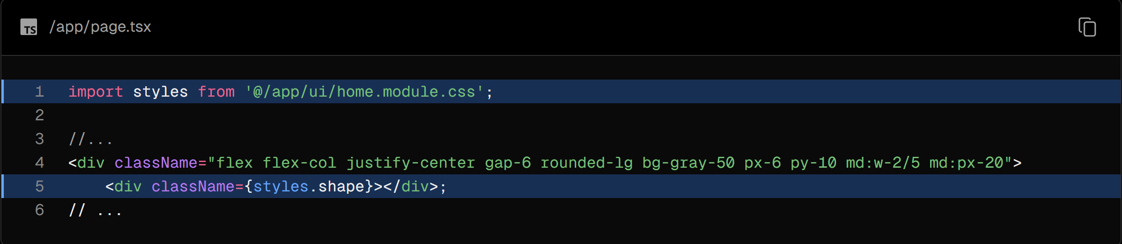

Save your changes and preview them in the browser. You should see the same shape as before.

Tailwind and CSS modules are the two most common ways of styling Next.js applications. Whether you use one or the other is a matter of preference - you can even use both in the same application!

### Using the clsx library to toggle class names

There may be cases where you may need to conditionally style an element based on state or some other condition.

clsx is a library that lets you toggle class names easily. We recommend taking a look at documentation for more details, but here's the basic usage:

* Suppose that you want to create an InvoiceStatus component which accepts status. The status can be 'pending' or 'paid'.
* If it's 'paid', you want the color to be green. If it's 'pending', you want the color to be gray.

You can use clsx to conditionally apply the classes, like this:

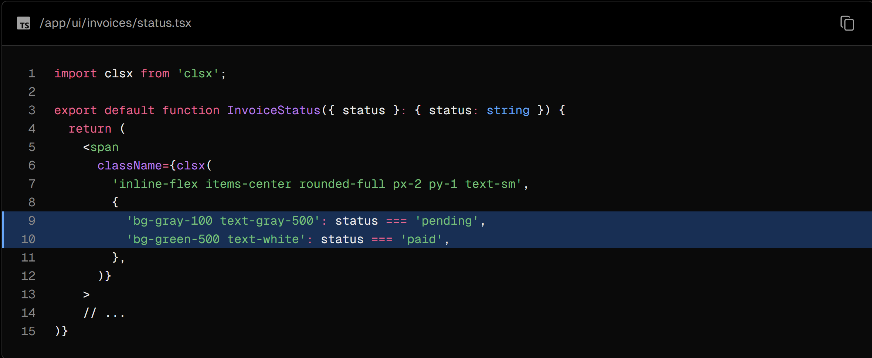

### Other styling solutions

In addition to the approaches we've discussed, you can also style your Next.js application with:

* Sass which allows you to import .css and .scss files.
* CSS-in-JS libraries such as styled-jsx, styled-components, and emotion.

Take a look at the [CSS documentation](https://nextjs.org/docs/app/building-your-application/styling) for more information.

## Chapter 3 - Optimizing Fonts and Images

In the previous chapter, you learned how to style your Next.js application. Let's continue working on your home page by adding a custom font and a hero image.

In this chapter...

Here are the topics we’ll cover

* How to add custom fonts with next/font.
* How to add images with next/image.
* How fonts and images are optimized in Next.js.

### Why optimize fonts?

Fonts play a significant role in the design of a website, but using custom fonts in your project can affect performance if the font files need to be fetched and loaded.

Cumulative Layout Shift is a metric used by Google to evaluate the performance and user experience of a website. With fonts, layout shift happens when the browser initially renders text in a fallback or system font and then swaps it out for a custom font once it has loaded. This swap can cause the text size, spacing, or layout to change, shifting elements around it.

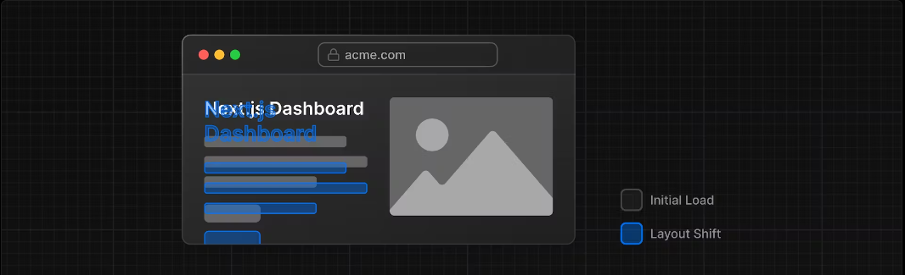

Next.js automatically optimizes fonts in the application when you use the next/font module. It downloads font files at build time and hosts them with your other static assets. This means when a user visits your application, there are no additional network requests for fonts which would impact performance.

### Adding a primary font

Let's add a custom Google font to your application to see how this works!

In your /app/ui folder, create a new file called fonts.ts. You'll use this file to keep the fonts that will be used throughout your application.

Import the Inter font from the next/font/google module - this will be your primary font. Then, specify what subset you'd like to load. In this case, 'latin':

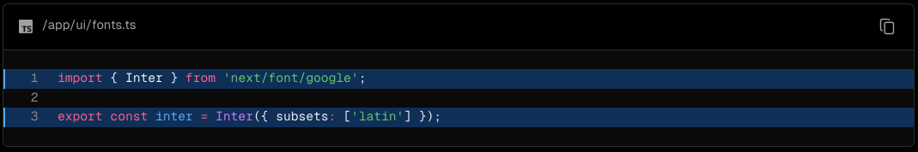

Finally, add the font to the <body> element in /app/layout.tsx:

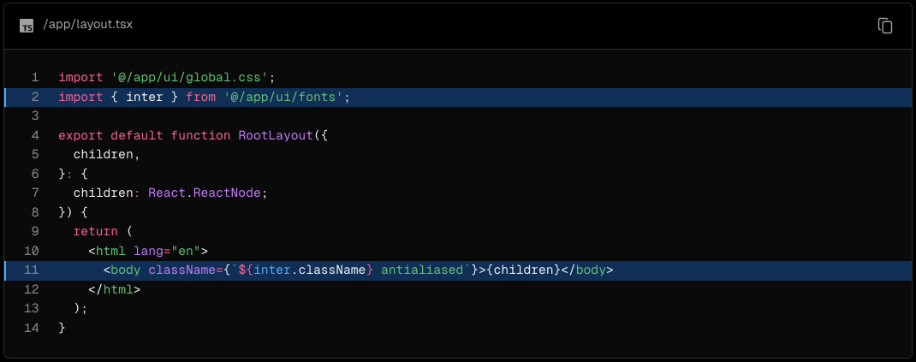

By adding Inter to the <body> element, the font will be applied throughout your application. Here, you're also adding the Tailwind antialiased class which smooths out the font. It's not necessary to use this class, but it adds a nice touch.

Navigate to your browser, open dev tools and select the body element. You should see Inter and Inter_Fallback are now applied under styles.

### Practice: Adding a secondary font

You can also add fonts to specific elements of your application.

Now it's your turn! In your fonts.ts file, import a secondary font called Lusitana and pass it to the <p> element in your /app/page.tsx file. In addition to specifying a subset like you did before, you'll also need to specify the font weight.

Once you're ready, expand the code snippet below to see the solution.

Hints:

If you're unsure what weight options to pass to a font, check the TypeScript errors in your code editor.

Visit the Google Fonts website and search for Lusitana to see what options are available.

See the documentation for adding multiple fonts and the full list of options.

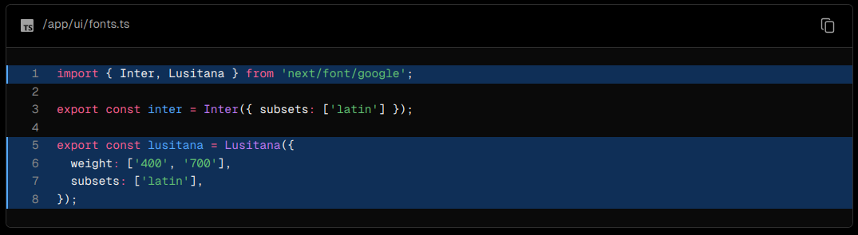

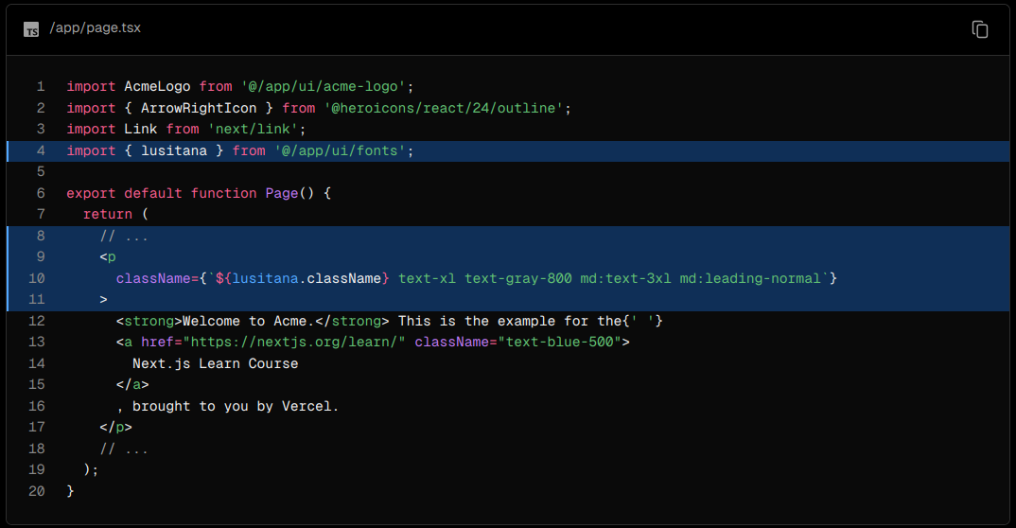

### Why optimize images?

Next.js can serve static assets, like images, under the top-level /public folder. Files inside /public can be referenced in your application.

With regular HTML, you would add an image as follows:

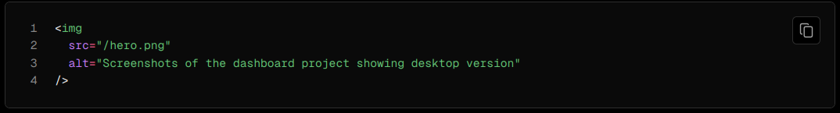

However, this means you have to manually:

* Ensure your image is responsive on different screen sizes.
* Specify image sizes for different devices.
* Prevent layout shift as the images load.
* Lazy load images that are outside the user's viewport.

Image Optimization is a large topic in web development that could be considered a specialization in itself. Instead of manually implementing these optimizations, you can use the next/image component to automatically optimize your images.

### The <Image> component

The <Image> Component is an extension of the HTML <img> tag, and comes with automatic image optimization, such as:

* Preventing layout shift automatically when images are loading.
* Resizing images to avoid shipping large images to devices with a smaller viewport.
* Lazy loading images by default (images load as they enter the viewport).
* Serving images in modern formats, like WebP and AVIF, when the browser supports it.

### Adding the desktop hero image

Let's use the <Image> component. If you look inside the /public folder, you'll see there are two images: hero-desktop.png and hero-mobile.png. These two images are completely different, and they'll be shown depending if the user's device is a desktop or mobile.

In your /app/page.tsx file, import the component from next/image. Then, add the image under the comment:

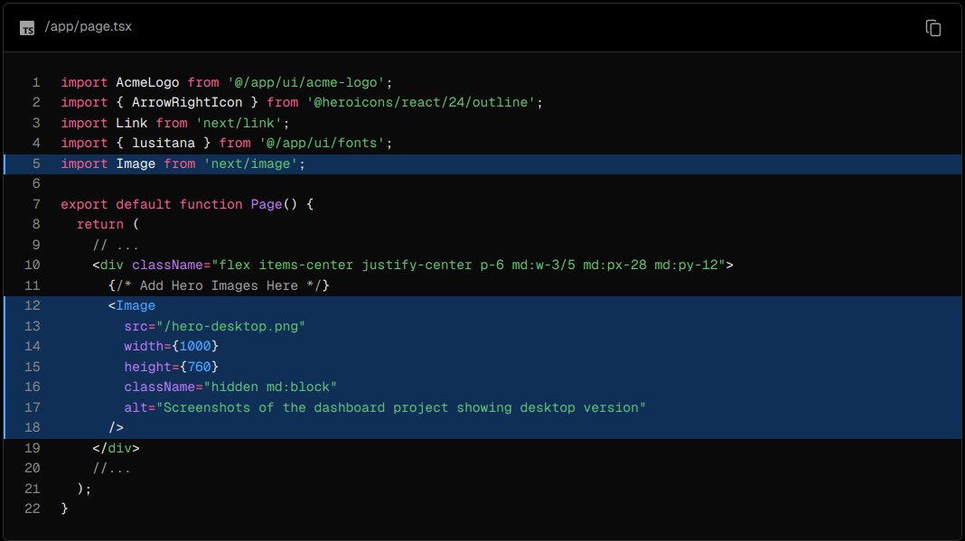

Here, you're setting the width to 1000 and height to 760 pixels. It's good practice to set the width and height of your images to avoid layout shift, these should be an aspect ratio identical to the source image.

You'll also notice the class hidden to remove the image from the DOM on mobile screens, and md:block to show the image on desktop screens.

This is what your home page should look like now:

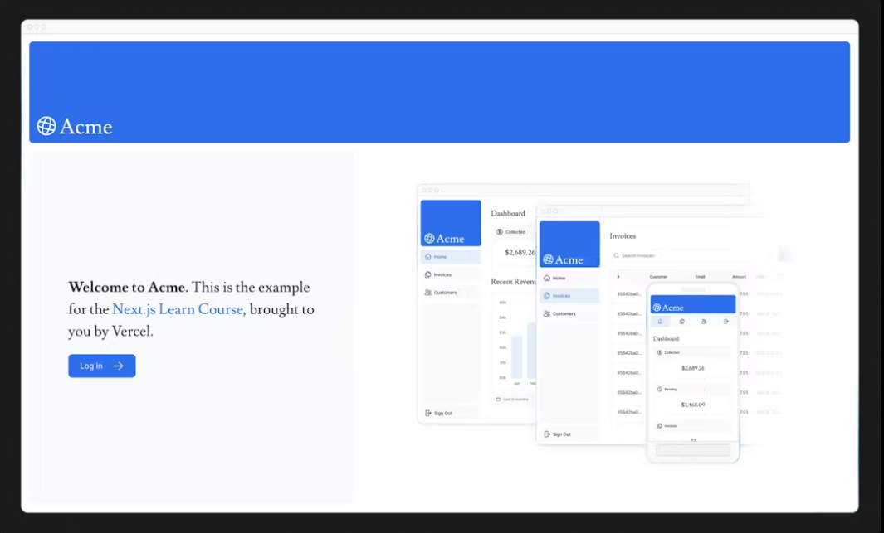

### Practice: Adding the mobile hero image

Now it's your turn! Under the image you've just added, add another <Image> component for hero-mobile.png.

* The image should have a width of 560 and height of 620 pixels.
* It should be shown on mobile screens, and hidden on desktop - you can use dev tools to check if the desktop and mobile images are swapped correctly.

Once you're ready, expand the code snippet below to see the solution.

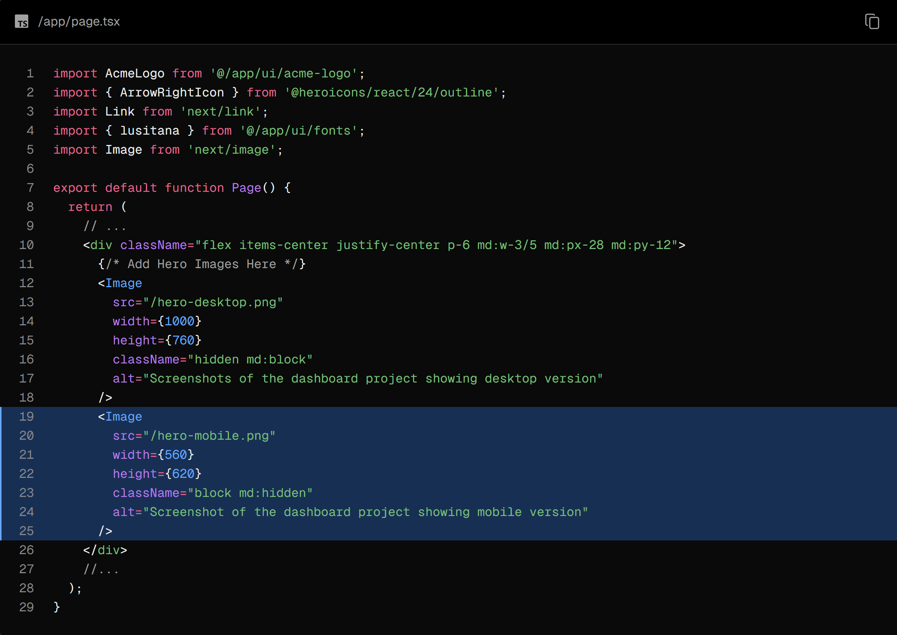

Great! Your home page now has a custom font and hero images.

### Recommended reading

There's a lot more to learn about these topics, including optimizing remote images and using local font files. If you'd like to dive deeper into fonts and images, see:

* [Image Optimization Docs](https://nextjs.org/docs/app/building-your-application/optimizing/images)
* [Font Optimization Docs](https://nextjs.org/docs/app/building-your-application/optimizing/fonts)
* [Improving Web Performance with Images (MDN)](https://developer.mozilla.org/en-US/docs/Learn/Performance/Multimedia)
* [Web Fonts (MDN)](https://developer.mozilla.org/en-US/docs/Learn/CSS/Styling_text/Web_fonts)

## Chapter 4 - Creating Layouts and Pages

So far, your application only has a home page. Let's learn how you can create more routes with layouts and pages.

In this chapter...

Here are the topics we’ll cover:

* Create the dashboard routes using file-system routing.
* Understand the role of folders and files when creating new route segments.
* Create a nested layout that can be shared between multiple dashboard pages.
* Understand what colocation, partial rendering, and the root layout are.

### Nested routing

Next.js uses file-system routing where folders are used to create nested routes. Each folder represents a route segment that maps to a URL segment.

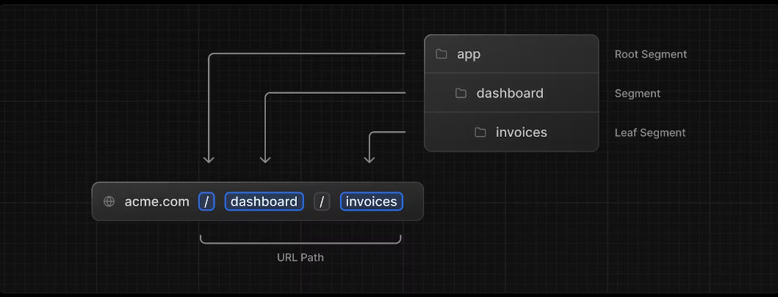

You can create separate UIs for each route using layout.tsx and page.tsx files.

page.tsx is a special Next.js file that exports a React component, and it's required for the route to be accessible. In your application, you already have a page file: /app/page.tsx - this is the home page associated with the route /.

To create a nested route, you can nest folders inside each other and add page.tsx files inside them. For example:

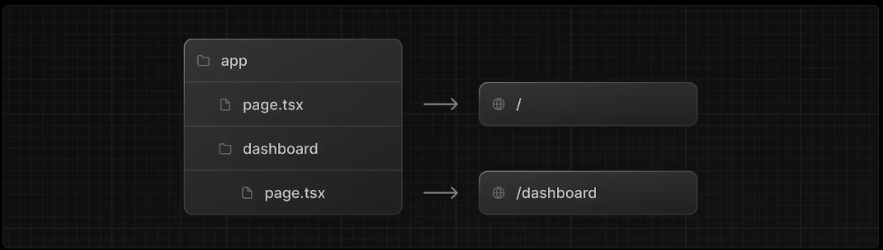

/app/dashboard/page.tsx is associated with the /dashboard path. Let's create the page to see how it works!

### Creating the dashboard page

Create a new folder called dashboard inside /app. Then, create a new page.tsx file inside the dashboard folder with the following content:

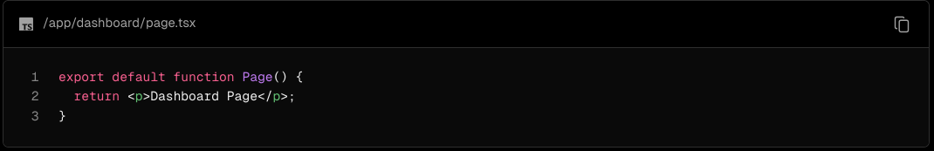

Now, make sure that the development server is running and visit http://localhost:3000/dashboard. You should see the "Dashboard Page" text.

### Practice: Creating the dashboard pages

Let's practice creating more routes. In your dashboard, create two more pages:

1. Customers Page: The page should be accessible on <http://localhost:3000/dashboard/customers>. For now, it should return a <p>Customers Page</p> element.
2. Invoices Page: The invoices page should be accessible on <http://localhost:3000/dashboard/invoices>. For now, also return a <p>Invoices Page</p> element.

Spend some time tackling this exercise, and when you're ready, expand the toggle below for the solution:

You should have the following folder structure:

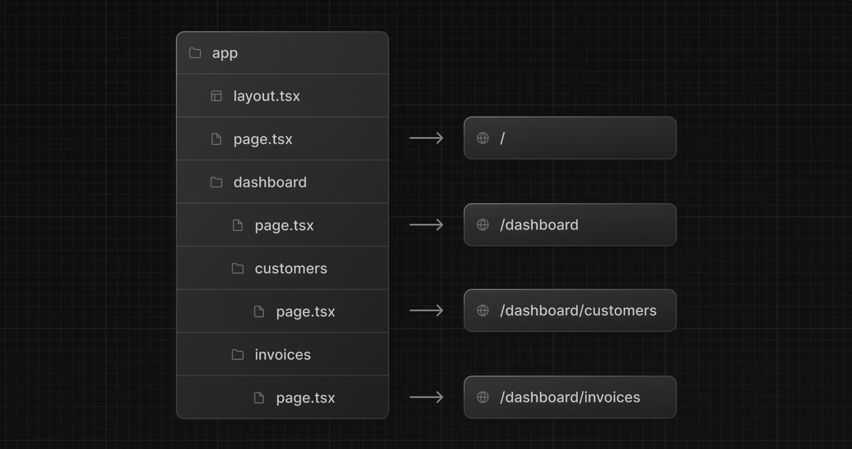

Customers Page:

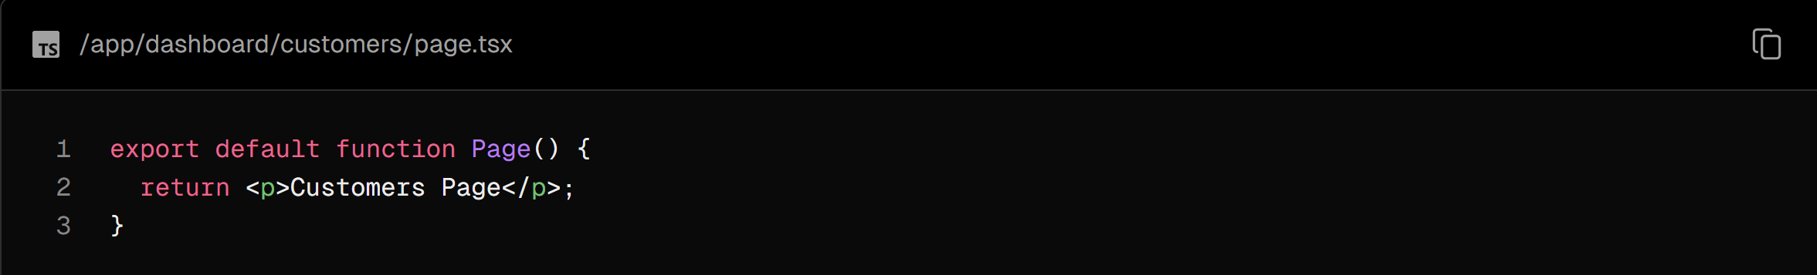

Invoices Page:

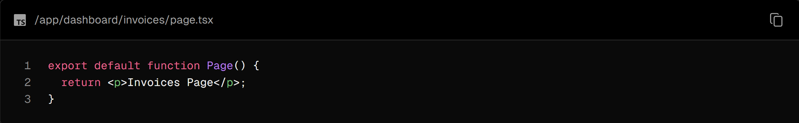

### Creating the dashboard layout

Dashboards have some sort of navigation that is shared across multiple pages. In Next.js, you can use a special layout.tsx file to create UI that is shared between multiple pages. Let's create a layout for the dashboard pages!

Inside the /dashboard folder, add a new file called layout.tsx and paste the following code:

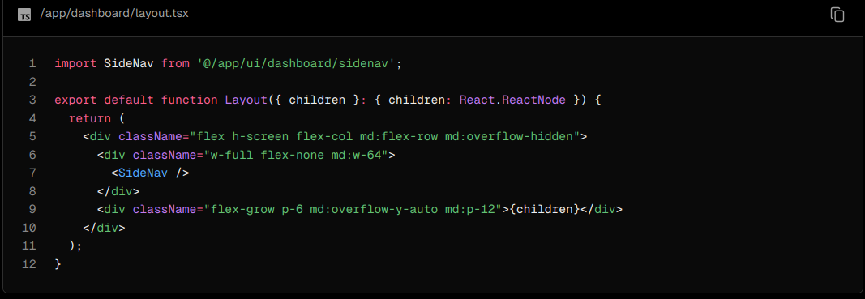

A few things are going on in this code, so let's break it down:

First, you're importing the <SideNav /> component into your layout. Any components you import into this file will be part of the layout.

The <Layout /> component receives a children prop. This child can either be a page or another layout. In your case, the pages inside /dashboard will automatically be nested inside a <Layout /> like so:

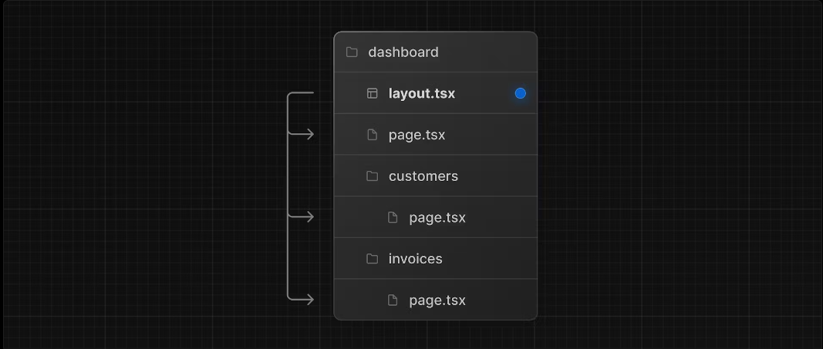

Check that everything is working correctly by saving your changes and checking your localhost. You should see the following:

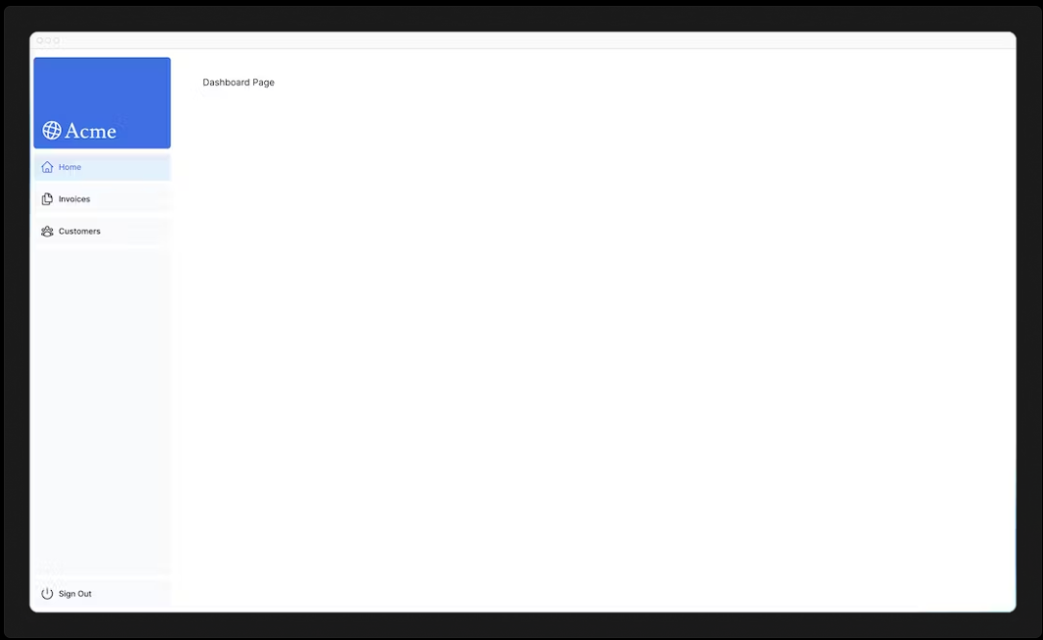

One benefit of using layouts in Next.js is that on navigation, only the page components update while the layout won't re-render. This is called partial rendering:

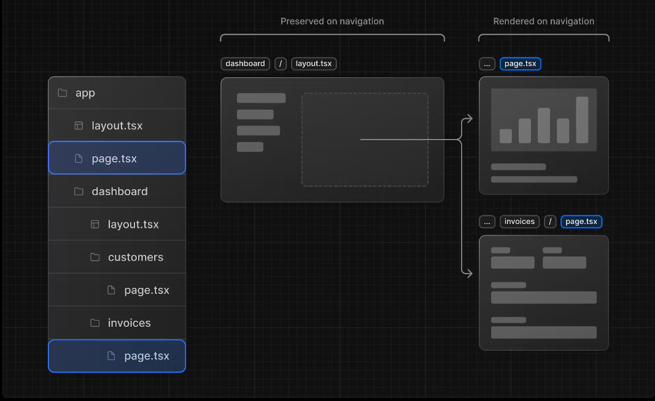

### Root layout

In Chapter 3, you imported the Inter font into another layout: /app/layout.tsx. As a reminder:

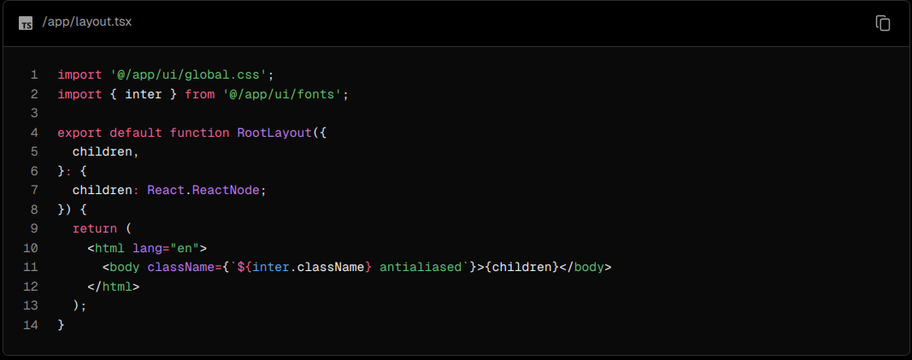

This is called a root layout and is required. Any UI you add to the root layout will be shared across all pages in your application. You can use the root layout to modify your <html> and <body> tags, and add metadata (you'll learn more about metadata in a later chapter).

Since the new layout you've just created (/app/dashboard/layout.tsx) is unique to the dashboard pages, you don't need to add any UI to the root layout above.

## Chapter 5 - Navigating Between Pages

In the previous chapter, you created the dashboard layout and pages. Now, let's add some links to allow users to navigate between the dashboard routes.

In this chapter...

Here are the topics we’ll cover

* How to use the next/link component.
* How to show an active link with the usePathname() hook.
* How navigation works in Next.js.

### Why optimize navigation?

To link between pages, you'd traditionally use the <a> HTML element. At the moment, the sidebar links use <a> elements, but notice what happens when you navigate between the home, invoices, and customers pages on your browser.

Did you see it?

There's a full page refresh on each page navigation!

### The <Link> component

In Next.js, you can use the <Link /> Component to link between pages in your application. <Link> allows you to do client-side navigation with JavaScript.

To use the <Link /> component, open /app/ui/dashboard/nav-links.tsx, and import the Link component from next/link. Then, replace the <a> tag with <Link>:

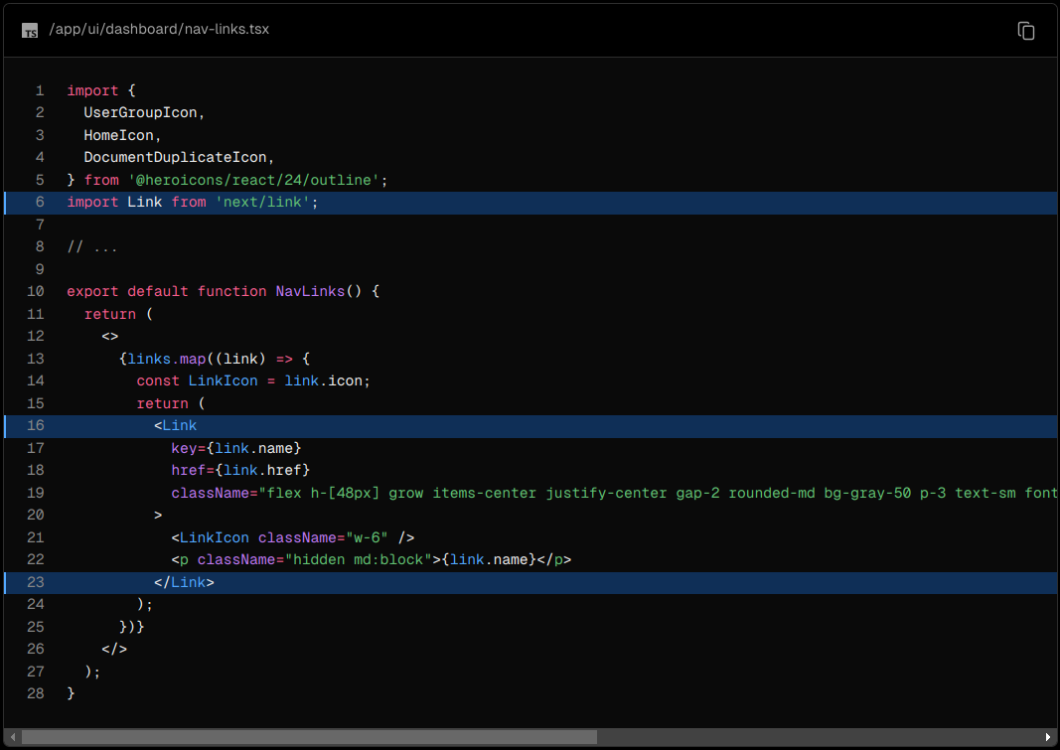

As you can see, the Link component is similar to using <a> tags, but instead of <a href="…">, you use <Link href="…">.

Save your changes and check to see if it works in your localhost. You should now be able to navigate between the pages without seeing a full refresh. Although parts of your application are rendered on the server, there's no full page refresh, making it feel like a web app. Why is that?

Automatic code-splitting and prefetching

To improve the navigation experience, Next.js automatically code splits your application by route segments. This is different from a traditional React SPA, where the browser loads all your application code on initial load.

Splitting code by routes means that pages become isolated. If a certain page throws an error, the rest of the application will still work.

Futhermore, in production, whenever <Link> components appear in the browser's viewport, Next.js automatically prefetches the code for the linked route in the background. By the time the user clicks the link, the code for the destination page will already be loaded in the background, and this is what makes the page transition near-instant!

Learn more about how navigation works.

### Pattern: Showing active links

A common UI pattern is to show an active link to indicate to the user what page they are currently on. To do this, you need to get the user's current path from the URL. Next.js provides a hook called usePathname() that you can use to check the path and implement this pattern.

Since usePathname() is a hook, you'll need to turn nav-links.tsx into a Client Component. Add React's "use client" directive to the top of the file, then import usePathname() from next/navigation:

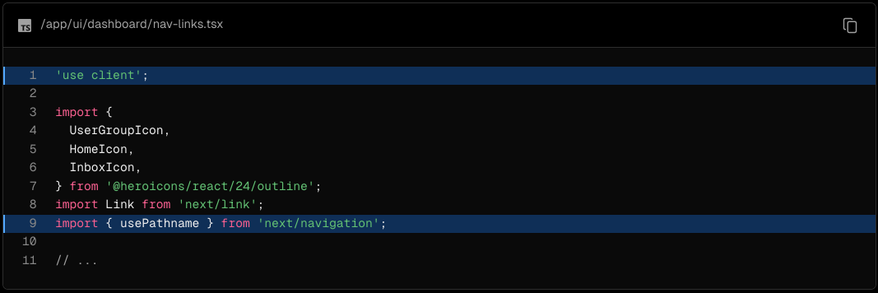

Next, assign the path to a variable called pathname inside your <NavLinks /> component:

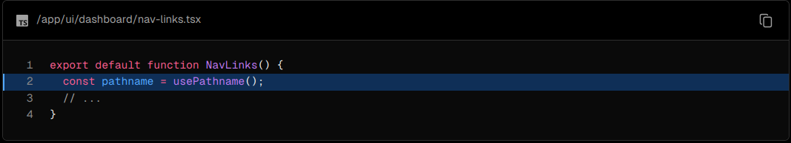

You can use the clsx library introduced in the chapter on CSS styling to conditionally apply class names when the link is active. When link.href matches the pathname, the link should displayed with blue text and a light blue background.

Here's the final code for nav-links.tsx:

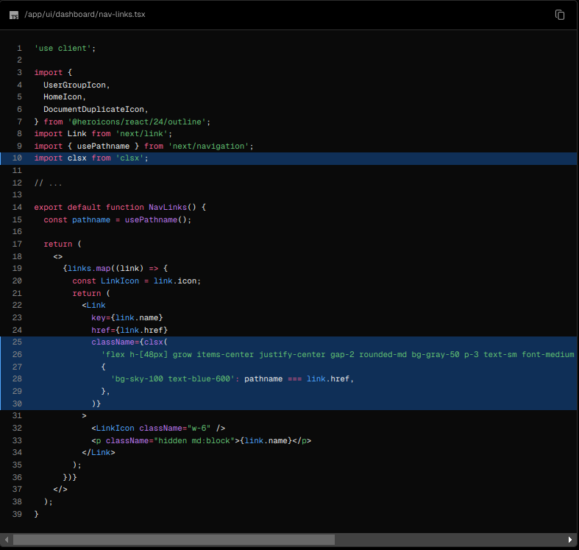

Save and check your localhost. You should now see the active link highlighted in blue.

## Chapter 6 - Setting Up Your Database

Before you can continue working on your dashboard, you'll need some data. In this chapter, you'll be setting up a PostgreSQL database using @vercel/postgres. If you're already familiar with PostgreSQL and would prefer to use your own provider, you can skip this chapter and set it up on your own. Otherwise, let's continue!

In this chapter...

Here are the topics we’ll cover

* Push your project to GitHub.
* Set up a Vercel account and link your GitHub repo for instant previews and deployments.
* Create and link your project to a Postgres database.
* Seed the database with initial data.

### Create a GitHub repository

To start, let's push your repository to Github if you haven't done so already. This will make it easier to set up your database and deploy.

If you need help setting up your repository, take a look at this guide on GitHub.

Good to know:

* You can also use other Git provider like GitLab or Bitbucket.
* If you're new to GitHub, we recommend the GitHub Desktop App for a simplified development workflow.

### Create a Vercel account

Visit vercel.com/signup to create an account. Choose the free "hobby" plan. Select Continue with GitHub to connect your GitHub and Vercel accounts.

### Connect and deploy your project

Next, you'll be taken to this screen where you can select and import the GitHub repository you've just created:

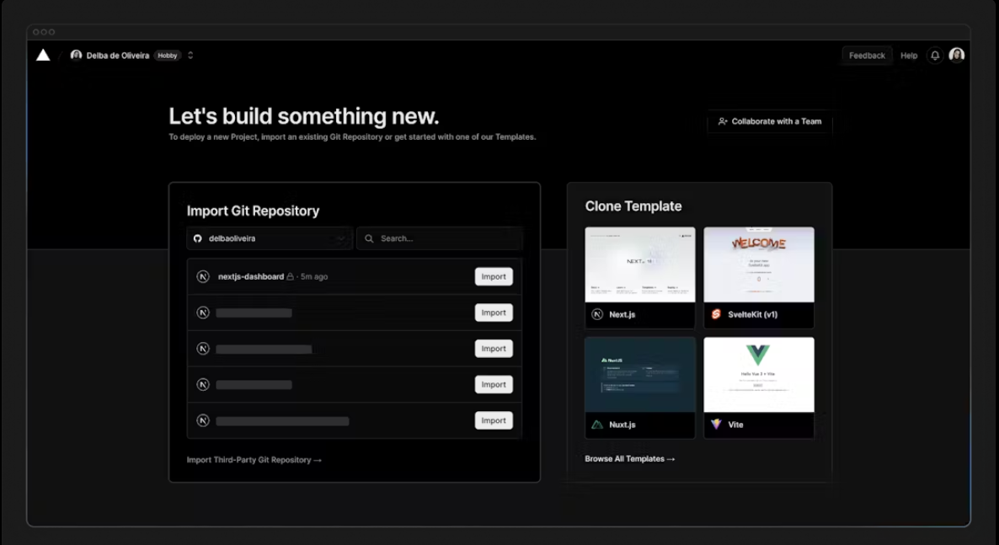

Name your project and click Deploy.

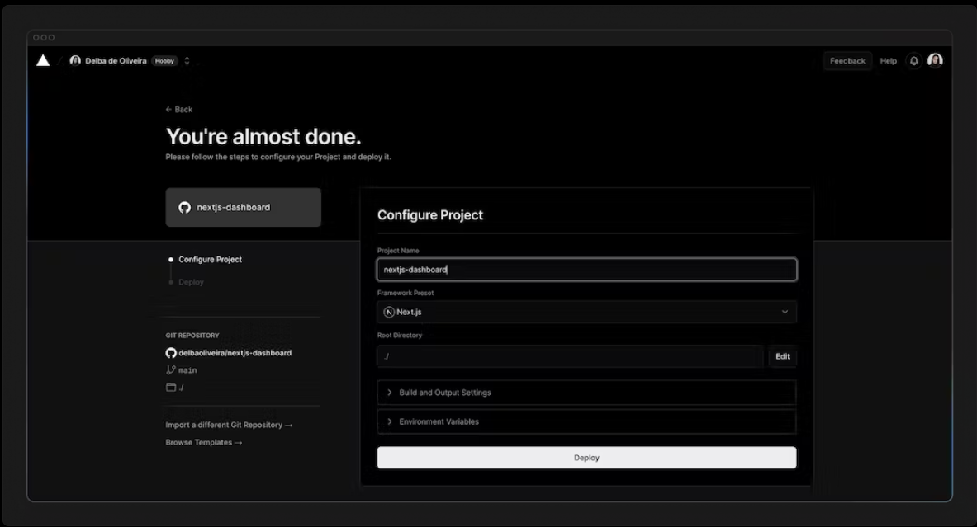

Hooray! 🎉 Your project is now deployed.

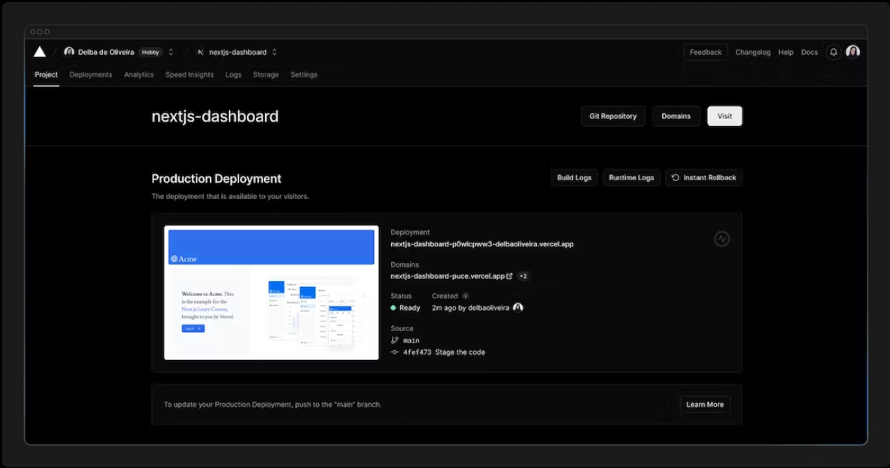

By connecting your GitHub repository, whenever you push changes to your main branch, Vercel will automatically redeploy your application with no configuration needed. When opening pull requests, you'll also have instant previews which allow you to catch deployment errors early and share a preview of your project with team members for feedback.

### Create a Postgres database

Next, to set up a database, click Continue to Dashboard and select the Storage tab from your project dashboard. Select Connect Store → Create New → Postgres → Continue.

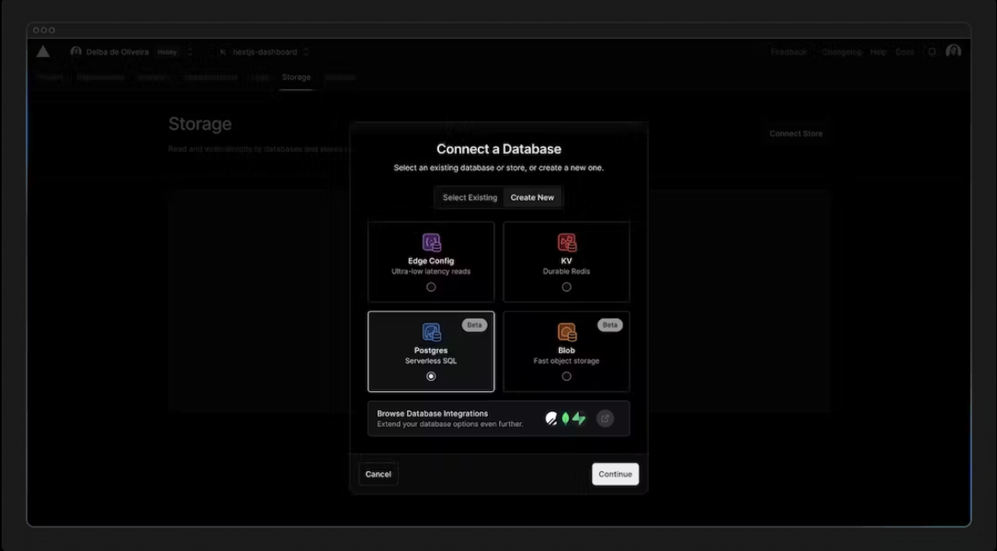

Accept the terms, assign a name to your database, and ensure your database region is set to Washington D.C (iad1) - this is also the default region for all new Vercel projects. By placing your database in the same region or close to your application code, you can reduce latency for data requests.

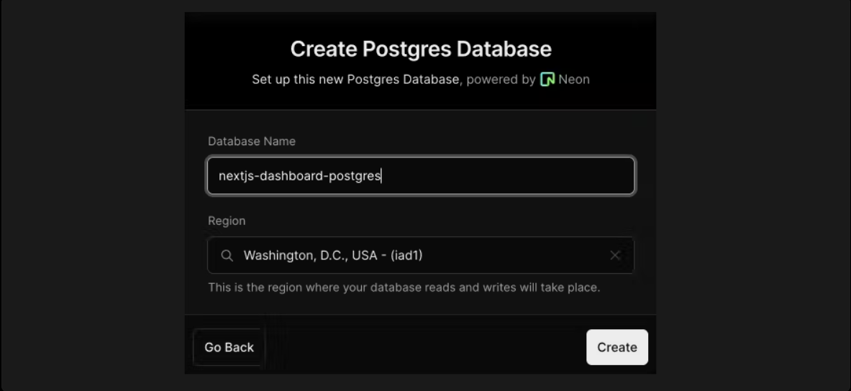

Once connected, navigate to the .env.local tab, click Show secret and Copy Snippet. Make sure you reveal the secrets before copying them.

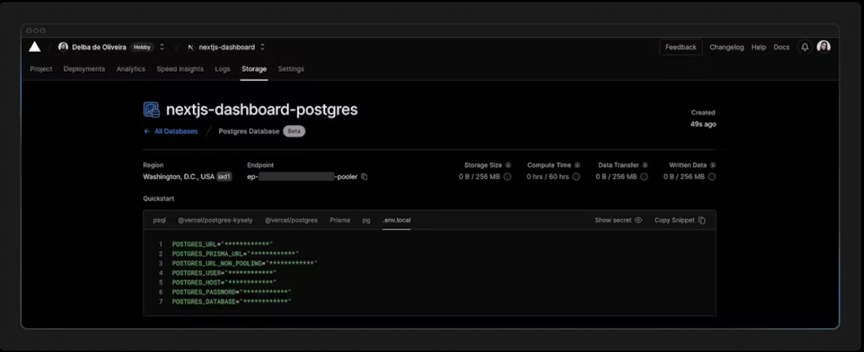

Navigate to your code editor and rename the .env.example file to .env. Paste in the copied contents from Vercel.

Important: Go to your .gitignore file and make sure .env is in the ignored files to prevent your database secrets from being exposed when you push to GitHub.

Finally, run npm i @vercel/postgres in your terminal to install the Vercel Postgres SDK.

### Seed your database

Now that your database has been created, let's seed it with some initial data. This will allow you to have some data to work with as you build the dashboard.

In the /scripts folder of your project, there's a file called seed.js. This script contains the instructions for creating and seeding the invoices, customers, user, revenue tables.

Don't worry if you don't understand everything the code is doing, but to give you an overview, the script uses SQL to create the tables, and the data from placeholder-data.js file to populate them after they've been created.

Next, in your package.json file, add the following line to your scripts:

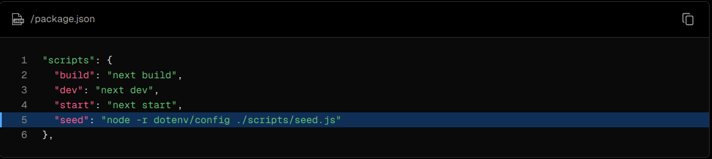

This is the command that will execute seed.js.

Now, run npm run seed. You should see some console.log messages in your terminal to let you know the script is running.

### Exploring your database

Let's see what your database looks like. Go back to Vercel, and click Data on the sidenav.

In this section, you'll find the four new tables: users, customers, invoices, and revenue.

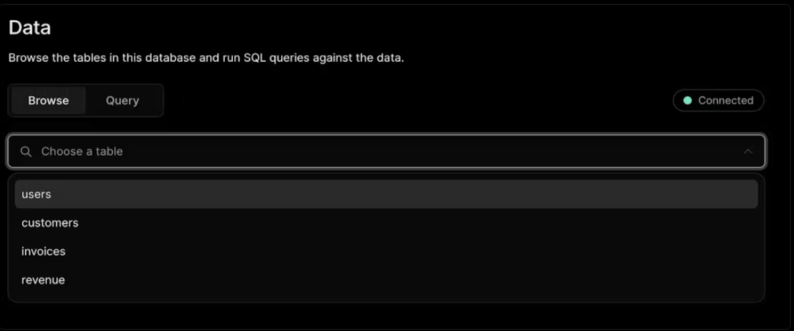By selecting each table, you can view its records and ensure the entries align with the data from placeholder-data.js file.

### Executing queries

You can switch to the "query" tab to interact with your database. This section supports standard SQL commands. For instance, inputting DROP TABLE customers will delete "customers" table along with all its data - so be careful!

Let's run your first database query. Paste and run the following SQL code into the Vercel interface:

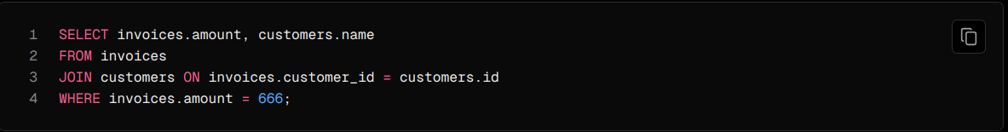

## Chapter 7 - Fetching Data

Now that you've created and seeded your database, let's discuss the different ways you can fetch data for your application, and build out your dashboard overview page.

In this chapter...

Here are the topics we’ll cover

* Learn about some approaches to fetching data: APIs, ORMs, SQL, etc.
* How Server Components can help you access back-end resources more securely.
* What network waterfalls are.
* How to implement parallel data fetching using a JavaScript Pattern.

### Choosing how to fetch data

API layer

APIs are an intermediary layer between your application code and database. There are a few cases where you might use an API:

* If you're using 3rd party services that provide an API.
* If you're fetching data from the client, you want to have an API layer that runs on the server to avoid exposing your database secrets to the client.

In Next.js, you can create API endpoints using Route Handlers.

### Database queries

When you're creating a full-stack application, you'll also need to write logic to interact with your database. For relational databases like Postgres, you can do this with SQL, or an ORM like Prisma.

There are a few cases where you have to write database queries:

* When creating your API endpoints, you need to write logic to interact with your database.
* If you are using React Server Components (fetching data on the server), you can skip the API layer, and query your database directly without risking exposing your database secrets to the client.

Let's learn more about React Server Components.

### Using Server Components to fetch data

By default, Next.js applications use React Server Components. Fetching data with Server Components is a relatively new approach and there are a few benefits of using them:

* Server Components support promises, providing a simpler solution for asynchronous tasks like data fetching. You can use async/await syntax without reaching out for useEffect, useState or data fetching libraries.
* Server Components execute on the server, so you can keep expensive data fetches and logic on the server and only send the result to the client.
* As mentioned before, since Server Components execute on the server, you can query the database directly without an additional API layer.

### Using SQL

For your dashboard project, you'll write database queries using the Vercel Postgres SDK and SQL. There are a few reasons why we'll be using SQL:

* SQL is the industry standard for querying relational databases (e.g. ORMs generate SQL under the hood).
* Having a basic understanding of SQL can help you understand the fundamentals of relational databases, allowing you to apply your knowledge to other tools.
* SQL is versatile, allowing you to fetch and manipulate specific data.
* The Vercel Postgres SDK provides protection against SQL injections.

Don't worry if you haven't used SQL before - we have provided the queries for you.

Go to /app/lib/data.ts, here you'll see that we're importing the sql function from @vercel/postgres. This function allows you to query your database:

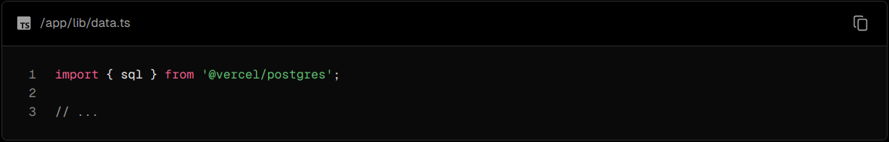

You can call sql inside any Server Component. But to allow you to navigate the components more easily, we've kept all the data queries in the data.ts file, and you can import them into the components.

### Fetching data for the dashboard overview page

Now that you understand different ways of fetching data, let's fetch data for the dashboard overview page. Navigate to /app/dashboard/page.tsx, paste the following code, and spend some time exploring it:

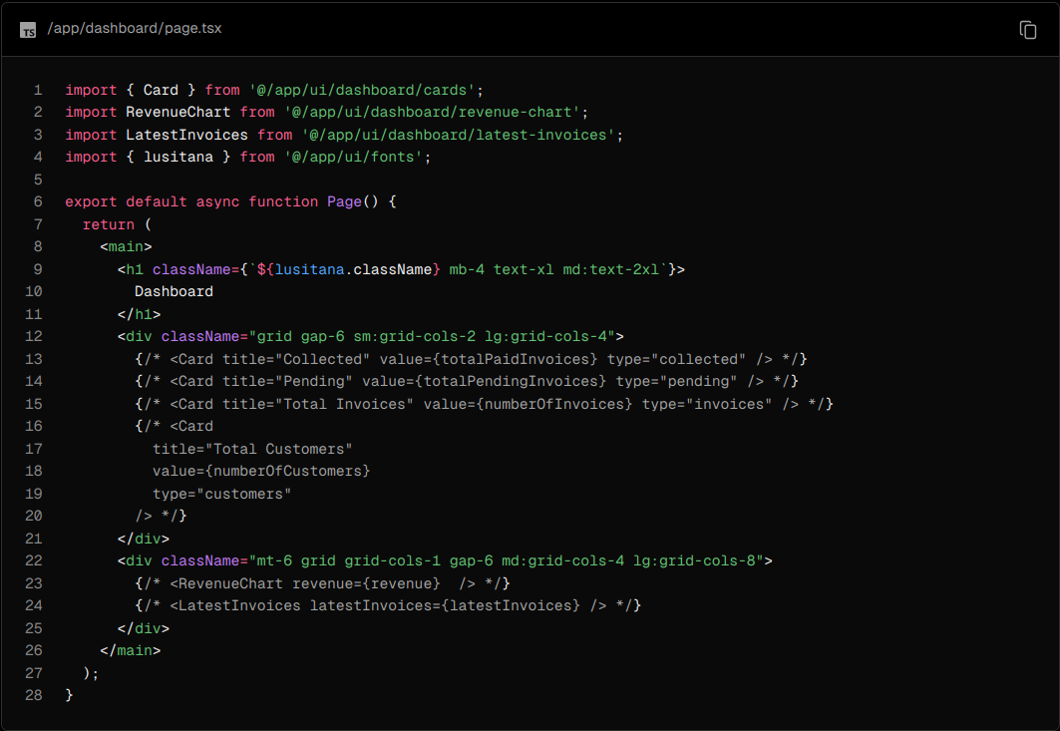

In the code above:

Page is an async component. This allows you to use await to fetch data.

There are also 3 components which receive data: <Card>, <RevenueChart>, and <LatestInvoices>. They are currently commented out to prevent the application from erroring.

### Fetching data for <RevenueChart/>

To fetch data for the <RevenueChart/> component, import the fetchRevenue function from data.ts and call it inside your component:

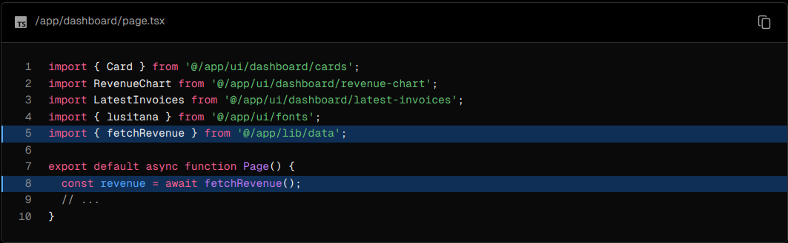

Then, uncomment the <RevenueChart/> component, navigate to the component file (/app/ui/dashboard/revenue-chart.tsx) and uncomment the code inside it. Check your localhost, you should be able to see a chart that uses revenue data.

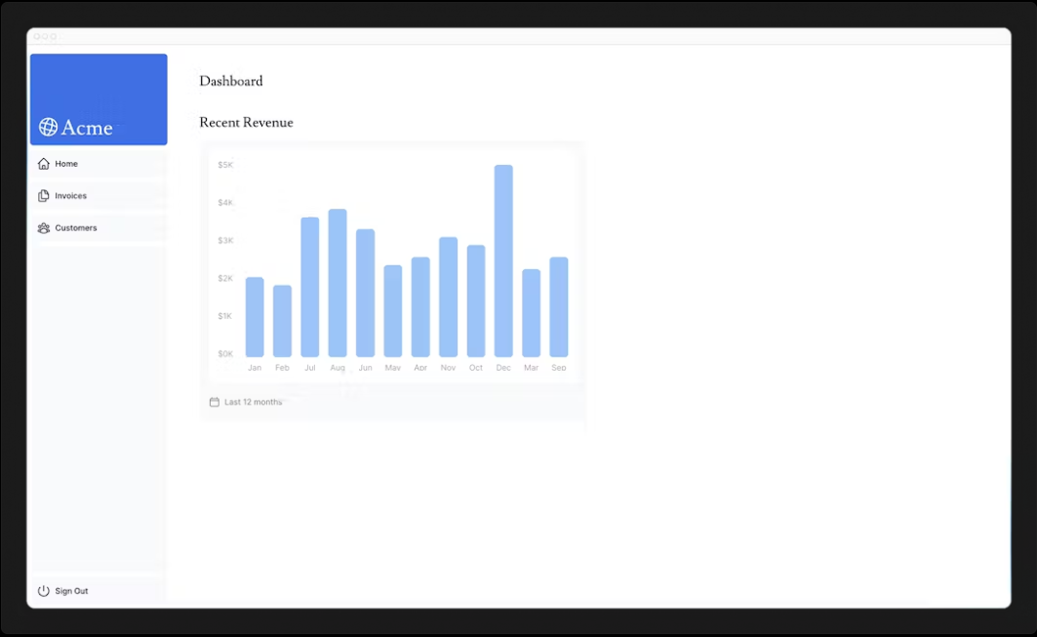

Let's continue importing some more data queries!

### Fetching data for <LatestInvoices/>

For the <LatestInvoices /> component, we need to get the latest 5 invoices, sorted by date.

You could fetch all the invoices and sort through them using JavaScript. This isn't a problem as our data is small, but as your application grows, it can significantly increase the amount of data transferred on each request and the JavaScript required to sort through it.

Instead of sorting through the latest invoices in-memory, you can use an SQL query to fetch only the last 5 invoices. For example, this is the SQL query from your data.ts file:

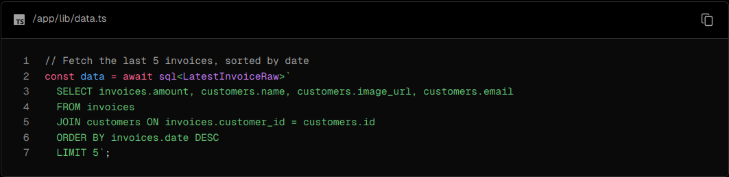

In your page, import the fetchLatestInvoices function:

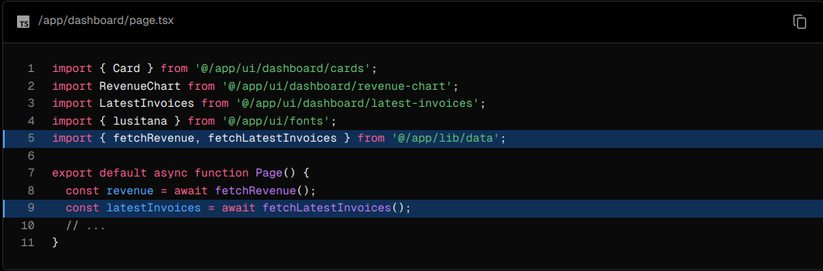

Then, uncomment the <LatestInvoices /> component. You will also need to uncomment the relevant code in the <LatestInvoices /> component itself, located at /app/ui/dashboard/latest-invoices.

If you visit your localhost, you should see that only the last 5 are returned from the database. Hopefully, you're beginning to see the advantages of querying your database directly!

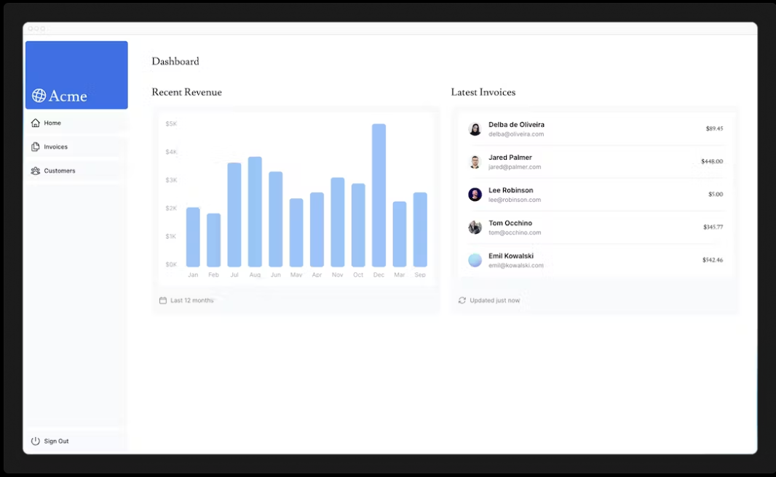

### Practice: Fetch data for the <Card> components

Now it's your turn to fetch data for the <Card> components. The cards will display the following data:

* Total amount of invoices collected.
* Total amount of invoices pending.
* Total number of invoices.
* Total number of customers.

Again, you might be tempted to fetch all the invoices and customers, and use JavaScript to manipulate the data. For example, you could use Array.length to get the total number of invoices and customers:



But with SQL, you can fetch only the data you need. It's a little longer than using Array.length, but it means less data needs to be transferred during the request. This is the SQL alternative:

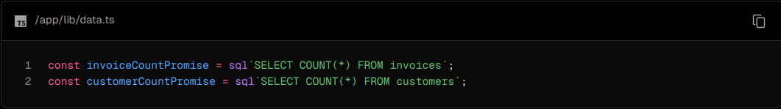

The function you will need to import is called fetchCardData. You will need to destructure the values returned from the function.

Hint:

* Check the card components to see what data they need.
* Check the data.ts file to see what the function returns.

Once you're ready, expand the toggle below for the final code:

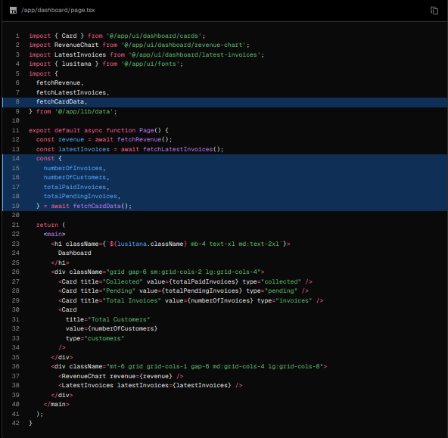

Great! You've now fetched all the data for the dashboard overview page. Your page should look like this:

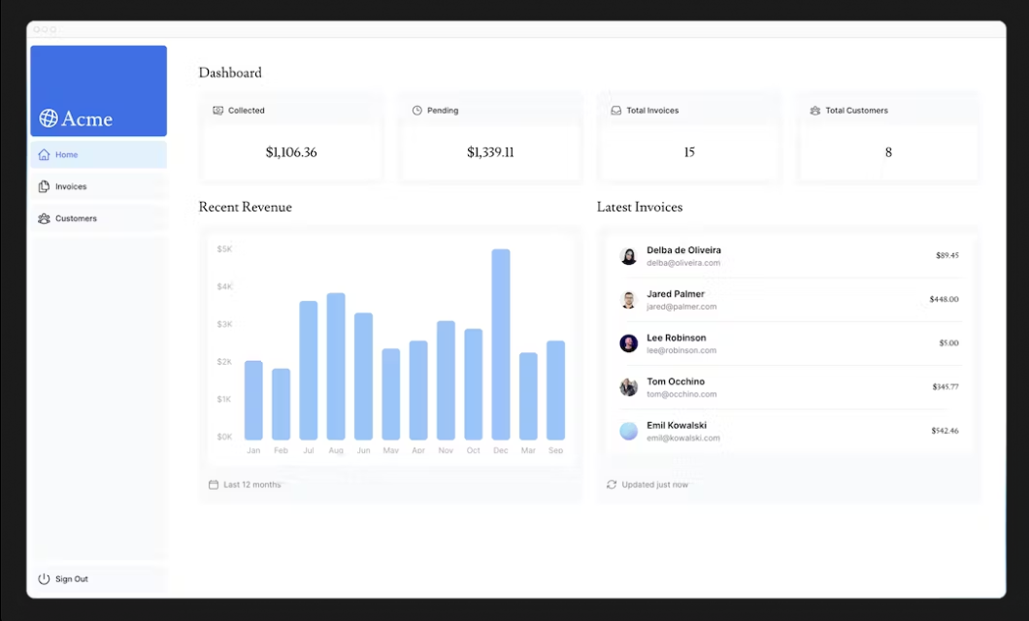

However... there are two things you need to be aware of:

1. The data requests are unintentionally blocking each other, creating a request waterfall.
2. By default, Next.js prerenders routes to improve performance, this is called Static Rendering. So if your data changes, it won't be reflected in your dashboard.

Let's discuss number 1 in this chapter, then look into detail at number 2 in the next chapter.

### What are request waterfalls?

A "waterfall" refers to a sequence of network requests that depend on the completion of previous requests. In the case of data fetching, each request can only begin once the previous request has returned data.

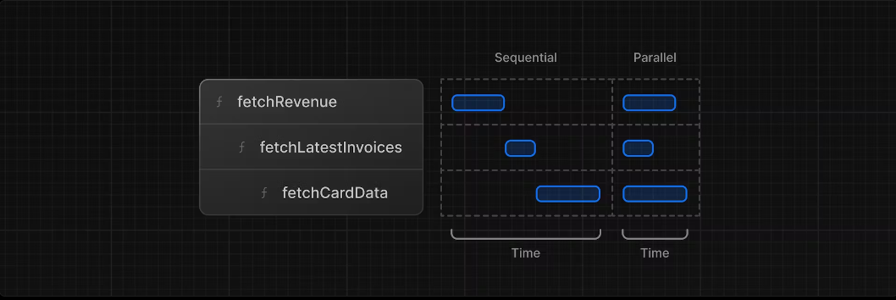

For example, we need to wait for fetchRevenue() to execute before fetchLatestInvoices() can start running, and so on.

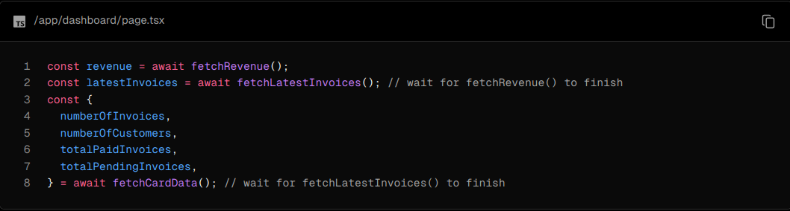

This pattern is not necessarily bad. There may be cases where you want waterfalls because you want a condition to be satisfied before you make the next request. For example, you might want to fetch a user's ID and profile information first. Once you have the ID, you might then proceed to fetch their list of friends. In this case, each request is contingent on the data returned from the previous request.

However, this behavior can also be unintentional and impact performance.

### Parallel data fetching

A common way to avoid waterfalls is to initiate all data requests at the same time - in parallel.

In JavaScript, you can use the Promise.all() or Promise.allSettled() functions to initiate all promises at the same time. For example, in data.ts, we're using Promise.all() in the fetchCardData() function:

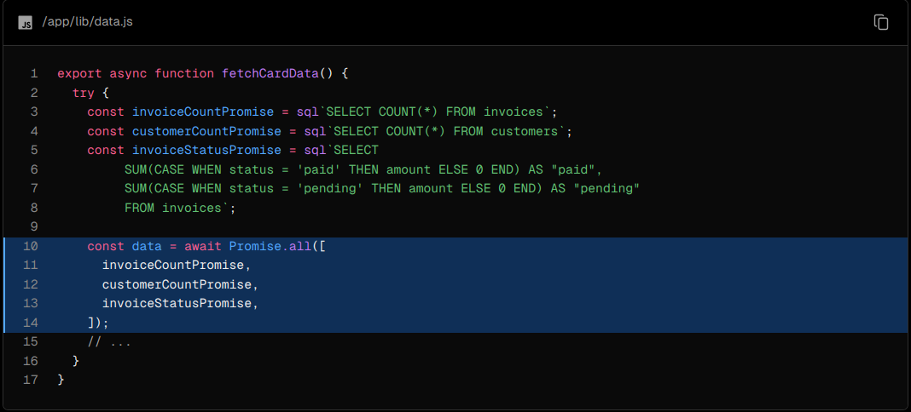

By using this pattern, you can:

* Start executing all data fetches at the same time, which can lead to performance gains.
* Use a native JavaScript pattern that can be applied to any library or framework.

However, there is one disadvantage of relying only on this JavaScript pattern: what happens if one data request is slower than all the others?

## Chapter 8 - Static and Dynamic Rendering

In the previous chapter, you fetched data for the Dashboard Overview page. However, we briefly discussed two limitations of the current setup:

1. The data requests are creating an unintentional waterfall.
2. The dashboard is static, so any data updates will not be reflected on your application.

In this chapter...

Here are the topics we’ll cover

* What static rendering is and how it can improve your application's performance.
* What dynamic rendering is and when to use it.
* Different approaches to make your dashboard dynamic.
* Simulate a slow data fetch to see what happens.

### What is Static Rendering?

With static rendering, data fetching and rendering happens on the server at build time (when you deploy) or during revalidation. The result can then be distributed and cached in a Content Delivery Network (CDN).

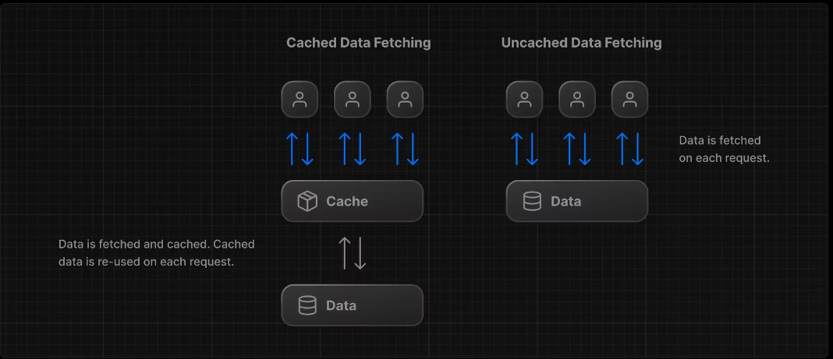

Whenever a user visits your application, the cached result is served. There are a couple of benefits of static rendering:

* Faster Websites - Prerendered content can be cached and globally distributed. This ensures that users around the world can access your website's content more quickly and reliably.
* Reduced Server Load - Because the content is cached, your server does not have to dynamically generate content for each user request.
* SEO - Prerendered content is easier for search engine crawlers to index, as the content is already available when the page loads. This can lead to improved search engine rankings.

Static rendering is useful for UI with no data or data that is shared across users, such as a static blog post or a product page. It might not be a good fit for a dashboard that has personalized data that is regularly updated.

The opposite of static rendering is dynamic rendering.

### What is Dynamic Rendering?

With dynamic rendering, content is rendered on the server for each user at request time (when the user visits the page). There are a couple of benefits of dynamic rendering:

* Real-Time Data - Dynamic rendering allows your application to display real-time or frequently updated data. This is ideal for applications where data changes often.
* User-Specific Content - It's easier to serve personalized content, such as dashboards or user profiles, and update the data based on user interaction.
* Request Time Information - Dynamic rendering allows you to access information that can only be known at request time, such as cookies or the URL search parameters.

### Making the dashboard dynamic

By default, @vercel/postgres doesn't set its own caching semantics. This allows the framework to set its own static and dynamic behavior.

You can use a Next.js API called unstable_noStore inside your Server Components or data fetching functions to opt out of static rendering. Let's add this.

In your data.ts, import unstable_noStore from next/cache, and call it the top of your data fetching functions:

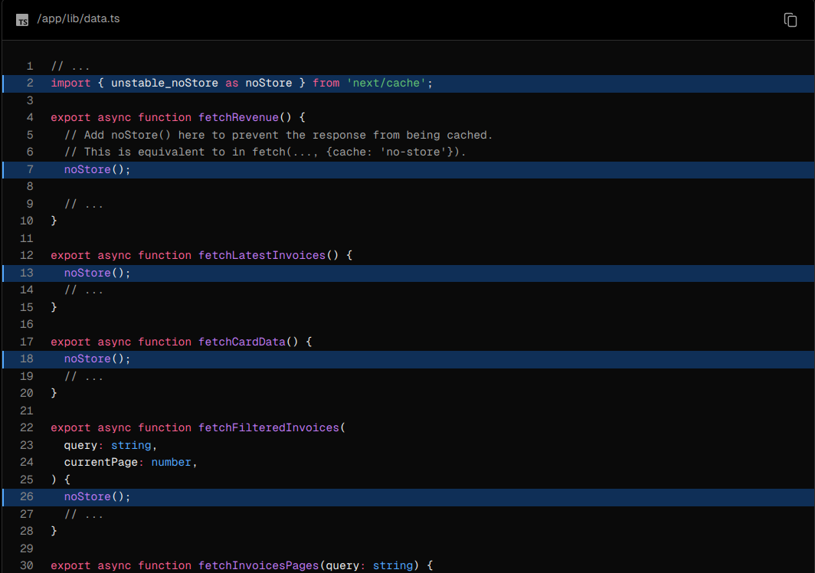

Note: unstable_noStore is an experimental API and may change in the future. If you prefer to use a stable API in your own projects, you can also use the Segment Config Option export const dynamic = "force-dynamic".

### Simulating a Slow Data Fetch

Making the dashboard dynamic is a good first step. However... there is still one problem we mentioned in the previous chapter. What happens if one data request is slower than all the others?

Let's simulate a slow data fetch. In your data.ts file, uncomment the console.log and setTimeout inside fetchRevenue():

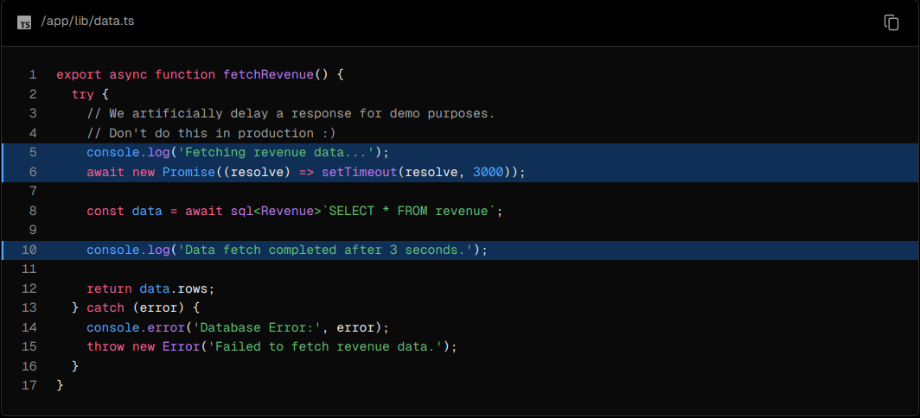

Now open http://localhost:3000/dashboard/ in a new tab and notice how the page takes longer to load. In your terminal, you should also see the following messages:



Here, you've added an artificial 3-second delay to simulate a slow data fetch. The result is that now your whole page is blocked while the data is being fetched.

Which brings us to a common challenge developers have to solve:

With dynamic rendering, your application is only as fast as your slowest data fetch.

## Chapter 9 - Streaming

In the previous chapter, you made your dashboard page dynamic, however, we discussed how the slow data fetches can impact the performance of your application. Let's look at how you can improve the user experience when there are slow data requests.

In this chapter...

Here are the topics we’ll cover

* What streaming is and when you might use it.
* How to implement streaming with loading.tsx and Suspense.
* What loading skeletons are.
* What route groups are, and when you might use them.
* Where to place Suspense boundaries in your application.

### What is streaming?

Streaming is a data transfer technique that allows you to break down a route into smaller "chunks" and progressively stream them from the server to the client as they become ready.

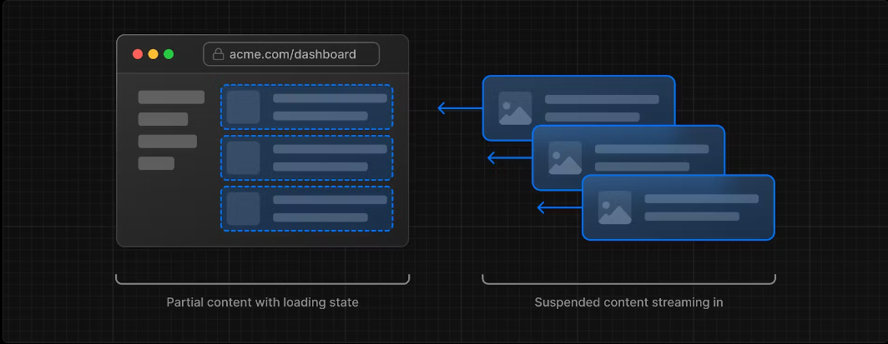

By streaming, you can prevent slow data requests from blocking your whole page. This allows the user to see and interact with parts of the page without waiting for all the data to load before any UI can be shown to the user.

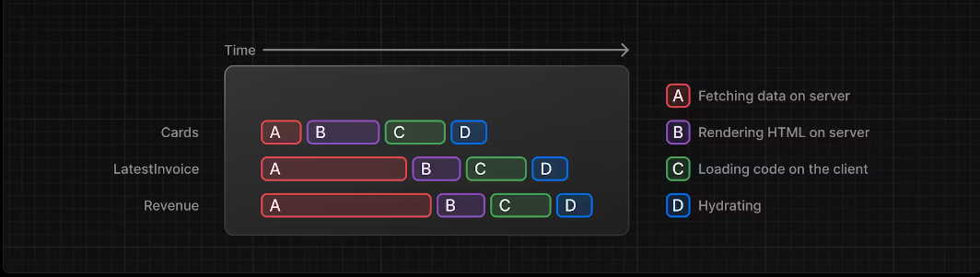

Streaming works well with React's component model, as each component can be considered a chunk.

There are two ways you implement streaming in Next.js:

1. At the page level, with the loading.tsx file.
2. For specific components, with <Suspense>.

Let's see how this works.

### Streaming a whole page with loading.tsx

In the /app/dashboard folder, create a new file called loading.tsx:

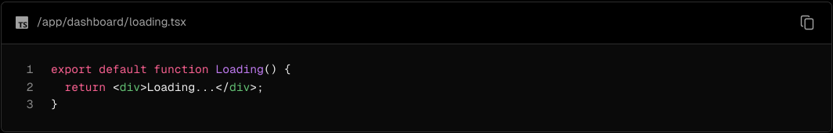

Refresh http://localhost:3000/dashboard, and you should now see:

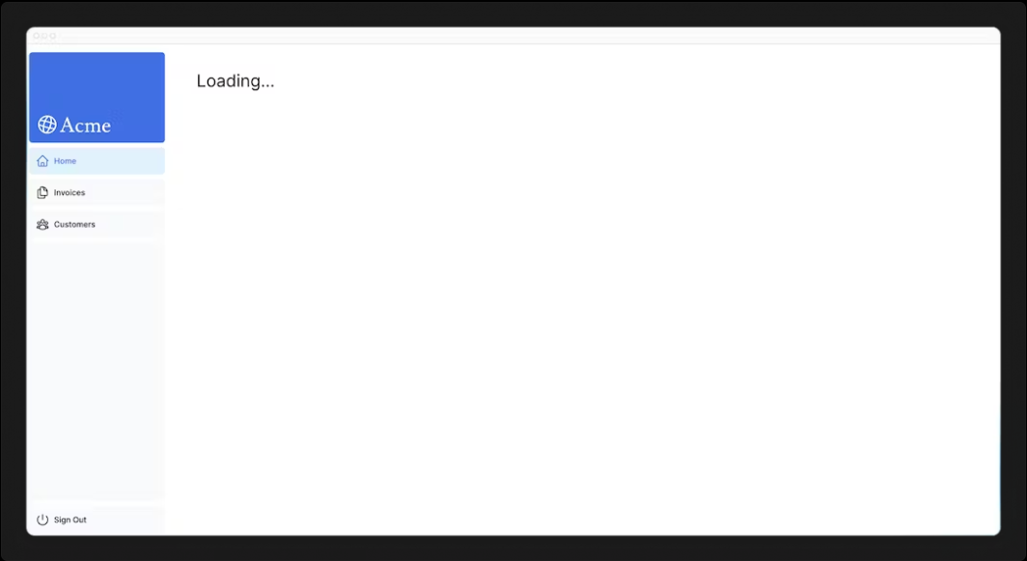

A few things are happening here:

1. loading.tsx is a special Next.js file built on top of Suspense, it allows you to create fallback UI to show as a replacement while page content loads.
2. Since <Sidebar> is static, so it's shown immediately. The user can interact with <Sidebar> while the dynamic content is loading.
3. The user doesn't have to wait for the page to finish loading before navigating away (this is called interruptable navigation).

Congratulations! You've just implemented streaming. But we can do more to improve the user experience. Let's show a loading skeleton instead of the Loading… text.

### Adding loading skeletons

A loading skeleton is a simplified version of the UI. Many websites use them as a placeholder (or fallback) to indicate to users that the content is loading. Any UI you embed into loading.tsx will be embedded as part of the static file, and sent first. Then, the rest of the dynamic content will be streamed from the server to the client.

Inside your loading.tsx file, import a new component called <DashboardSkeleton>:

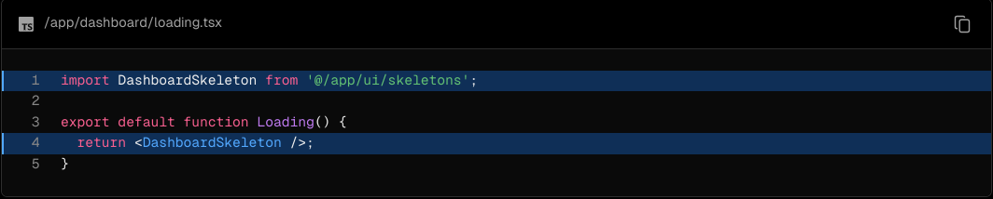

Then, refresh http://localhost:3000/dashboard, and you should now see:

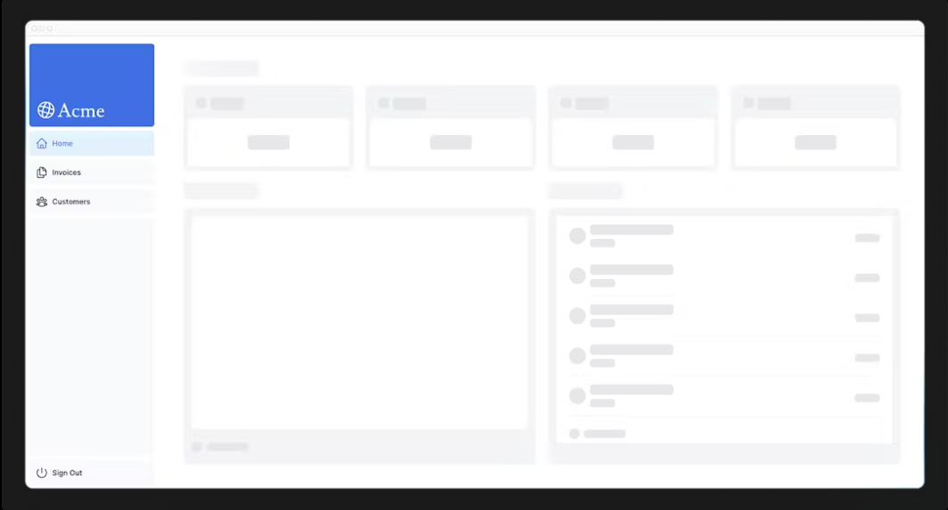

### Fixing the loading skeleton bug with route groups

Right now, your loading skeleton will apply to the invoices and customers pages as well.

Since loading.tsx is a level higher than /invoices/page.tsx and /customers/page.tsx in the file system, it's also applied to those pages.

We can change this with Route Groups. Create a new folder called /(overview) inside the dashboard folder. Then, move your loading.tsx and page.tsx files inside the folder:



Now, the loading.tsx file will only apply to your dashboard overview page.

Route groups allow you to organize files into logical groups without affecting the URL path structure. When you create a new folder using parentheses (), the name won't be included in the URL path. So /dashboard/(overview)/page.tsx becomes /dashboard.

Here, you're using a route group to ensure loading.tsx only applies to your dashboard overview page. However, you can also use route groups to separate your application into sections (e.g. (marketing) routes and (shop) routes) or by teams for larger applications.

### Streaming a component

So far, you're streaming a whole page. But, instead, you can be more granular and stream specific components using React Suspense.

Suspense allows you to defer rendering parts of your application until some condition is met (e.g. data is loaded). You can wrap your dynamic components in Suspense. Then, pass it a fallback component to show while the dynamic component loads.

If you remember the slow data request, fetchRevenue(), this is the request that is slowing down the whole page. Instead of blocking your page, you can use Suspense to stream only this component and immediately show the rest of the page's UI.

To do so, you'll need to move the data fetch to the component, let's update the code to see what that'll look like:

Delete all instances of fetchRevenue() and its data from /dashboard/(overview)/page.tsx:

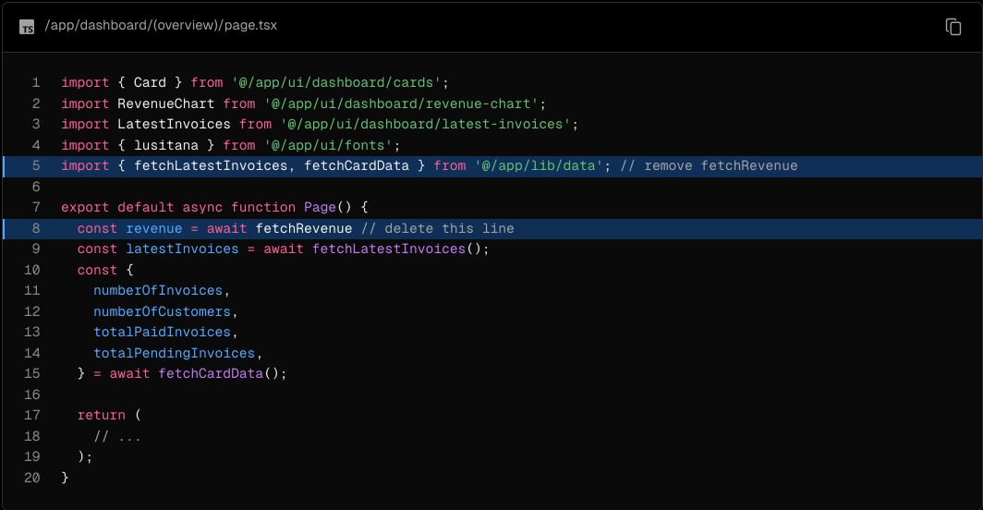

Then, import <Suspense> from React, and wrap it around <RevenueChart />. You can pass it a fallback component called <RevenueChartSkeleton>.

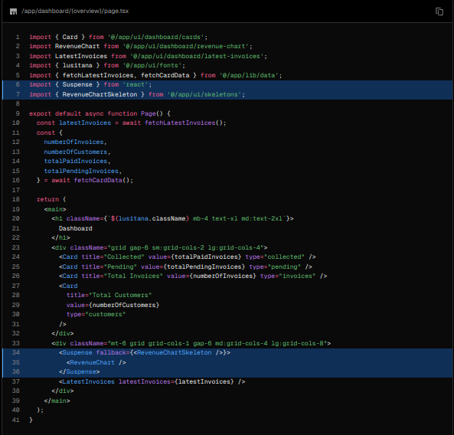

Finally, update the <RevenueChart> component to fetch its own data and remove the prop passed to it:

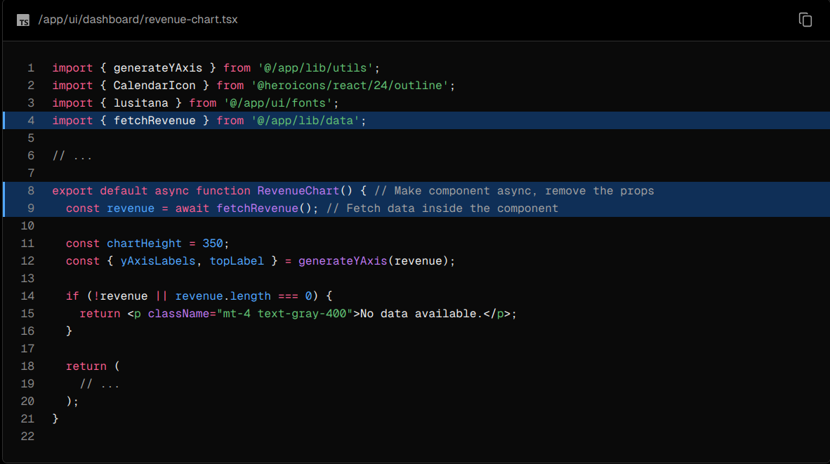

Now refresh the page, you should see the dashboard information almost immediately, while a fallback skeleton is shown for <RevenueChart>:

### 

### Practice: Streaming <LatestInvoices>

Now it's your turn! Practice what you've just learned by streaming the <LatestInvoices> component.

Move fetchLatestInvoices() down from the page to the <LatestInvoices> component. Wrap the component in a <Suspense> boundary with a fallback called <LatestInvoicesSkeleton>.

Once you're ready, expand the toggle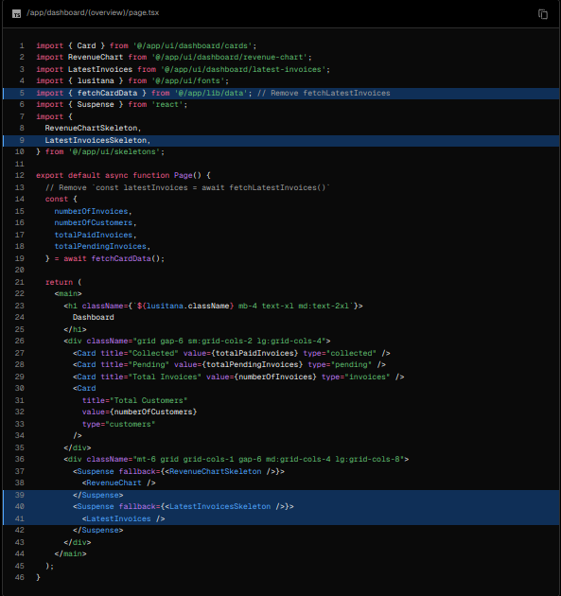 to see the solution code:

Dashboard Page:

<LatestInvoices> component. Remember to remove the props!:

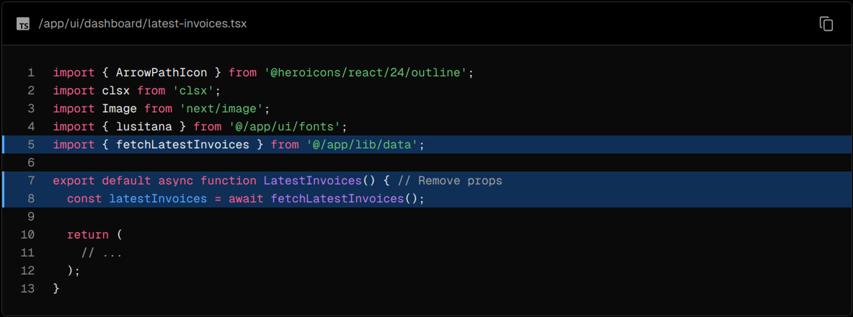

### Grouping components

Great! You're almost there, now you need to wrap the <Card> components in Suspense. You can fetch data for each individual card, but this could lead to a popping effect as the cards load in, this can be visually jarring for the user.

So, how would you tackle this problem?

To create more of a staggered effect, you can group the cards using a wrapper component. This means the static <Sidebar/> will be shown first, followed by the cards, etc.

In your page.tsx file:

1. Delete your <Card> components.
2. Delete the fetchCardData() function.
3. Import a new wrapper component called <CardWrapper />.
4. Import a new skeleton component called <CardsSkeleton />.
5. Wrap <CardWrapper /> in Suspense.

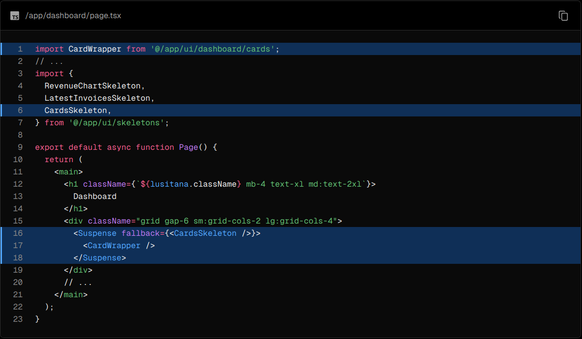

Then, move into the file /app/ui/dashboard/cards.tsx, import the fetchCardData() function, and invoke it inside the <CardWrapper/> component. Make sure to uncomment any necessary code in this component.

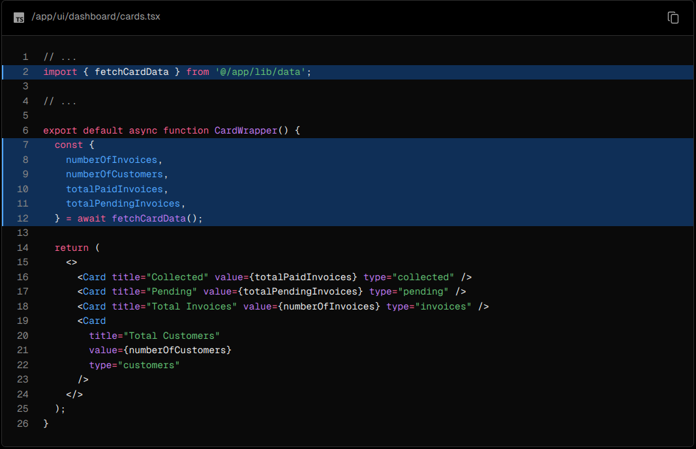

Refresh the page, and you should see all the cards load in at the same time. You can use this pattern when you want multiple components to load in at the same time.

### Deciding where to place your Suspense boundaries

Where you place your Suspense boundaries will depend on a few things:

1. How you want the user to experience the page as it streams.
2. What content you want to prioritize.
3. If the components rely on data fetching.

Take a look at your dashboard page, is there anything you would've done differently?

Don't worry. There isn't a right answer.

* You could stream the whole page like we did with loading.tsx... but that may lead to a longer loading time if one of the components has a slow data fetch.
* You could stream every component individually... but that may lead to UI popping into the screen as it becomes ready.
* You could also create a staggered effect by streaming page sections. But you'll need to create wrapper components.

Where you place your suspense boundaries will vary depending on your application. In general, it's good practice to move your data fetches down to the components that need it, and then wrap those components in Suspense. But there is nothing wrong with streaming the sections or the whole page if that's what your application needs.

Don't be afraid to experiment with Suspense and see what works best, it's a powerful API that can help you create more delightful user experiences.

### Looking ahead

Streaming and Server Components give us new ways to handle data fetching and loading states, ultimately with the goal of improving the end user experience.

In the next chapter, you'll learn about Partial Prerendering, a new Next.js rendering model built with streaming in mind.

## Chapter 10 - Partial Prerendering (Optional)

Partial Prerendering is an experimental feature introduced in Next.js 14. The content of this page may be updated as the feature progresses in stability. You may want to skip this chapter if you prefer to not use experimental features. This chapter is not required to complete the course.

In this chapter...

Here are the topics we’ll cover

* What Partial Prerendering is.
* How Partial Prerendering works.

### Combining Static and Dynamic Content

Currently, if you call a dynamic function inside your route (e.g. noStore(), cookies(), etc), your whole route becomes dynamic.

This aligns with how most web apps are built today, you either choose between static and dynamic rendering for your entire application or for specific routes.

However, most routes are not fully static or dynamic. You may have a route that has both static and dynamic content. For example, let's say you have a social media feed, the posts would be static, but the likes for the post would be dynamic. Or an ecommerce site, where the product details are static, but the user's cart is dynamic.

Going back to your dashboard page, what components would you consider static vs. dynamic?

Once you're ready, click the button below to see how we would split the dashboard route:

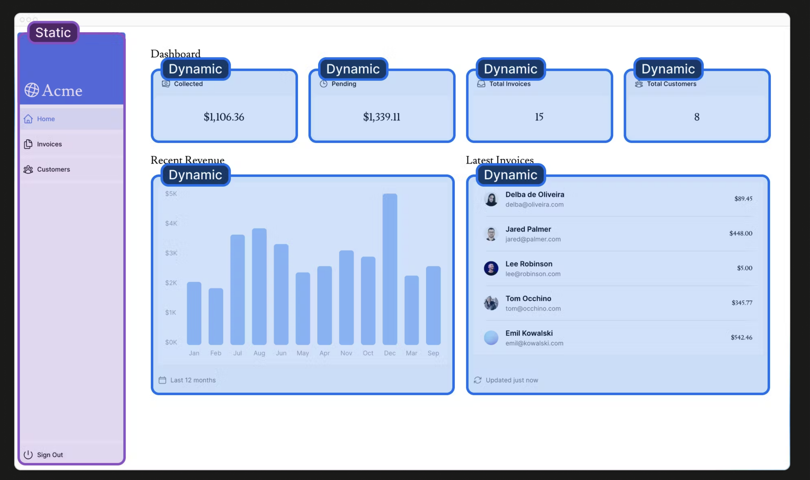

* The <SideNav> Component doesn't rely on data, and is not personalized to the user, so it can be static.
* The components in <Page> rely on data that changes often and will be personalized to the user, so they can be dynamic.

### What is Partial Prerendering?

In Next.js 14, there is a preview of a new rendering model called Partial Prerendering. Partial Prerendering is an experimental feature that allows you to render a route with a static loading shell, while keeping some parts dynamic. In other words, you can isolate the dynamic parts of a route. For example:

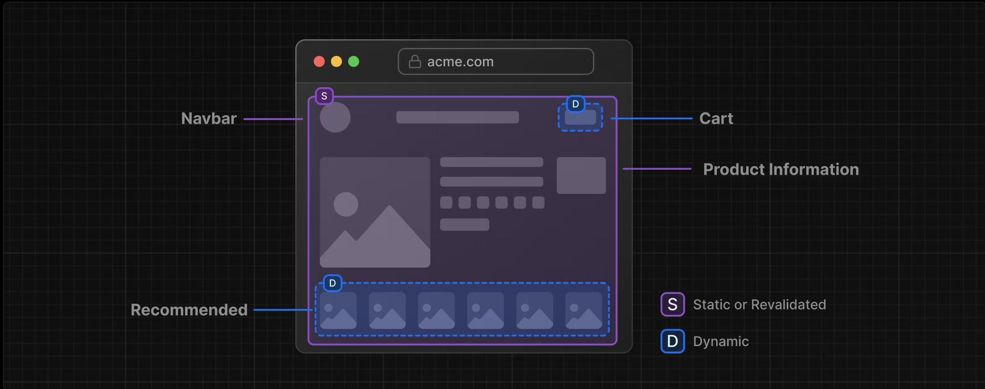

When a user visits a route:

A static route shell is served, this makes the initial load fast.

The shell leaves holes where dynamic content will load in async.

The async holes are loaded in parallel, reducing the overall load time of the page.

This is different from how your application behaves today, where entire routes are either fully static or dynamic.

Partial Prerendering combines ultra-quick static edge delivery with fully dynamic capabilities and we believe it has the potential to become the default rendering model for web applications, bringing together the best of static site generation and dynamic delivery.

### How does Partial Prerendering work?

Partial Prerendering leverages React's Concurrent APIs and uses Suspense to defer rendering parts of your application until some condition is met (e.g. data is loaded).

The fallback is embedded into the initial static file along with other static content. At build time (or during revalidation), the static parts of the route are prerendered, and the rest is postponed until the user requests the route.

It's worth noting that wrapping a component in Suspense doesn't make the component itself dynamic (remember you used unstable_noStore to achieve this behavior), but rather Suspense is used as a boundary between the static and dynamic parts of your route.

The great thing about Partial Prerendering is that you don't need to change your code to use it. As long as you're using Suspense to wrap the dynamic parts of your route, Next.js will know which parts of your route are static and which are dynamic.

Note: To learn more about how Partial Prerendering can be configured, see the Partial Prerendering (experimental) documentation or try the Partial Prerendering template and demo. It's important to note that this feature is experimental and not yet ready for production deployment.

### Summary

To recap, you've done a few things to optimize data fetching in your application, you've:

1. Created a database in the same region as your application code to reduce latency between your server and database.
2. Fetched data on the server with React Server Components. This allows you to keep expensive data fetches and logic on the server, reduces the client-side JavaScript bundle, and prevents your database secrets from being exposed to the client.
3. Used SQL to only fetch the data you needed, reducing the amount of data transferred for each request and the amount of JavaScript needed to transform the data in-memory.
4. Parallelize data fetching with JavaScript - where it made sense to do so.
5. Implemented Streaming to prevent slow data requests from blocking your whole page, and to allow the user to start interacting with the UI without waiting for everything to load.
6. Move data fetching down to the components that need it, thus isolating which parts of your routes should be dynamic in preparation for Partial Prerendering.

In the next chapter, we'll look at two common patterns you might need to implement when fetching data: search and pagination.

## Chapter 11 - Adding Search and Pagination

In the previous chapter, you improved your dashboard's initial loading performance with streaming. Now let's move on to the /invoices page, and learn how to add search and pagination!

* Learn how to use the Next.js APIs: searchParams, usePathname, and useRouter.
* Implement search and pagination using URL search params.

### Starting code

Inside your /dashboard/invoices/page.tsx file, paste the following code:

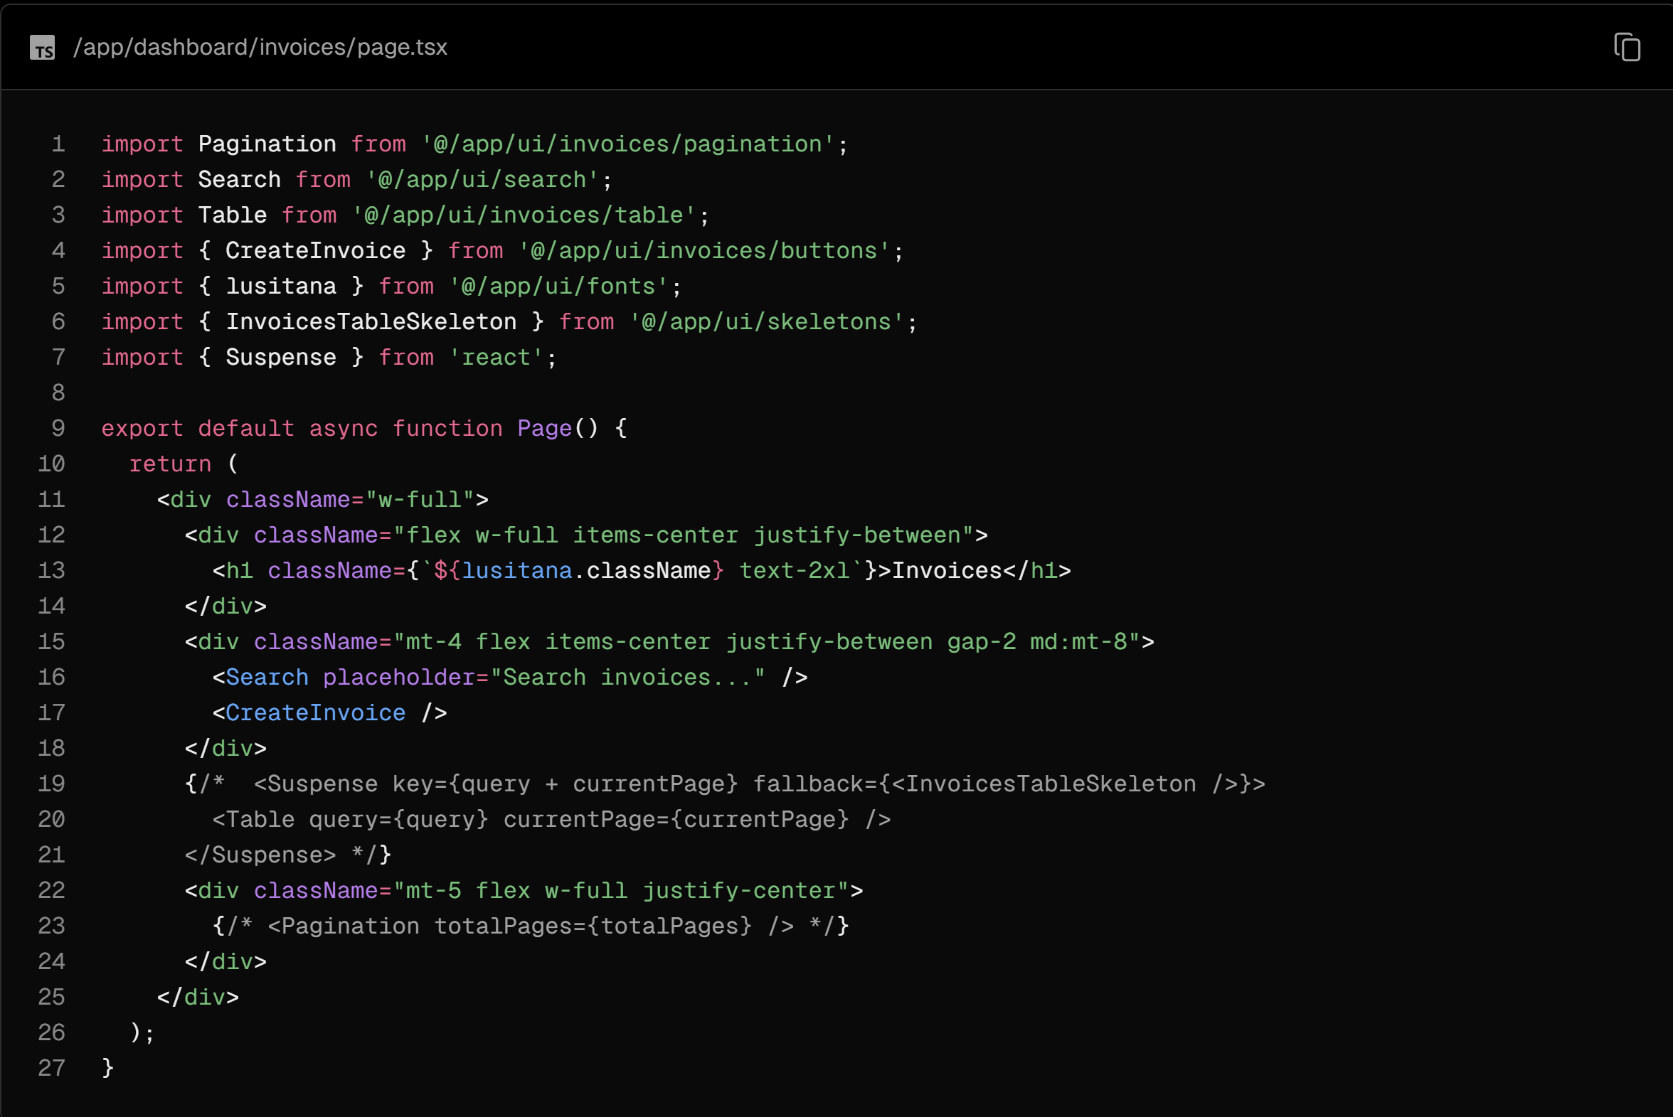

Spend some time familiarizing yourself with the page and the components you'll be working with:

* <Search/> allows users to search for specific invoices.
* <Pagination/> allows users to navigate between pages of invoices.
* <Table/> displays the invoices.

Your search functionality will span the client and the server. When a user searches for an invoice on the client, the URL params will be updated, data will be fetched on the server, and the table will re-render on the server with the new data.

### Why use URL search params?

As mentioned above, you'll be using URL search params to manage the search state. This pattern may be new if you're used to doing it with client side state.

There are a couple of benefits of implementing search with URL params:

* Bookmarkable and Shareable URLs: Since the search parameters are in the URL, users can bookmark the current state of the application, including their search queries and filters, for future reference or sharing.
* Server-Side Rendering and Initial Load: URL parameters can be directly consumed on the server to render the initial state, making it easier to handle server rendering.
* Analytics and Tracking: Having search queries and filters directly in the URL makes it easier to track user behavior without requiring additional client-side logic.

### Adding the search functionality

These are the Next.js client hooks that you'll use to implement the search functionality:

* useSearchParams- Allows you to access the parameters of the current URL. For example, the search params for this URL /dashboard/invoices?page=1&query=pending would look like this: {page: '1', query: 'pending'}.
* usePathname - Lets you read the current URL's pathname. For example, for the route /dashboard/invoices, usePathname would return '/dashboard/invoices'.
* useRouter - Enables navigation between routes within client components programmatically. There are multiple methods you can use.

Here's a quick overview of the implementation steps:

1. Capture the user's input.
2. Update the URL with the search params.
3. Keep the URL in sync with the input field.
4. Update the table to reflect the search query.

### 1. Capture the user's input

Go into the <Search> Component (/app/ui/search.tsx), and you'll notice:

* "use client" - This is a Client Component, which means you can use event listeners and hooks.
* <input> - This is the search input.

Create a new handleSearch function, and add an onChange listener to the <input> element. onChange will invoke handleSearch whenever the input value changes.

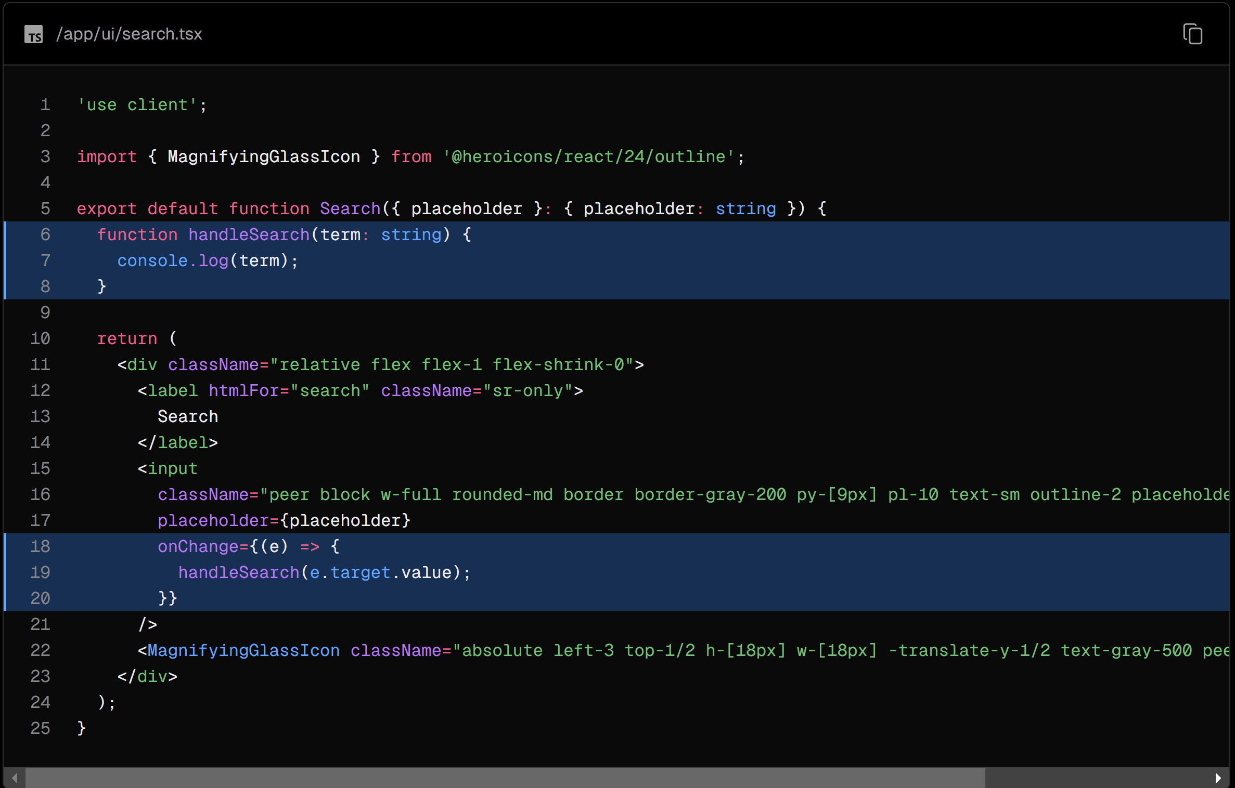

Test that it's working correctly by opening the console in your Developer Tools, then type into the search field. You should see the search term logged to the console.

Great! You're capturing the user's search input. Now, you need to update the URL with the search term.

### 2. Update the URL with the search params

Import the useSearchParams hook from 'next/navigation', and assign it to a variable:

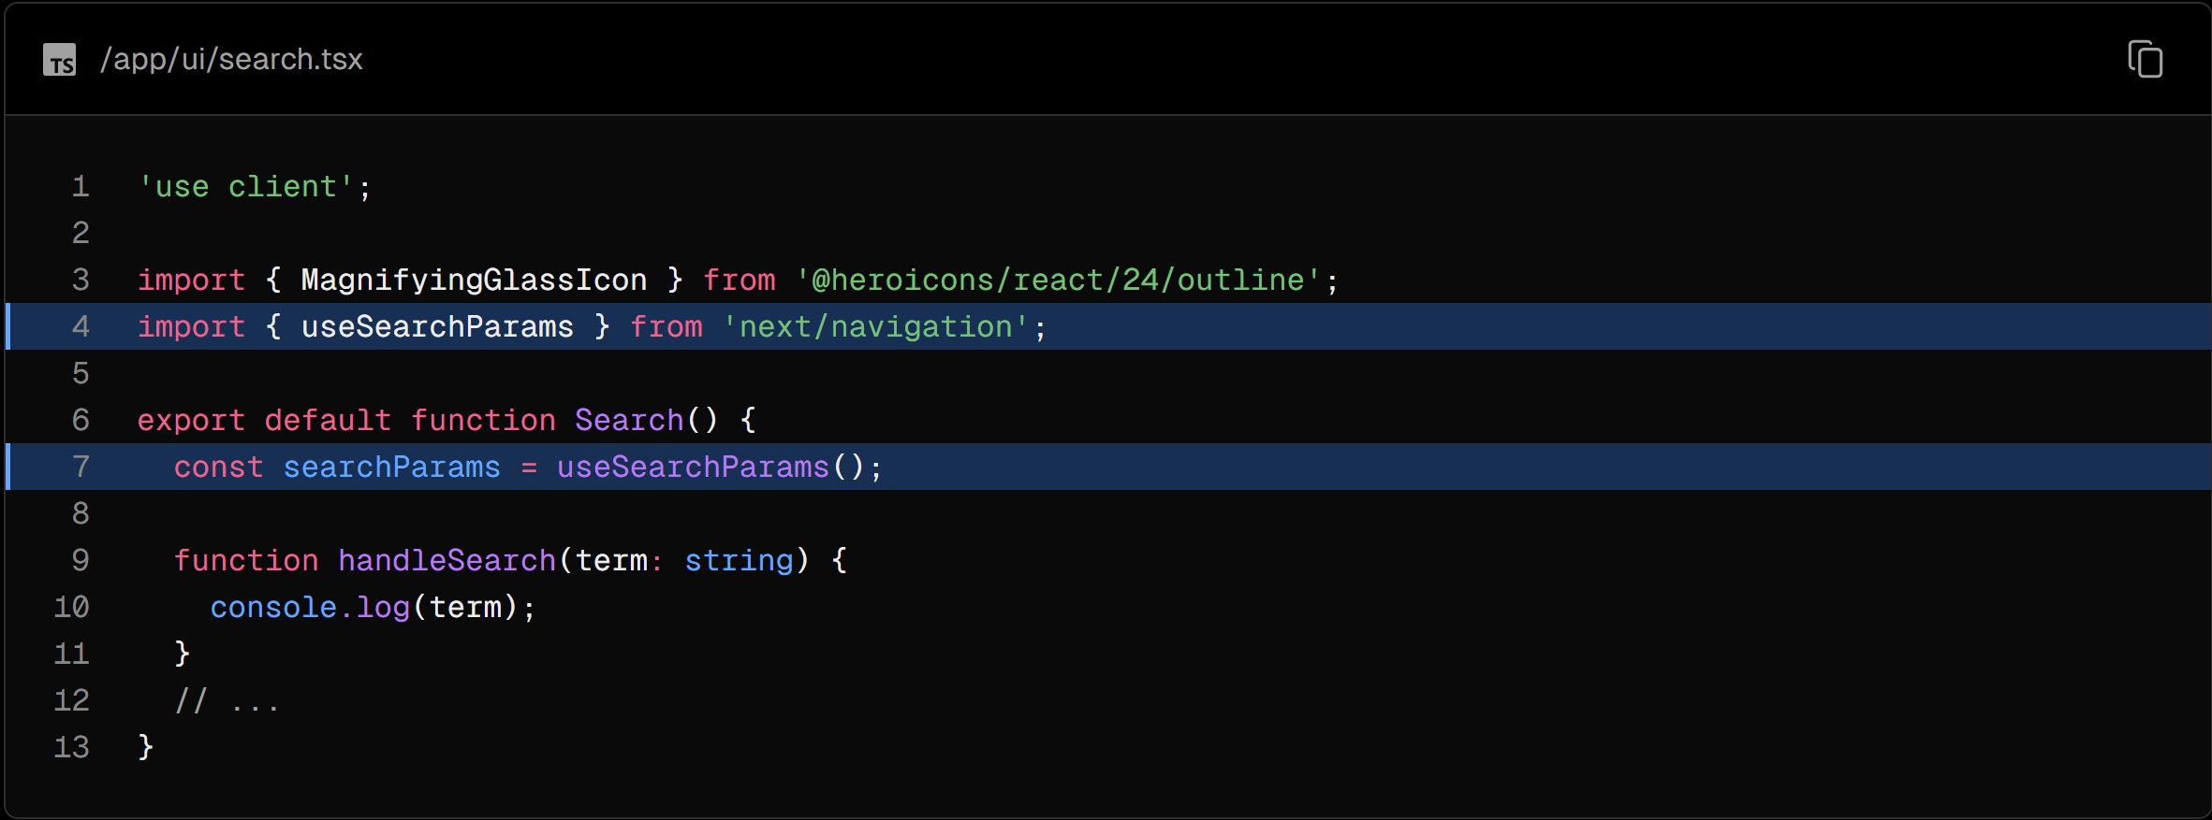

Inside handleSearch, create a new URLSearchParams instance using your new searchParams variable.

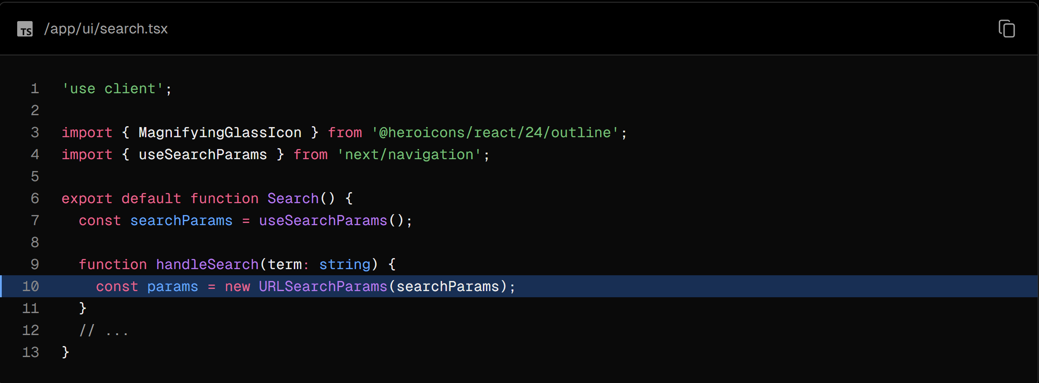

URLSearchParams is a Web API that provides utility methods for manipulating the URL query parameters. Instead of creating a complex string literal, you can use it to get the params string like ?page=1&query=a.

Next, set the params string based on the user’s input. If the input is empty, you want to delete it:

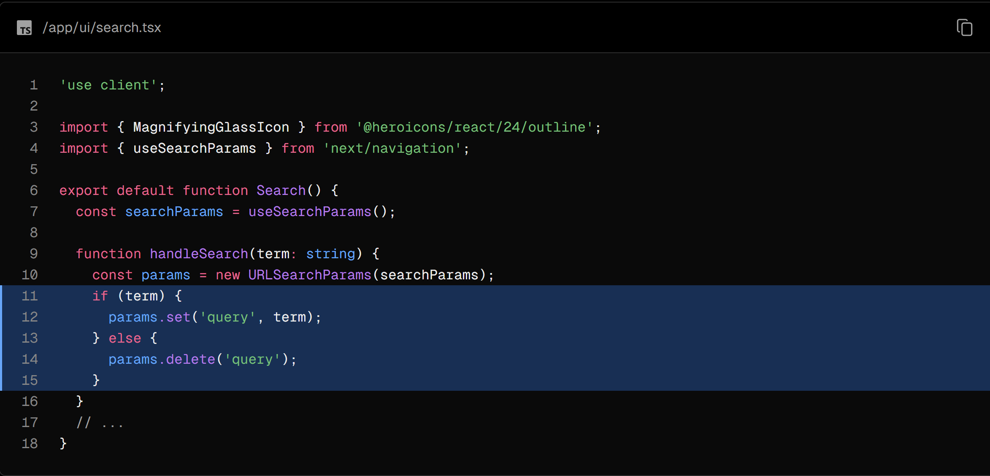

Now that you have the query string. You can use Next.js's useRouter and usePathname hooks to update the URL.

Import useRouter and usePathname from 'next/navigation', and use the replace method from useRouter() inside handleSearch:

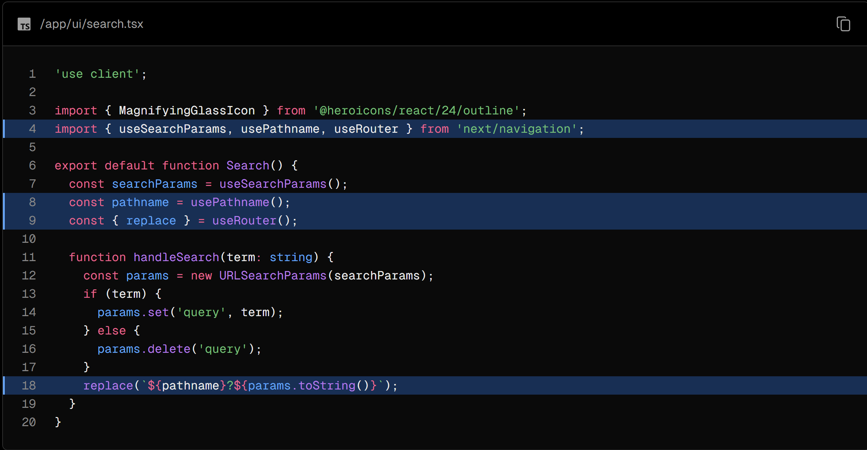

Here's a breakdown of what's happening:

* ${pathname} is the current path, in your case, "/dashboard/invoices".
* As the user types into the search bar, params.toString() translates this input into a URL-friendly format.
* replace(${pathname}?${params.toString()}) updates the URL with the user's search data. For example, /dashboard/invoices?query=lee if the user searches for "Lee".
* The URL is updated without reloading the page, thanks to Next.js's client-side navigation (which you learned about in the chapter on navigating between pages.

### 3. Keeping the URL and input in sync

To ensure the input field is in sync with the URL and will be populated when sharing, you can pass a defaultValue to input by reading from searchParams:

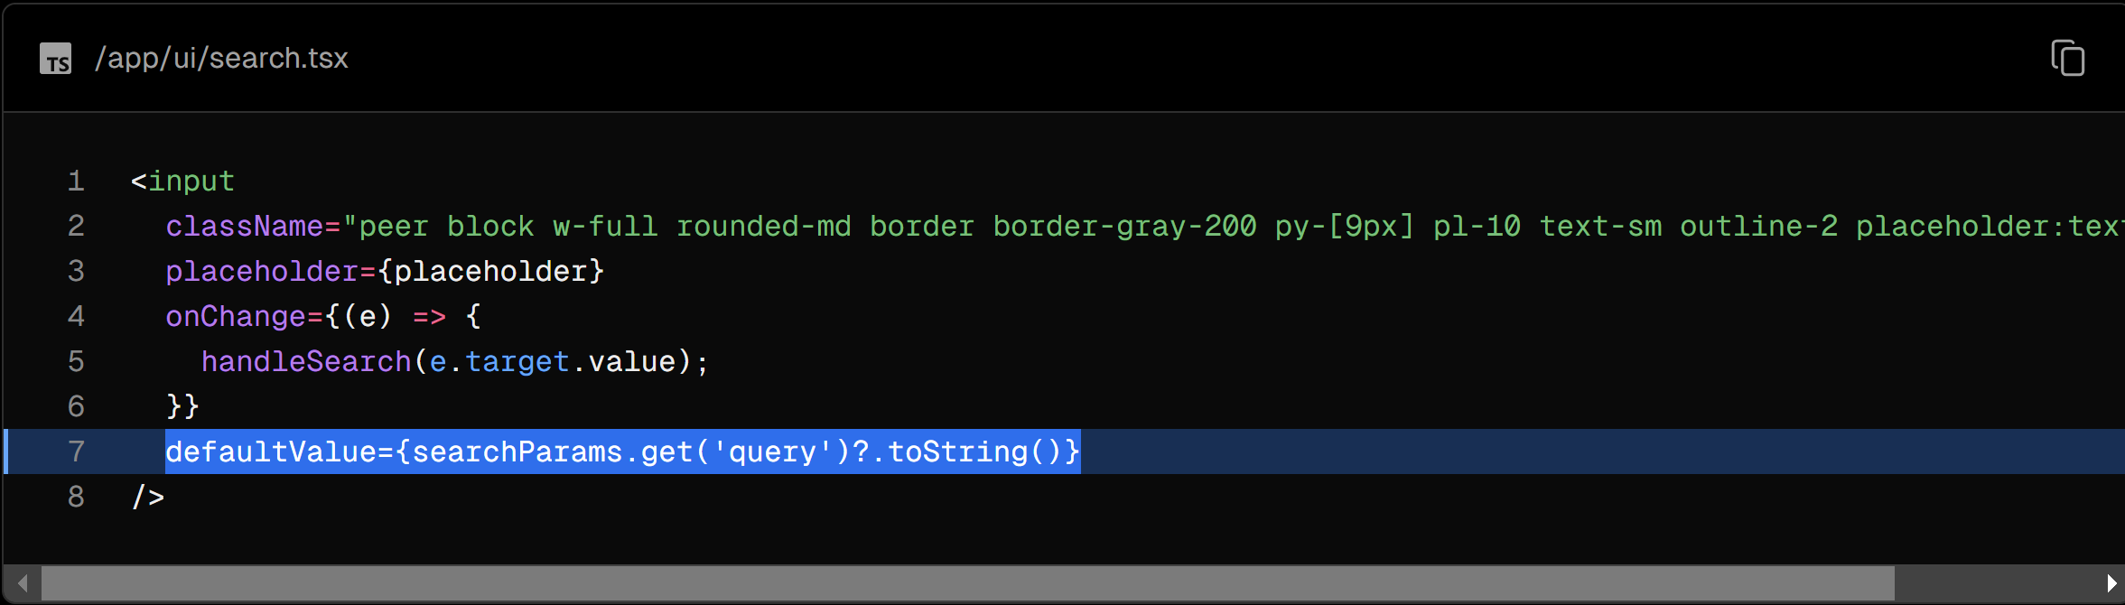

defaultValue vs. value / Controlled vs. Uncontrolled

If you're using state to manage the value of an input, you'd use the value attribute to make it a controlled component. This means React would manage the input's state.

However, since you're not using state, you can use defaultValue. This means the native input will manage its own state. This is okay since you're saving the search query to the URL instead of state.

### 4. Updating the table

Finally, you need to update the table component to reflect the search query.

Navigate back to the invoices page.

Page components accept a prop called searchParams, so you can pass the current URL params to the <Table> component.

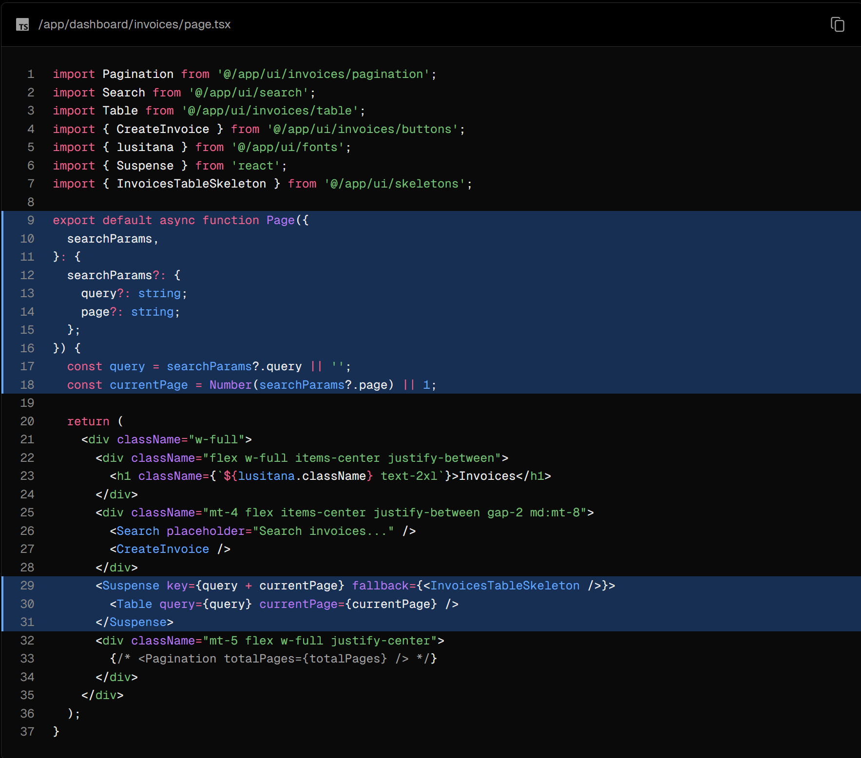

If you navigate to the <Table> Component, you'll see that the two props, query and currentPage, are passed to the fetchFilteredInvoices() function which returns the invoices that match the query.

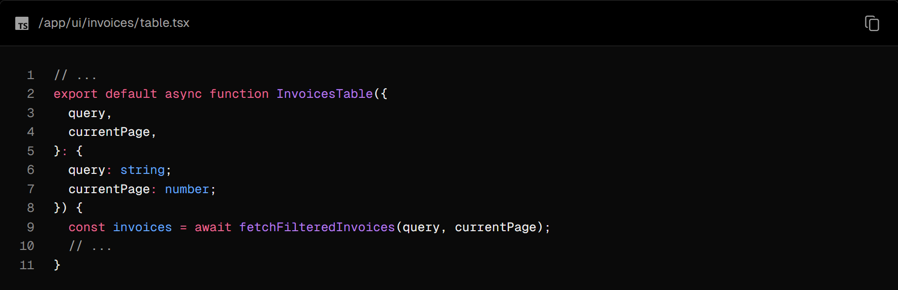

With these changes in place, go ahead and test it out. If you search for a term, you'll update the URL, which will send a new request to the server, data will be fetched on the server, and only the invoices that match your query will be returned.

When to use the useSearchParams() hook vs. the searchParams prop?

You might have noticed you used two different ways to extract search params. Whether you use one or the other depends on whether you're working on the client or the server.

<Search> is a Client Component, so you used the useSearchParams() hook to access the params from the client.

<Table> is a Server Component that fetches its own data, so you can pass the searchParams prop from the page to the component.

As a general rule, if you want to read the params from the client, use the useSearchParams() hook as this avoids having to go back to the server.

### Best practice: Debouncing

Congratulations! You've implemented search with Next.js! But there's something you can do to optimize it.

Inside your handleSearch function, add the following console.log:

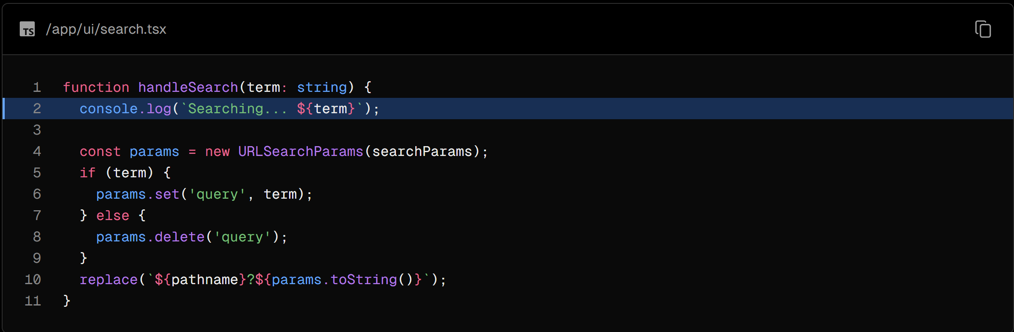

Then type "Emil" into your search bar and check the console in dev tools. What is happening?

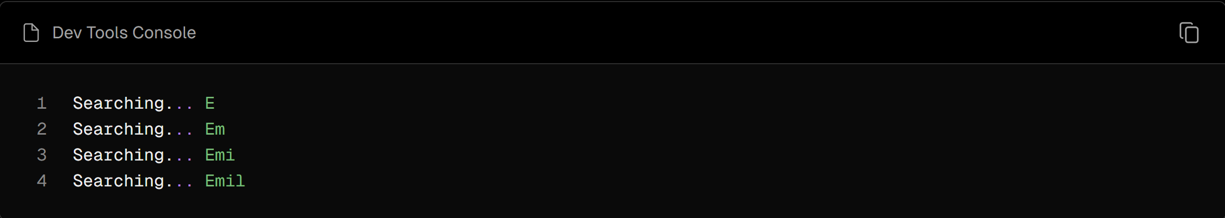

You're updating the URL on every keystroke, and therefore querying your database on every keystroke! This isn't a problem as our application is small, but imagine if your application had thousands of users, each sending a new request to your database on each keystroke.

Debouncing is a programming practice that limits the rate at which a function can fire. In our case, you only want to query the database when the user has stopped typing.

How Debouncing Works:

1. Trigger Event: When an event that should be debounced (like a keystroke in the search box) occurs, a timer starts.
2. Wait: If a new event occurs before the timer expires, the timer is reset.
3. Execution: If the timer reaches the end of its countdown, the debounced function is executed.

You can implement debouncing in a few ways, including manually creating your own debounce function. To keep things simple, we'll use a library called use-debounce.

Install use-debounce:

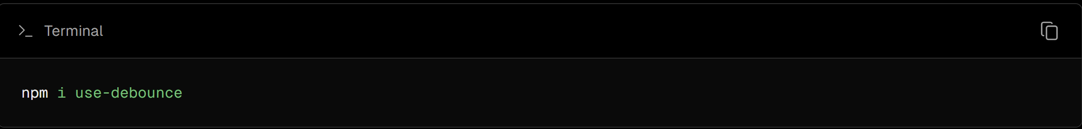

In your <Search> Component, import a function called useDebouncedCallback:

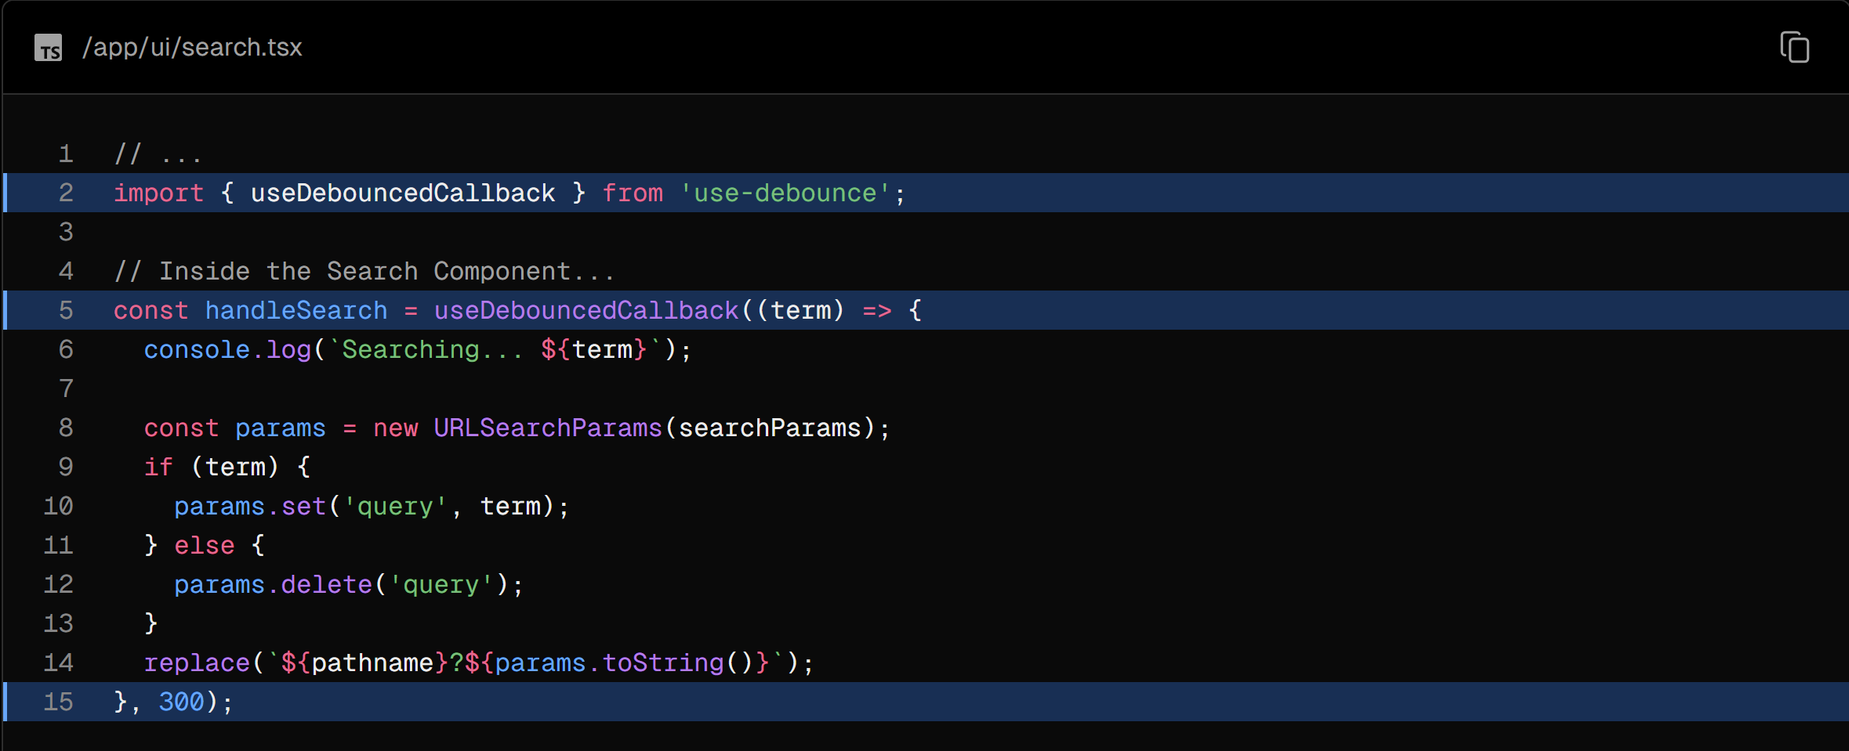

This function will wrap the contents of handleSearch, and only run the code after a specific time once the user has stopped typing (300ms).

Now type in your search bar again, and open the console in dev tools. You should see the following:

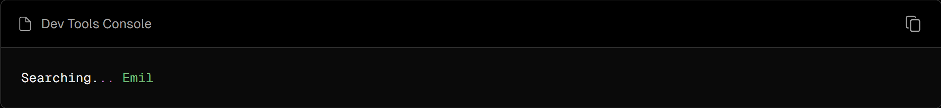

By debouncing, you can reduce the number of requests sent to your database, thus saving resources.

### Adding pagination

After introducing the search feature, you'll notice the table displays only 6 invoices at a time. This is because the fetchFilteredInvoices() function in data.ts returns a maximum of 6 invoices per page.

Adding pagination allows users to navigate through the different pages to view all the invoices. Let's see how you can implement pagination using URL params, just like you did with search.

Navigate to the <Pagination/> component and you'll notice that it's a Client Component. You don't want to fetch data on the client as this would expose your database secrets (remember, you're not using an API layer). Instead, you can fetch the data on the server, and pass it to the component as a prop.

In /dashboard/invoices/page.tsx, import a new function called fetchInvoicesPages and pass the query from searchParams as an argument:

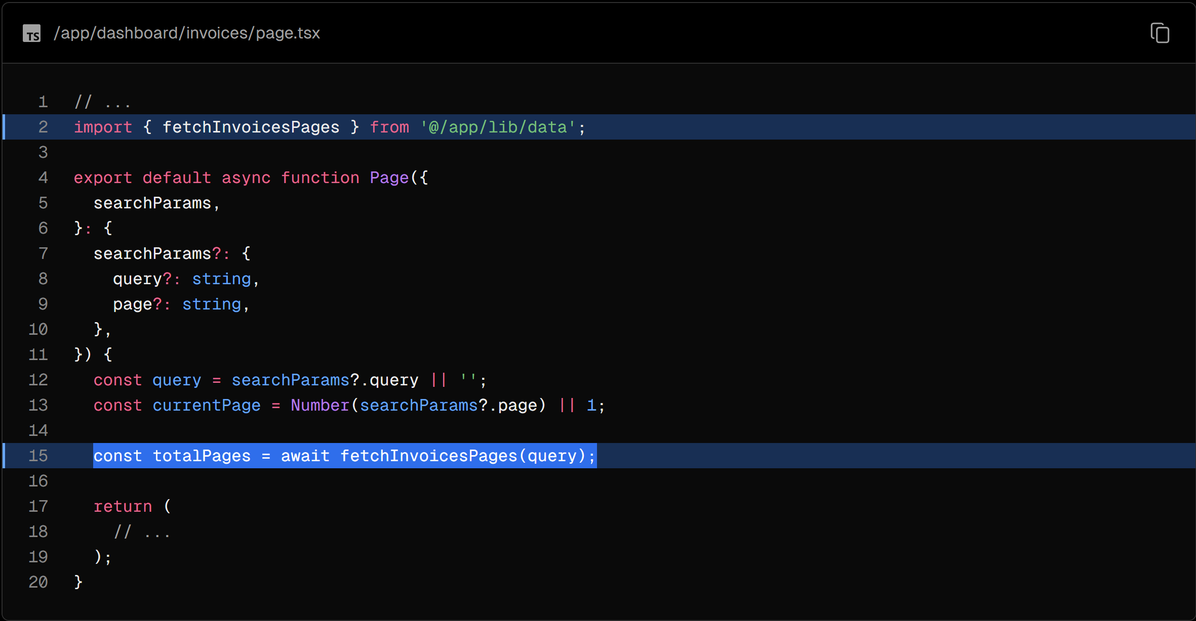

fetchInvoicesPages returns the total number of pages based on the search query. For example, if there are 12 invoices that match the search query, and each page displays 6 invoices, then the total number of pages would be 2.

Next, pass the totalPages prop to the <Pagination/> component:

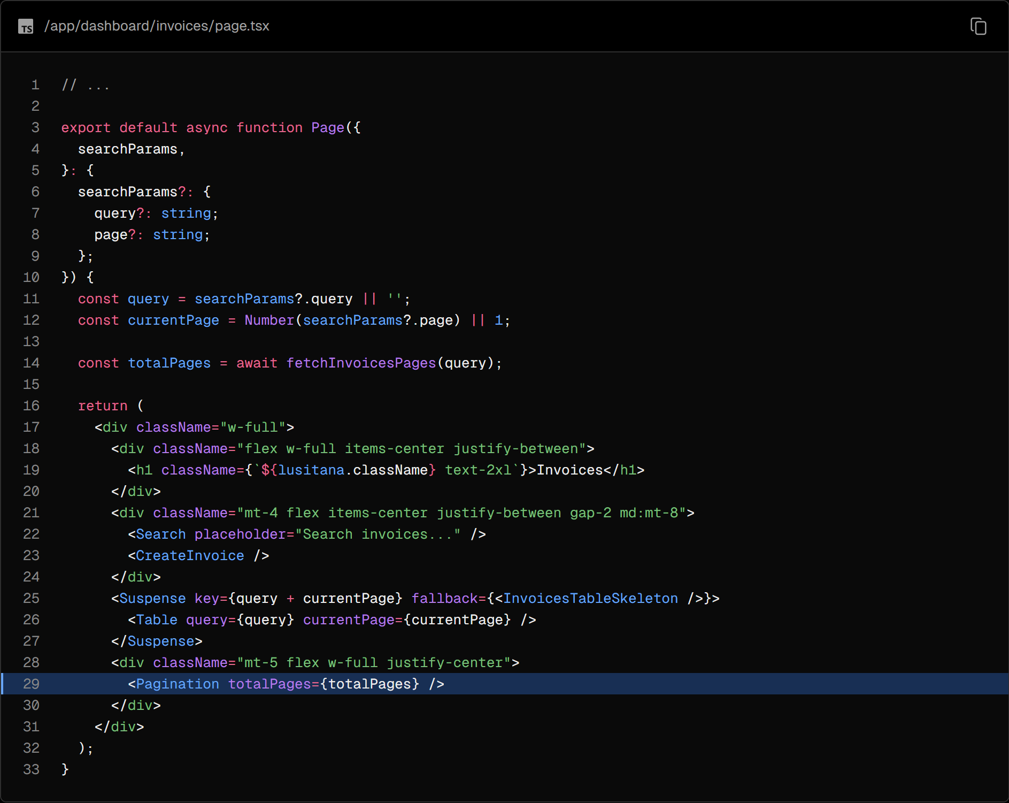

Navigate to the <Pagination/> component and import the usePathname and useSearchParams hooks. We will use this to get the current page and set the new page. Make sure to also uncomment the code in this component. Your application will break temporarily as you haven't implemented the <Pagination/> logic yet. Let's do that now!

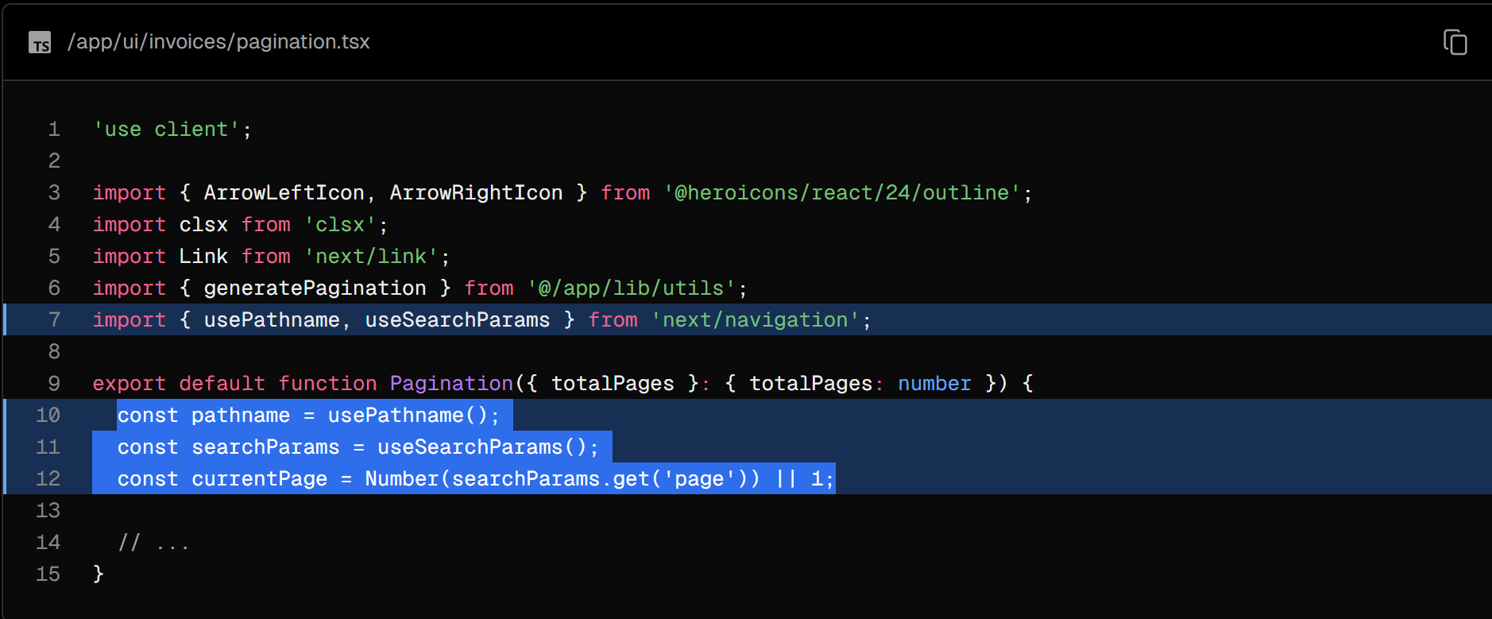

Next, create a new function inside the <Pagination> Component called createPageURL. Similarly to the search, you'll use URLSearchParams to set the new page number, and pathName to create the URL string.

Here's a breakdown of what's happening:

* createPageURL creates an instance of the current search parameters.
* Then, it updates the "page" parameter to the provided page number.
* Finally, it constructs the full URL using the pathname and updated search parameters.

The rest of the <Pagination> component deals with styling and different states (first, last, active, disabled, etc). We won't go into detail for this course, but feel free to look through the code to see where createPageURL is being called.

Finally, when the user types a new search query, you want to reset the page number to 1. You can do this by updating the handleSearch function in your <Search> component:

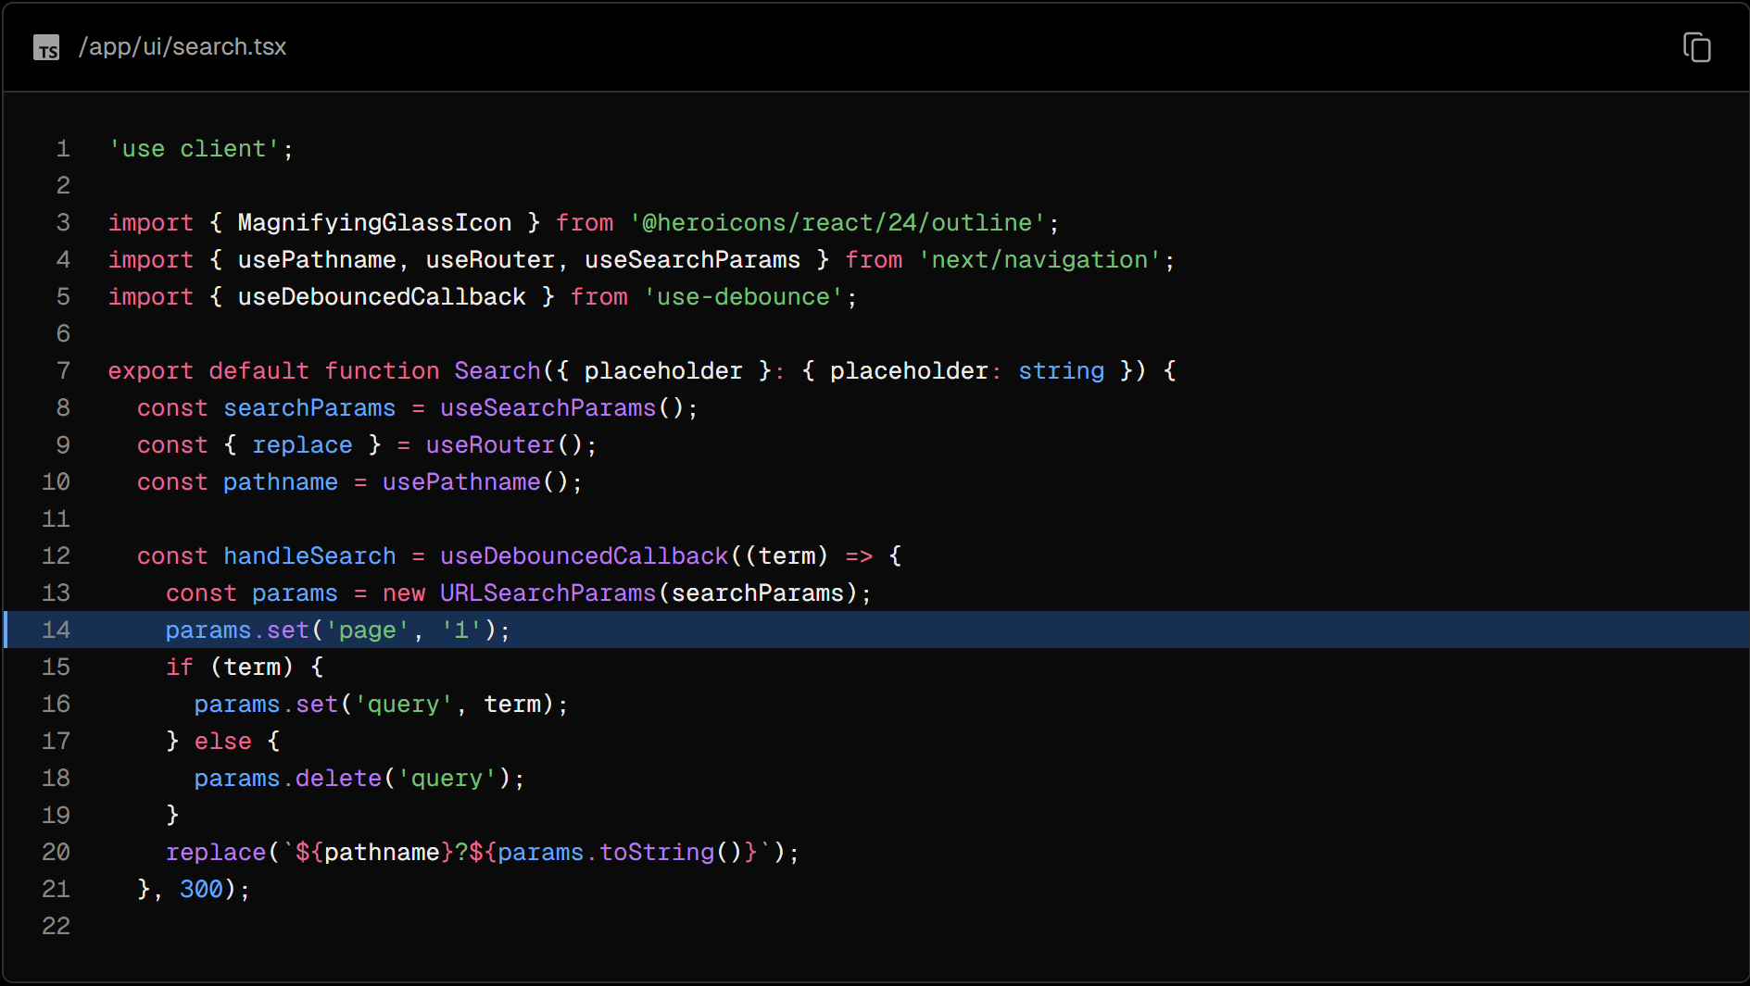

### Summary

Congratulations! You've just implemented search and pagination using URL Params and Next.js APIs.

To summarize, in this chapter:

* You've handled search and pagination with URL search parameters instead of client state.
* You've fetched data on the server.
* You're using the useRouter router hook for smoother, client-side transitions.

These patterns are different from what you may be used to when working with client-side React, but hopefully, you now better understand the benefits of using URL search params and lifting this state to the server.

## Chapter 12- Mutating Data

In the previous chapter, you implemented search and pagination using URL Search Params and Next.js APIs. Let's continue working on the Invoices page by adding the ability to create, update, and delete invoices!

In this chapter...

Here are the topics we’ll cover

* What React Server Actions are and how to use them to mutate data.
* How to work with forms and Server Components.
* Best practices for working with the native formData object, including type validation.
* How to revalidate the client cache using the revalidatePath API.
* How to create dynamic route segments with specific IDs.
* How to use the React’s useFormStatus hook for optimistic updates.

### What are Server Actions?

React Server Actions allow you to run asynchronous code directly on the server. They eliminate the need to create API endpoints to mutate your data. Instead, you write asynchronous functions that execute on the server and can be invoked from your Client or Server Components.

Security is a top priority for web applications, as they can be vulnerable to various threats. This is where Server Actions come in. They offer an effective security solution, protecting against different types of attacks, securing your data, and ensuring authorized access. Server Actions achieve this through techniques like POST requests, encrypted closures, strict input checks, error message hashing, and host restrictions, all working together to significantly enhance your app's safety.

### Using forms with Server Actions

In React, you can use the action attribute in the <form> element to invoke actions. The action will automatically receive the native FormData object, containing the captured data.

For example:

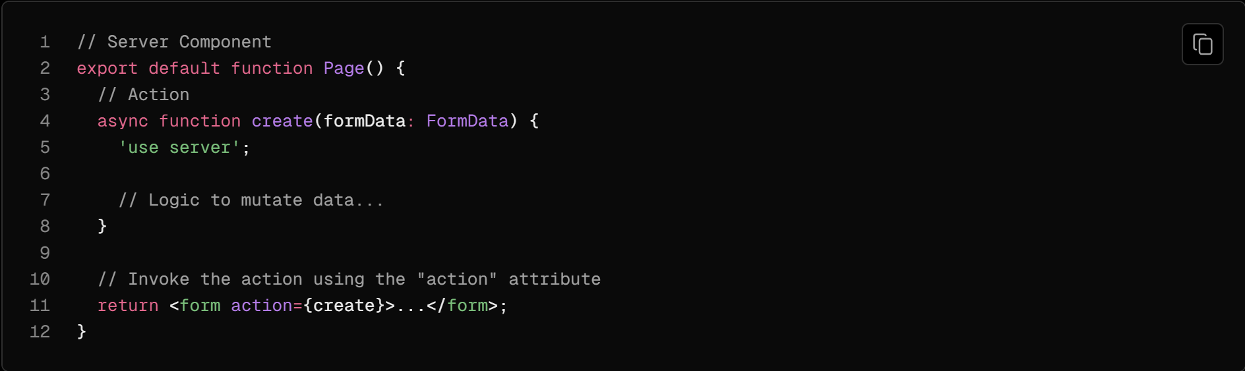

An advantage of invoking a Server Action within a Server Component is progressive enhancement - forms work even if JavaScript is disabled on the client.

### Next.js with Server Actions

Server Actions are also deeply integrated with Next.js caching. When a form is submitted through a Server Action, not only can you use the action to mutate data, but you can also revalidate the associated cache using APIs like revalidatePath and revalidateTag.

Let's see how it all works together!

### Creating an invoice

Here are the steps you'll take to create a new invoice:

1. Create a form to capture the user's input.
2. Create a Server Action and invoke it from the form.
3. Inside your Server Action, extract the data from the formData object.
4. Validate and prepare the data to be inserted into your database.
5. Insert the data and handle any errors.
6. Revalidate the cache and redirect the user back to invoices page.

### 1. Create a new route and form

To start, inside the /invoices folder, add a new route segment called /create with a page.tsx file:



You'll be using this route to create new invoices. Inside your page.tsx file, paste the following code, then spend some time studying it:

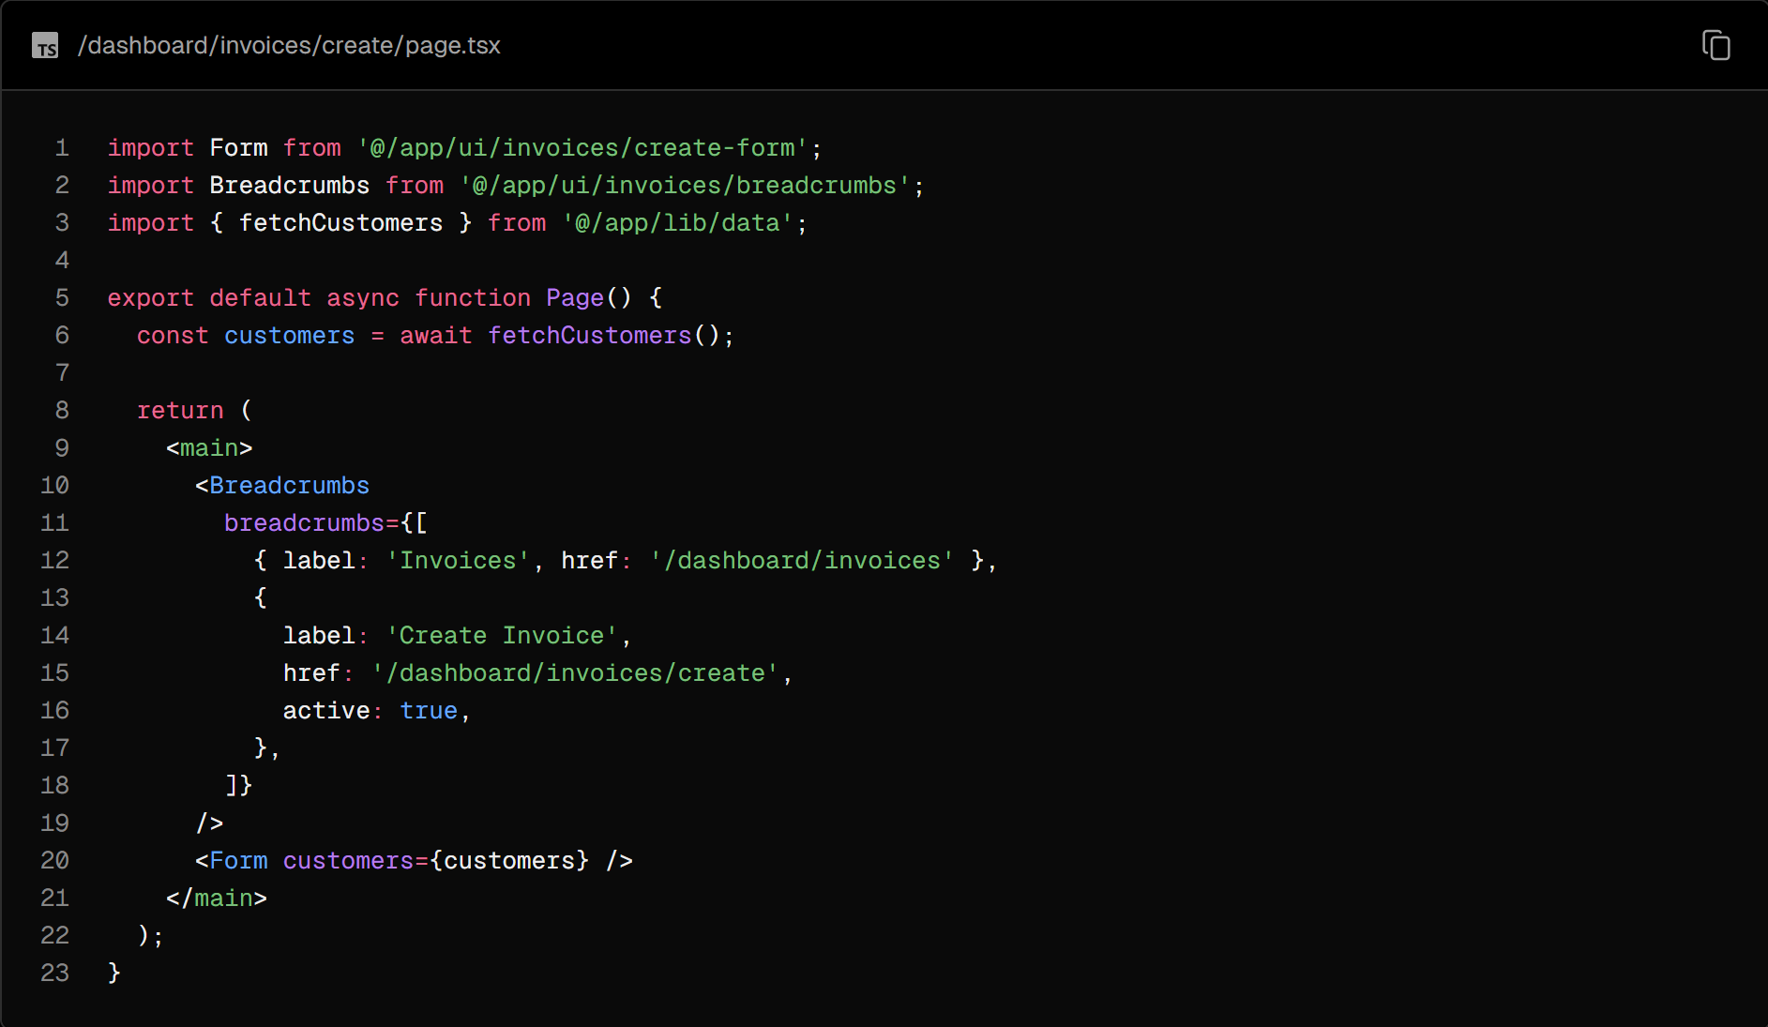

Your page is a Server Component that fetches customers and passes it to the <Form> component. To save time, we've already created the <Form> component for you.

Navigate to the <Form> component, and you'll see that the form:

* Has one <select> (dropdown) element with a list of customers.
* Has one <input> element for the amount with type="number".
* Has two <input> elements for the status with type="radio".
* Has one button with type="submit".

On http://localhost:3000/dashboard/invoices/create, you should see the following UI:

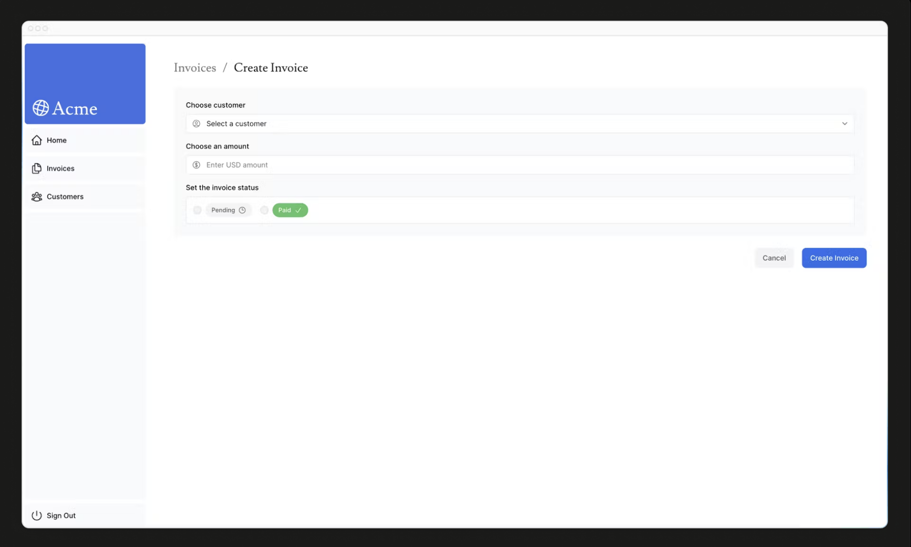

### 2. Create a Server Action

Great, now let's create a Server Action that is going to be called when the form is submitted.

Navigate to your lib directory and create a new file named actions.ts. At the top of this file, add the React use server directive:

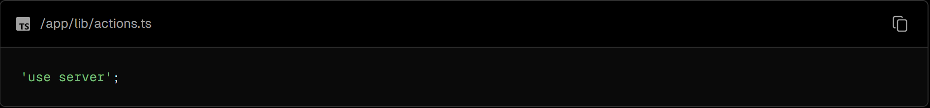

By adding the 'use server', you mark all the exported functions within the file as server functions. These server functions can then be imported into Client and Server components, making them extremely versatile.

You can also write Server Actions directly inside Server Components by adding "use server" inside the action. But for this course, we'll keep them all organized in a separate file.

In your actions.ts file, create a new async function that accepts formData:

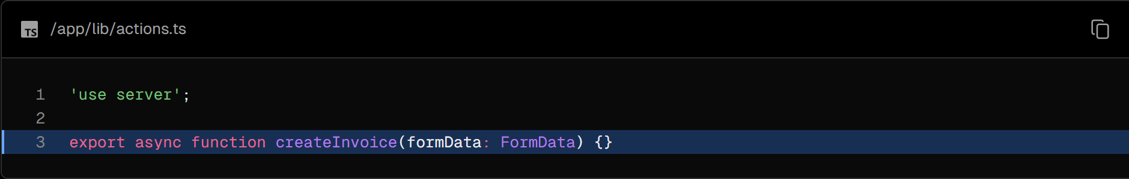

Then, in your <Form> component, import the createInvoice from your actions.ts file. Add a action attribute to the <form> element, and call the createInvoice action.

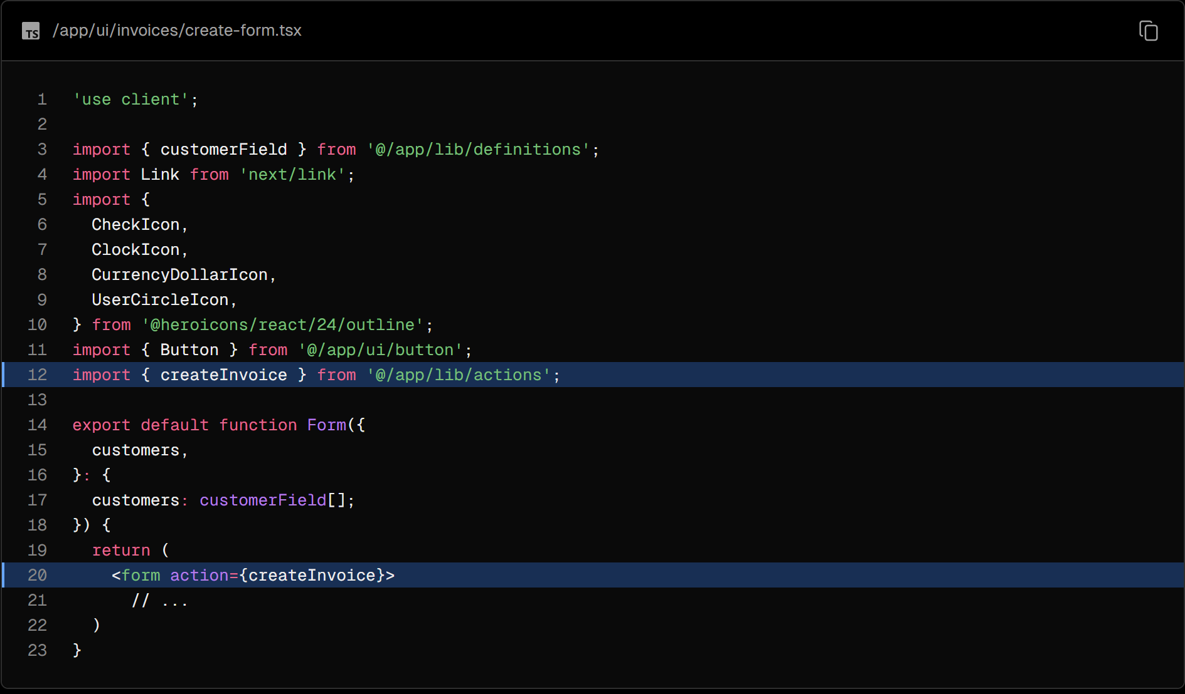

Good to know: In HTML, you'd pass a URL to the action attribute. This URL would be the destination where your form data should be submitted (usually an API endpoint).

However, in React, the action attribute is considered a special prop - meaning React builds on top of it to allow actions to be invoked.

Behind the scenes, Server Actions create a POST API endpoint. This is why you don't need to create API endpoints manually when using Server Actions.

### 3. Extract the data from formData

Back in your actions.ts file, you'll need to extract the values of formData, there are a couple of methods you can use. For this example, let's use the .get(name) method.

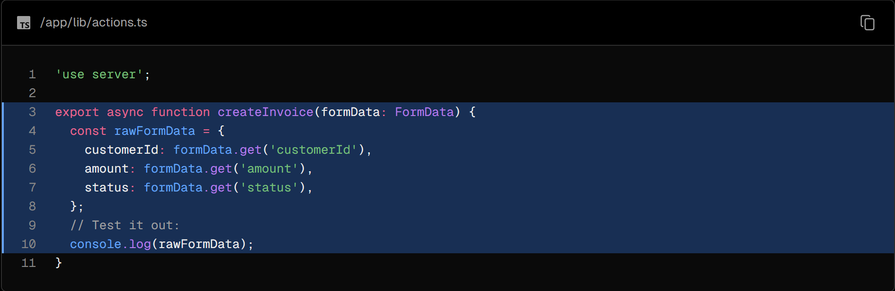

Tip: If you're working with forms that have many fields, you may want to consider using the entries() method with JavaScript's Object.fromEntries(). For example:

const rawFormData = Object.fromEntries(formData.entries())

To check everything is connected correctly, go ahead and try out the form. After submitting, you should see the data you just entered into the form logged in your terminal.

Now that your data is in the shape of an object, it'll be much easier to work with.

### 4. Validate and prepare the data

Before sending the form data to your database, you want to ensure it's in the correct format and with the correct types. If you remember from earlier in the course, your invoices table expects data in the following format:

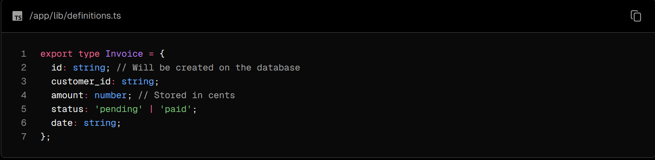

So far, you only have the customer_id, amount, and status from the form.

Type validation and coercion

It's important to validate that the data from your form aligns with the expected types in your database. For instance, if you add a console.log inside your action:



You'll notice that amount is of type string and not number. This is because input elements with type="number" actually return a string, not a number!

To handle type validation, you have a few options. While you can manually validate types, using a type validation library can save you time and effort. For your example, we'll use Zod, a TypeScript-first validation library that can simplify this task for you.

In your actions.ts file, import Zod and define a schema that matches the shape of your form object. This schema will validate the formData before saving it to a database.

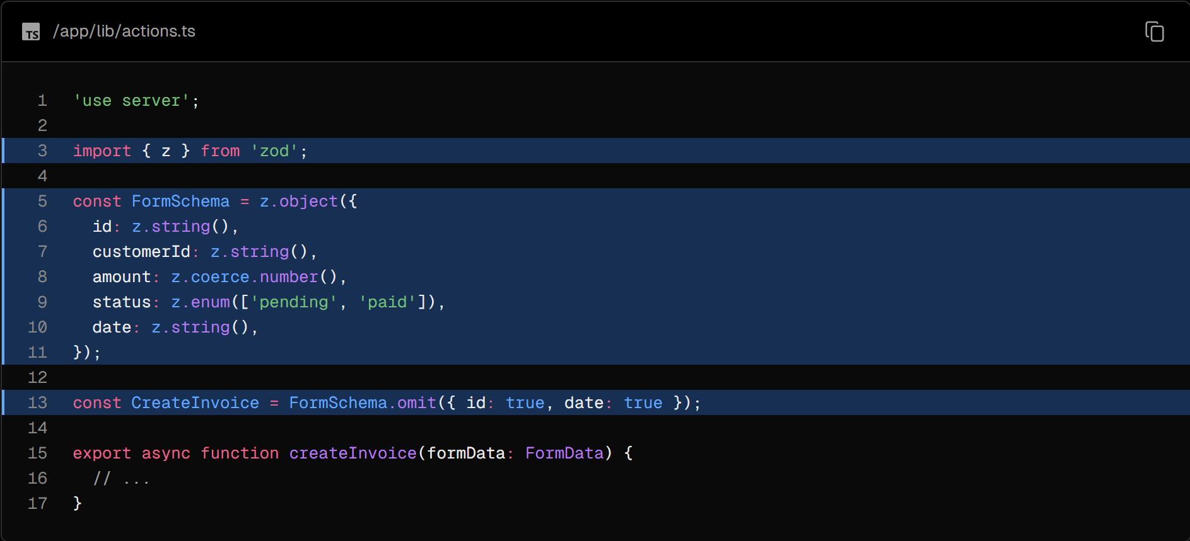

The amount field is specifically set to coerce (change) from a string to a number while also validating its type.

You can then pass your rawFormData to CreateInvoice to validate the types:

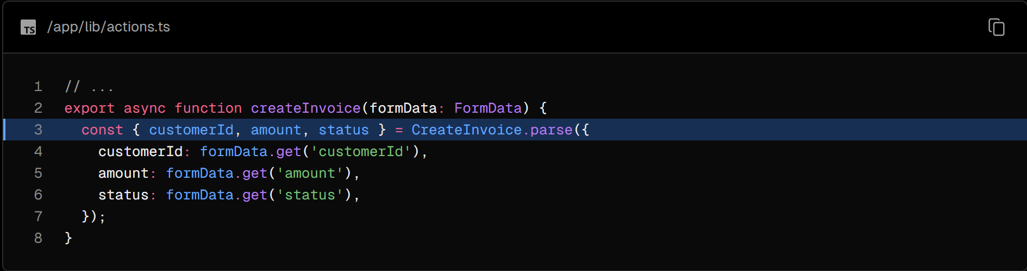

Storing values in cents

It's usually good practice to store monetary values in cents in your database to eliminate JavaScript floating-point errors and ensure greater accuracy.

Let's convert the amount into cents:

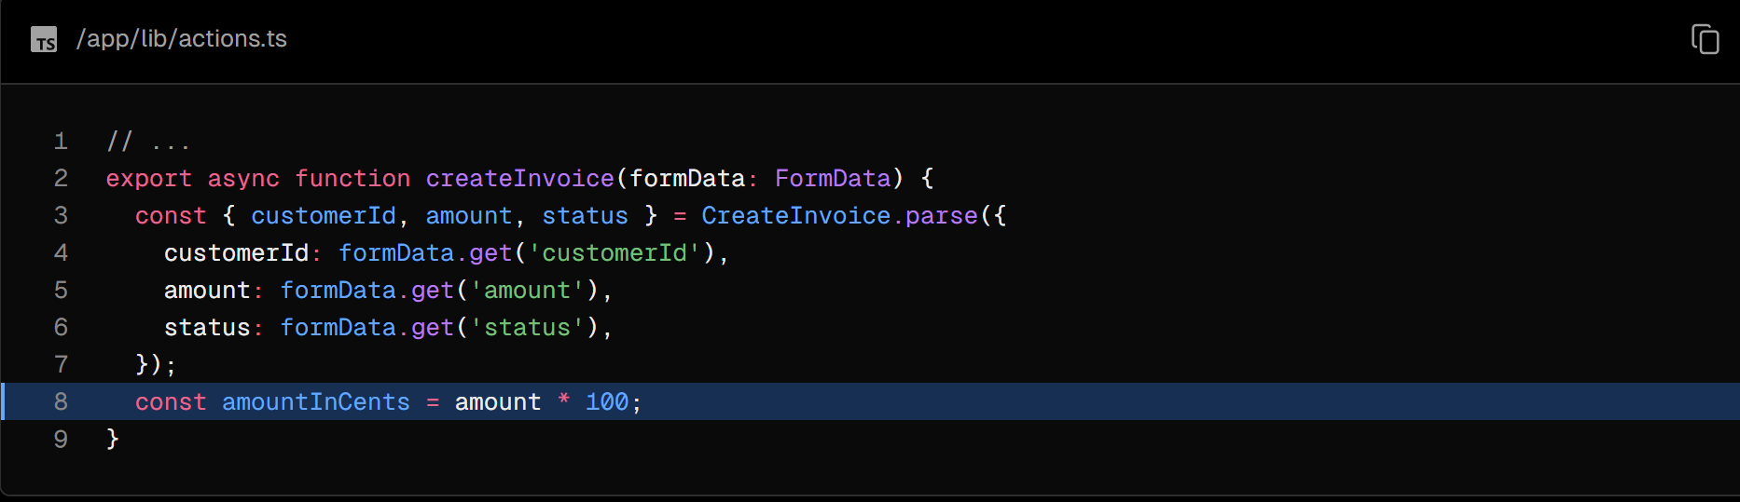

Creating new dates

Finally, let's create a new date with the format "YYYY-MM-DD" for the invoice's creation date:

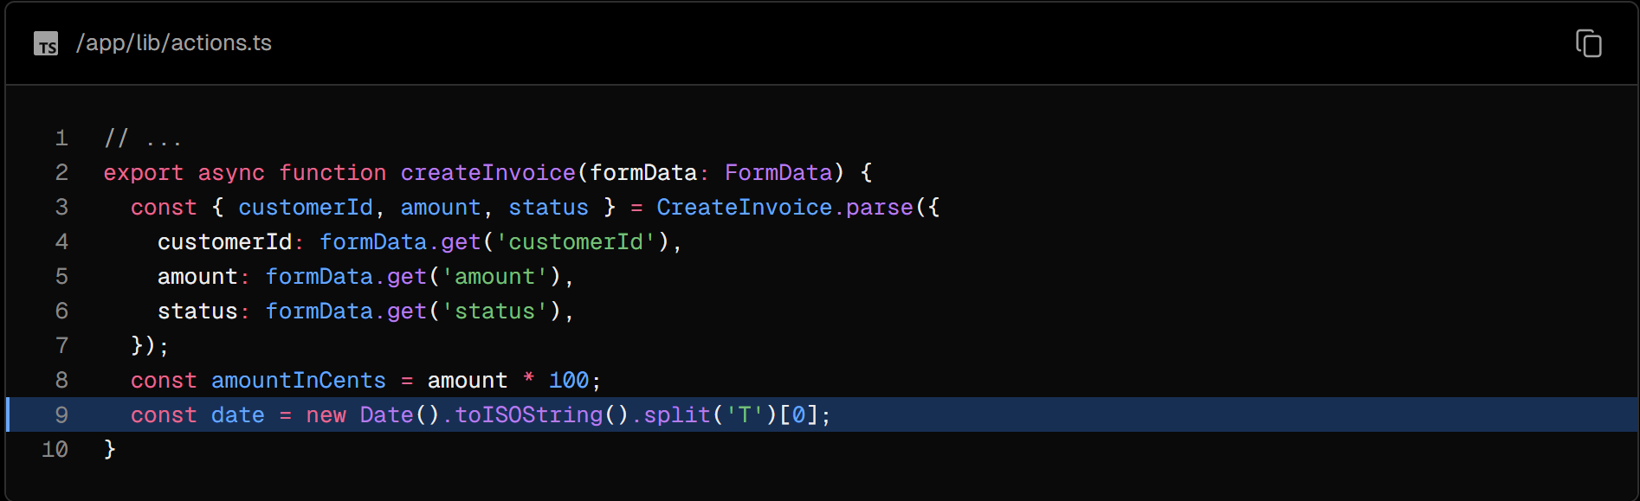

### 5. Inserting the data into your database

Now that you have all the values you need for your database, you can create an SQL query to insert the new invoice into your database and pass in the variables:

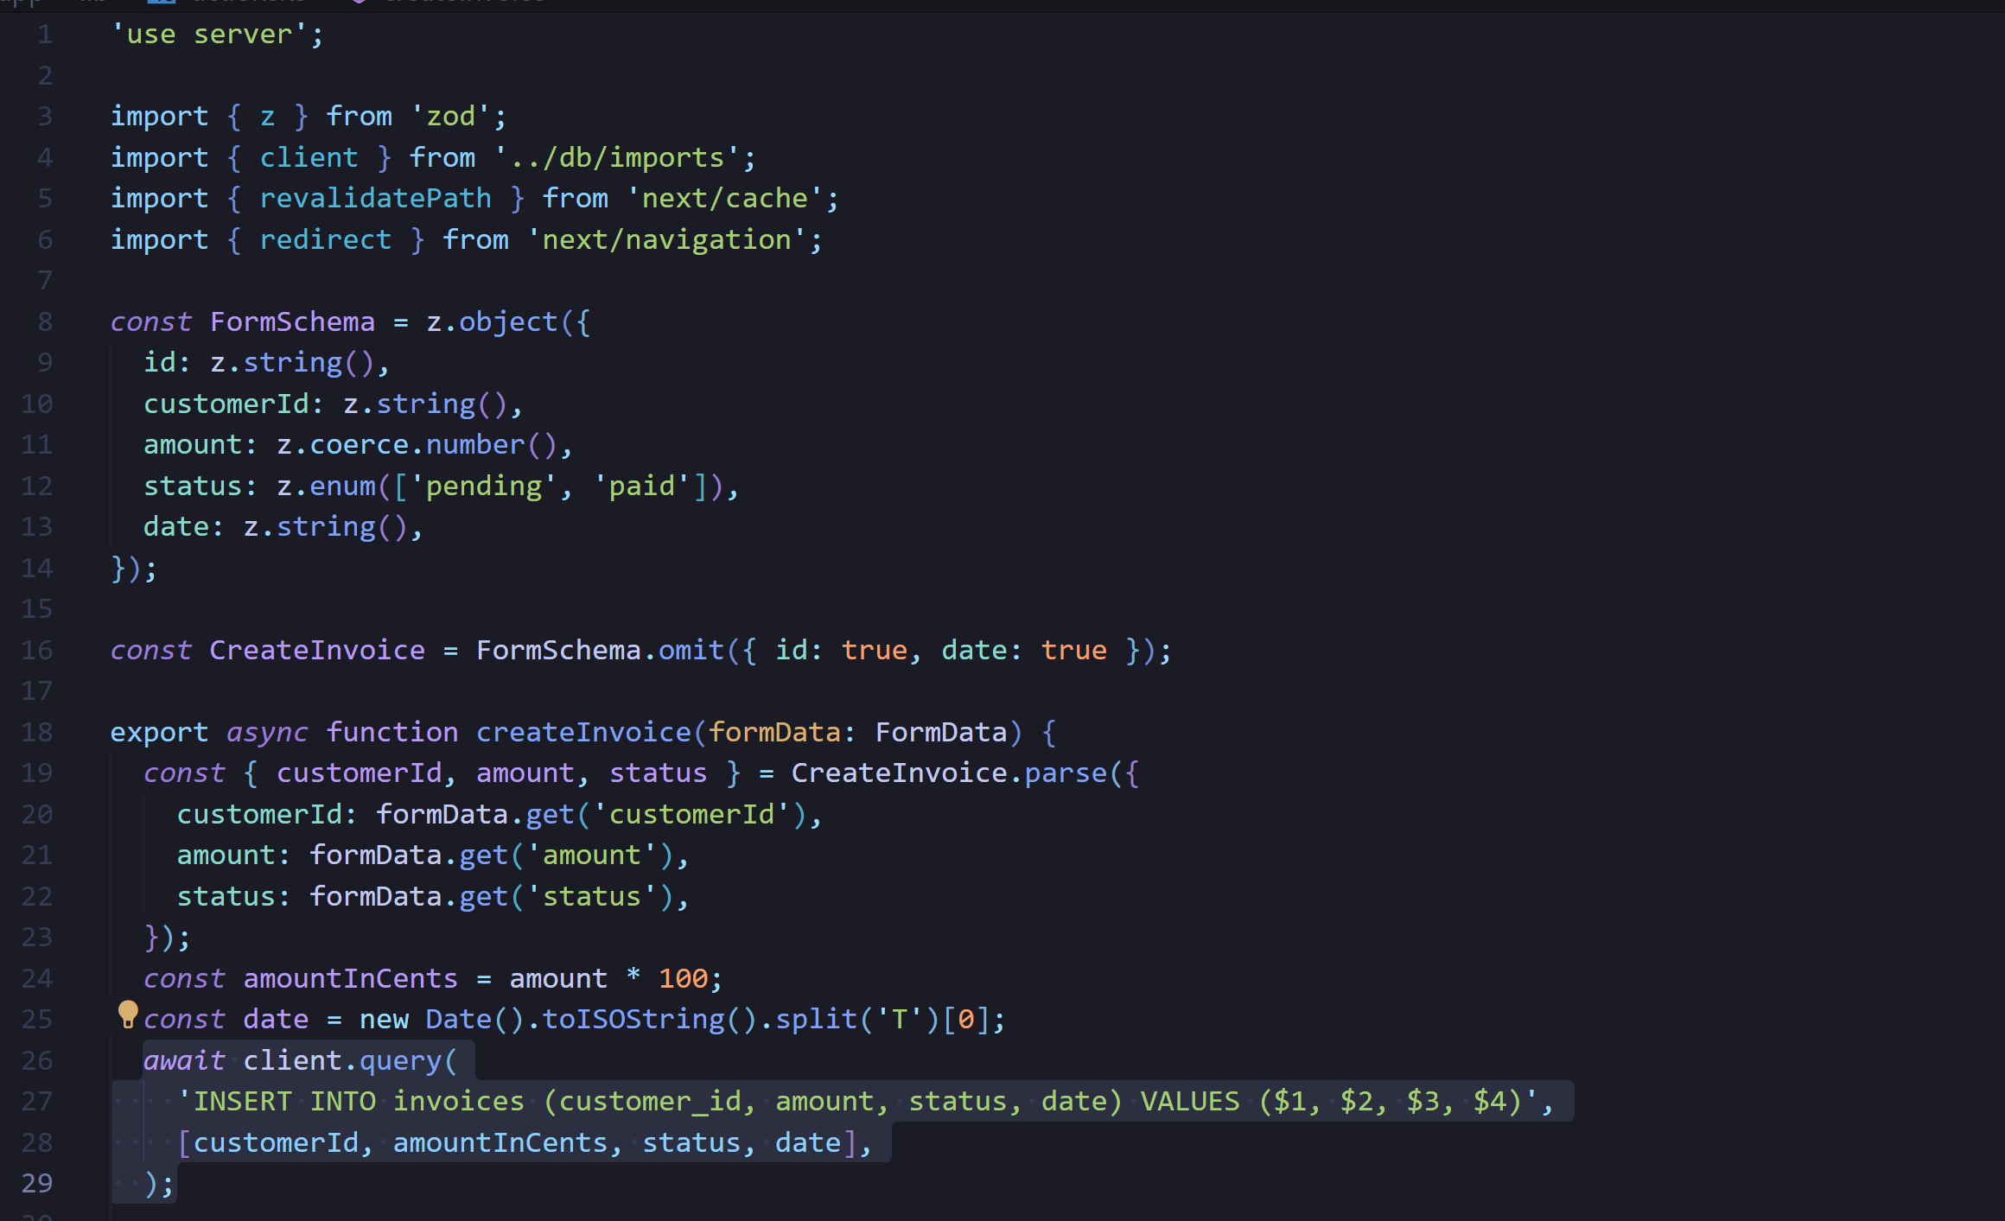

Right now, we're not handling any errors. We'll do it in the next chapter. For now, let's move on to the next step.

### 6. Revalidate and redirect

Next.js has a Client-side Router Cache that stores the route segments in the user's browser for a time. Along with prefetching, this cache ensures that users can quickly navigate between routes while reducing the number of requests made to the server.

Since you're updating the data displayed in the invoices route, you want to clear this cache and trigger a new request to the server. You can do this with the revalidatePath function from Next.js:

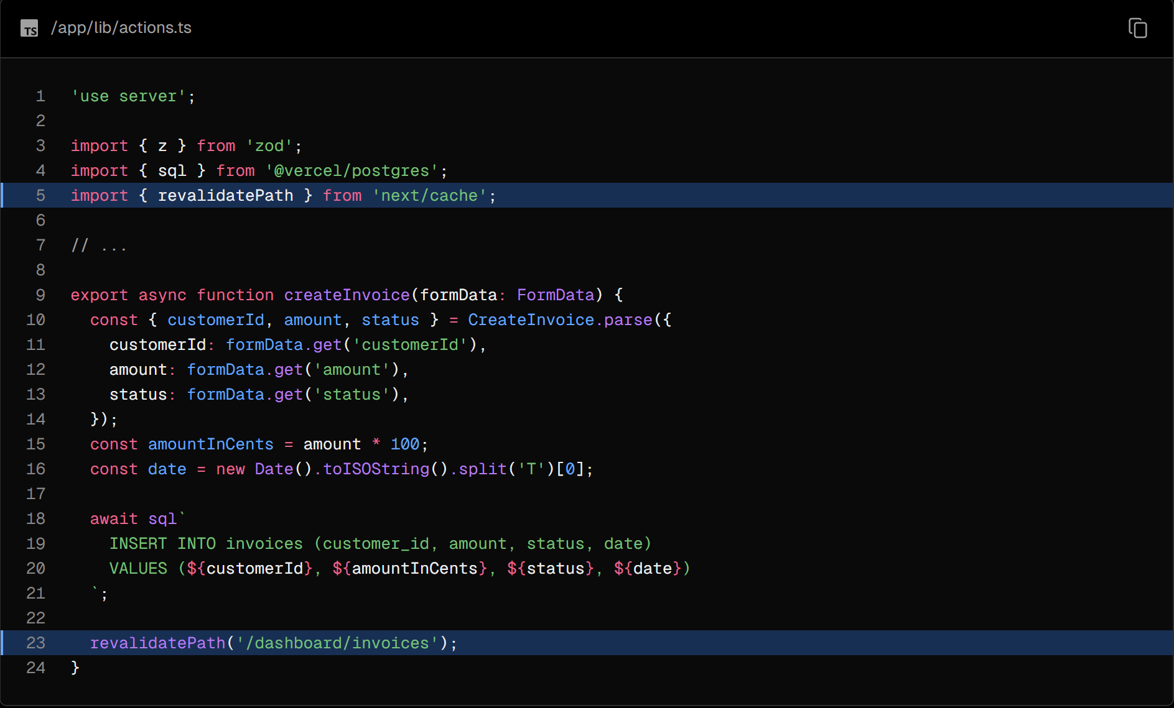

Once the database has been updated, the /dashboard/invoices path will be revalidated, and fresh data will be fetched from the server.

At this point, you also want to redirect the user back to the /dashboard/invoices page. You can do this with the redirect function from Next.js:

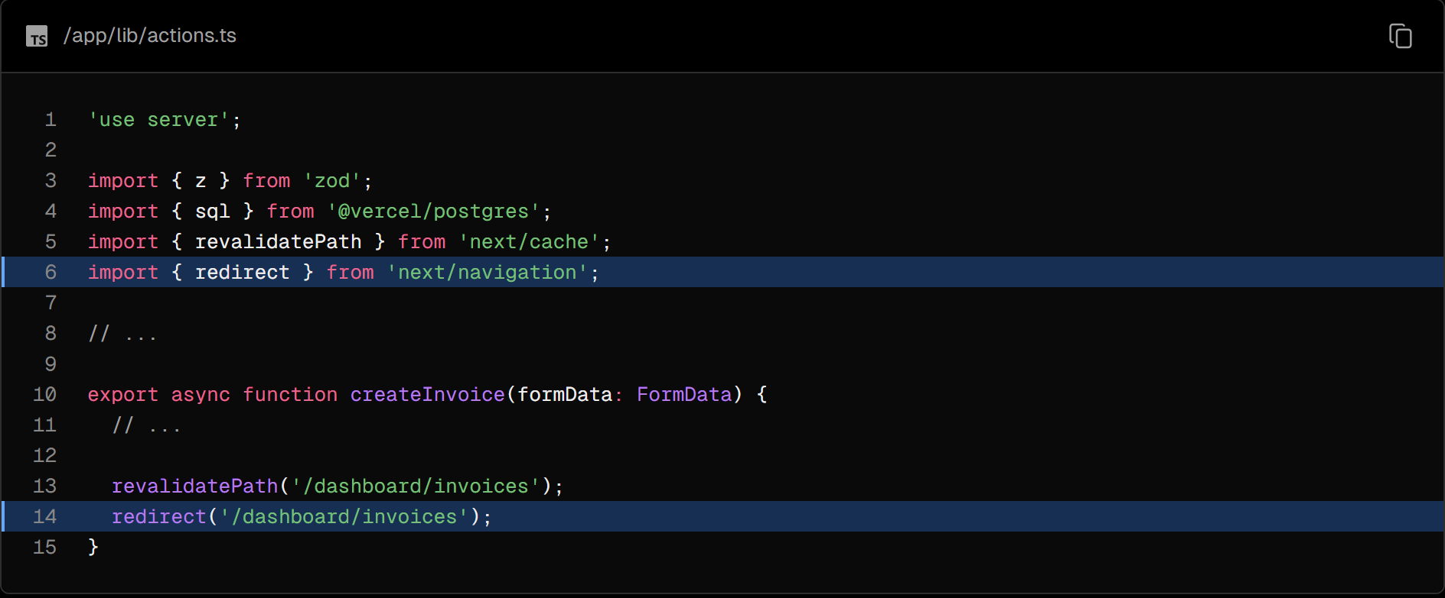

Congratulations! You've just implemented your first Server Action. Test it out by adding a new invoice, if everything is working correctly:

1. You should be redirected to the /dashboard/invoices route on submission.
2. You should see the new invoice at the top of the table.

### Updating an invoice

The updating invoice form is similar to the create an invoice form, except you'll need to pass the invoice id to update the record in your database. Let's see how you can get and pass the invoice id.

These are the steps you'll take to update an invoice:

1. Create a new dynamic route segment with the invoice id.
2. Read the invoice id from the page params.
3. Fetch the specific invoice from your database.
4. Pre-populate the form with the invoice data.
5. Update the invoice data in your database.

### 1. Create a Dynamic Route Segment with the invoice id

Next.js allows you to create Dynamic Route Segments when you don't know the exact segment name and want to create routes based on data. This could be blog post titles, product pages, etc. You can create dynamic route segments by wrapping a folder's name in square brackets. For example, [id], [post] or [slug].

In your /invoices folder, create a new dynamic route called [id], then a new route called edit with a page.tsx file. Your file structure should look like this:



In your <Table> component, notice there's a <UpdateInvoice /> button that receives the invoice's id from the table records.

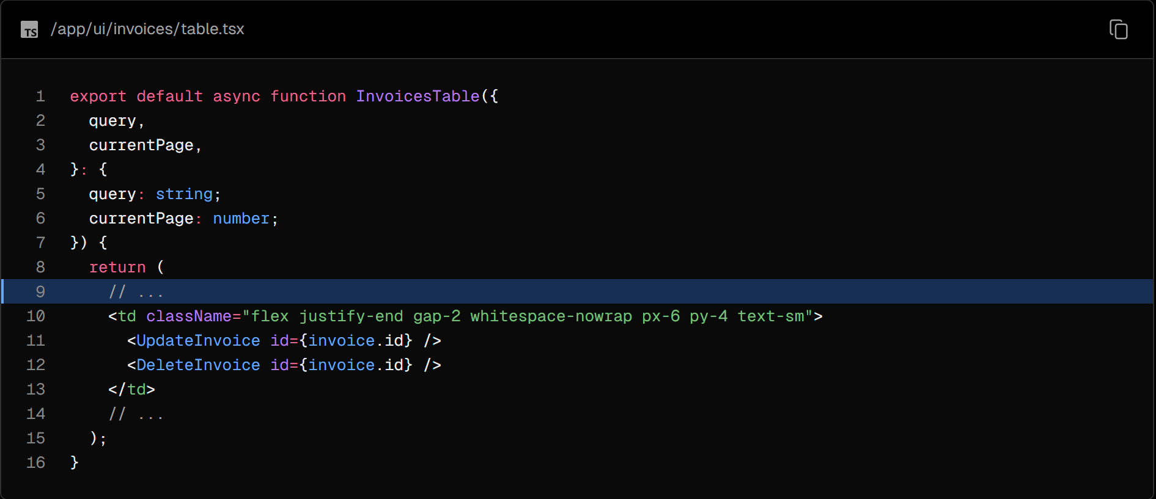

Navigate to your <UpdateInvoice /> component, and update the href of the Link to accept the id prop. You can use template literals to link to a dynamic route segment:

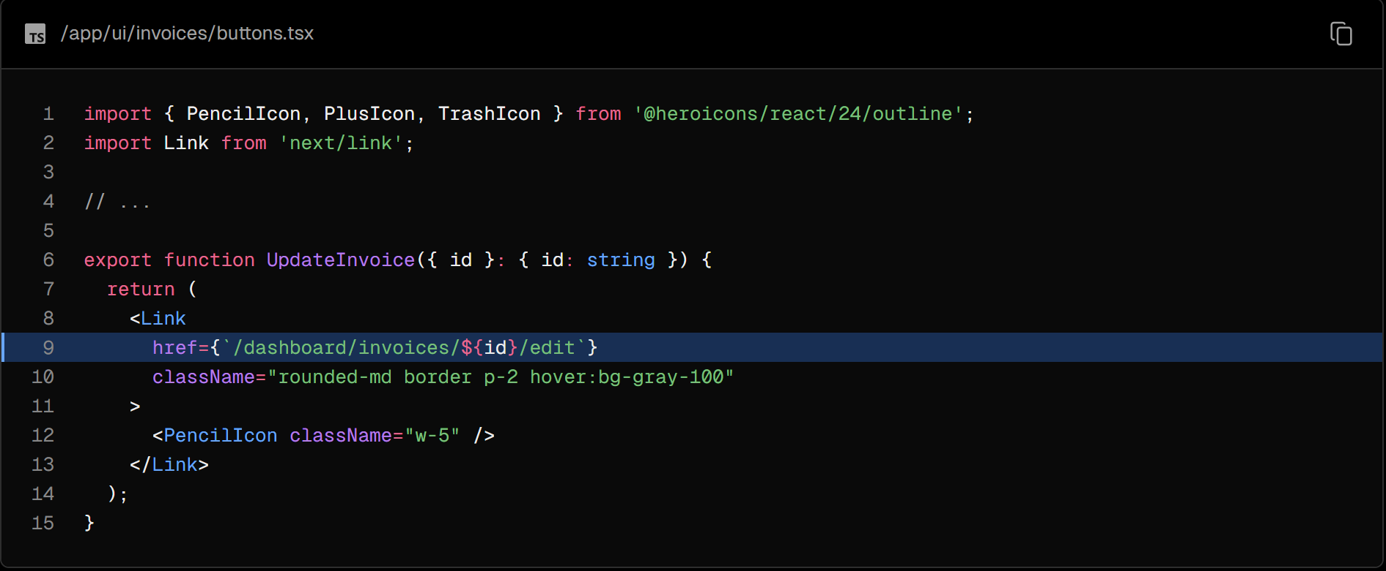

### 2. Read the invoice id from page params

Back on your <Page> component, paste the following code:

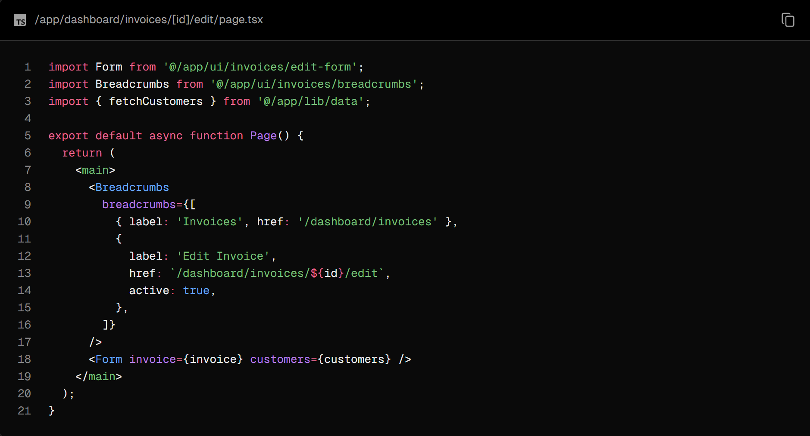

Notice how it's similar to your /create invoice page, except it imports a different form (from the edit-form.tsx file). This form should be pre-populated with a defaultValue for the customer's name, invoice amount, and status. To pre-populate the form fields, you need to fetch the specific invoice using id.

In addition to searchParams, page components also accept a prop called params which you can use to access the id. Update your <Page> component to receive the prop:

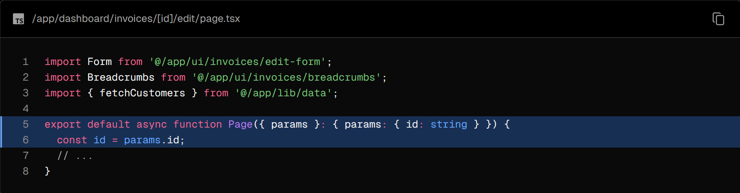

### 3. Fetch the specific invoice

Then:

* Import a new function called fetchInvoiceById and pass the id as an argument.
* Import fetchCustomers to fetch the customer names for the dropdown.

You can use Promise.all to fetch both the invoice and customers in parallel:

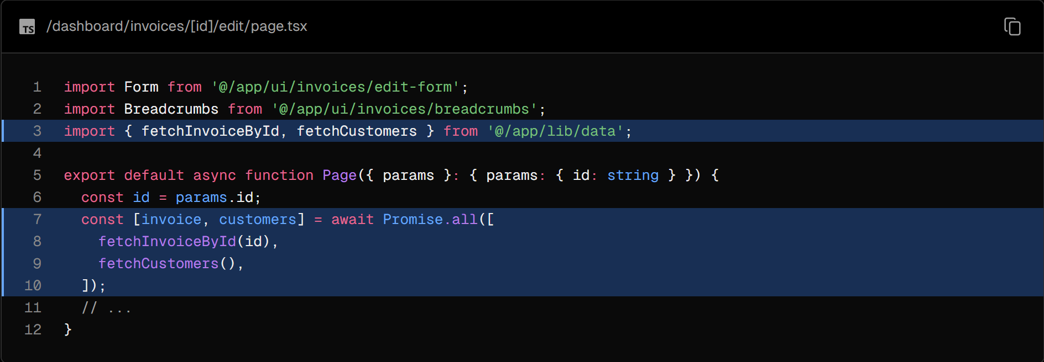

You will see a temporary TS error for the invoices prop in your terminal because invoices could be potentially undefined. Don't worry about it for now, you'll resolve it in the next chapter when you add error handling.

Great! Now, test that everything is wired correctly. Visit http://localhost:3000/dashboard/invoices and click on the Pencil icon to edit an invoice. After navigation, you should see a form that is pre-populated with the invoice details:

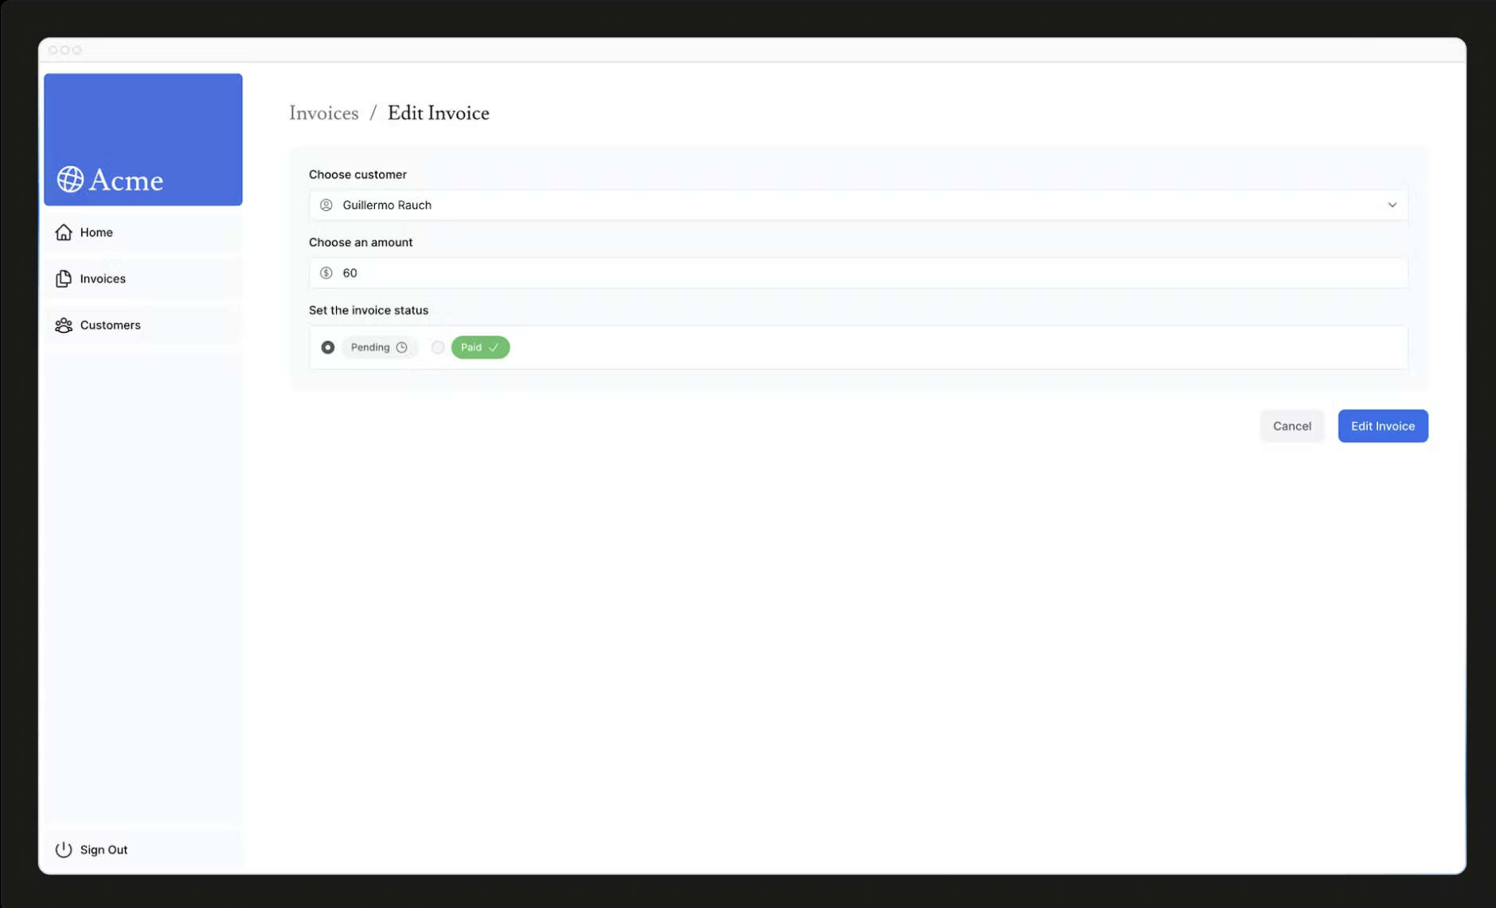

The URL should also be updated with an id as follows:

http://localhost:3000/dashboard/invoice/uuid/edit

UUIDs vs. Auto-incrementing Keys

We use UUIDs instead of incrementing keys (e.g., 1, 2, 3, etc.). This makes the URL longer; however, UUIDs eliminate the risk of ID collision, are globally unique, and reduce the risk of enumeration attacks - making them ideal for large databases.

However, if you prefer cleaner URLs, you might prefer to use auto-incrementing keys.

### 4. Pass the id to the Server Action

Lastly, you want to pass the id to the Server Action so you can update the right record in your database. You cannot pass the id as an argument like so:

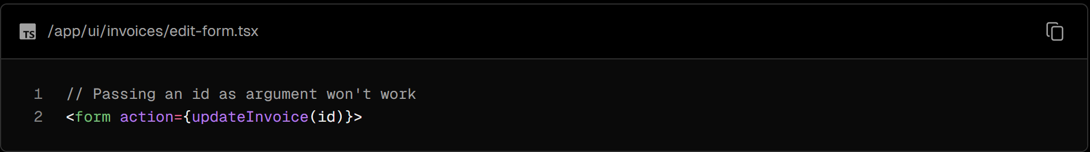

Instead, you can pass id to the Server Action using JS bind. This will ensure that any values passed to the Server Action are encoded.

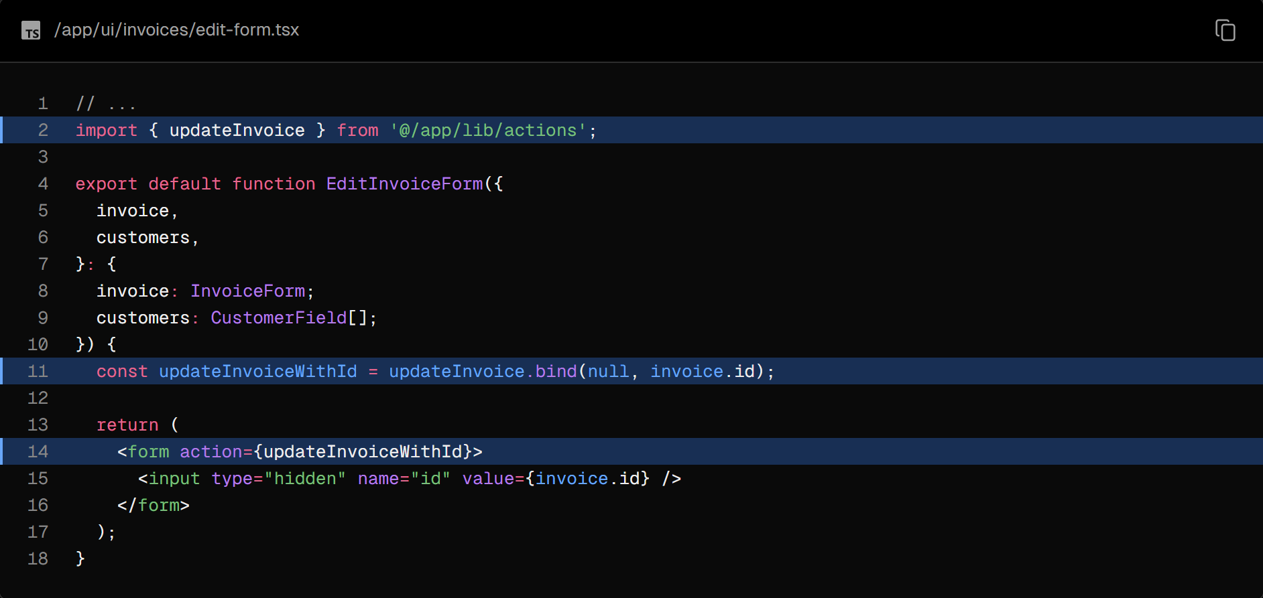

Note: Using a hidden input field in your form also works (e.g. <input type="hidden" name="id" value={invoice.id} />). However, the values will appear as full text in the HTML source, which is not ideal for sensitive data like IDs.

Then, in your actions.ts file, create a new action, updateInvoice:

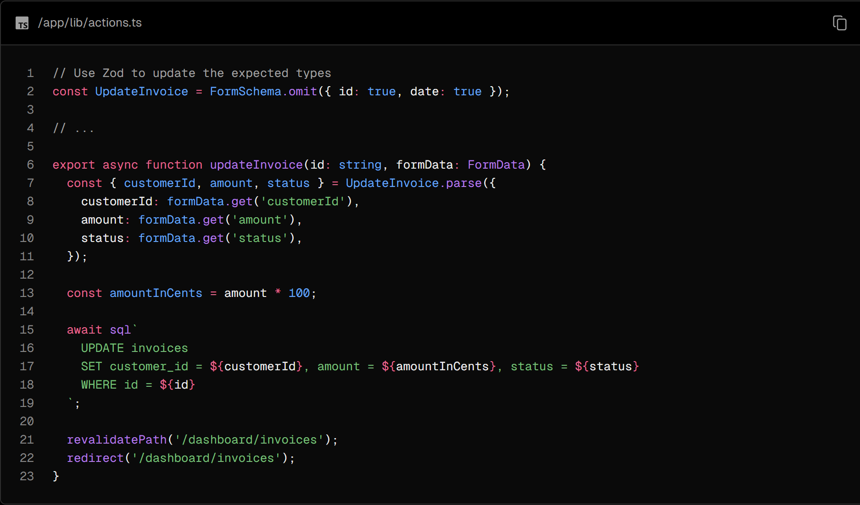

Similarly to the createInvoice action, here you are:

1. Extracting the data from formData.
2. Validating the types with Zod.
3. Converting the amount to cents.
4. Passing the variables to your SQL query.
5. Calling revalidatePath to clear the client cache and make a new server request.
6. Calling redirect to redirect the user to the invoice's page.

Test it out by editing an invoice. After submitting the form, you should be redirected to the invoices page, and the invoice should be updated.

### Deleting an invoice

To delete an invoice using a Server Action, wrap the delete button in a <form> element and pass the id to the Server Action using bind:

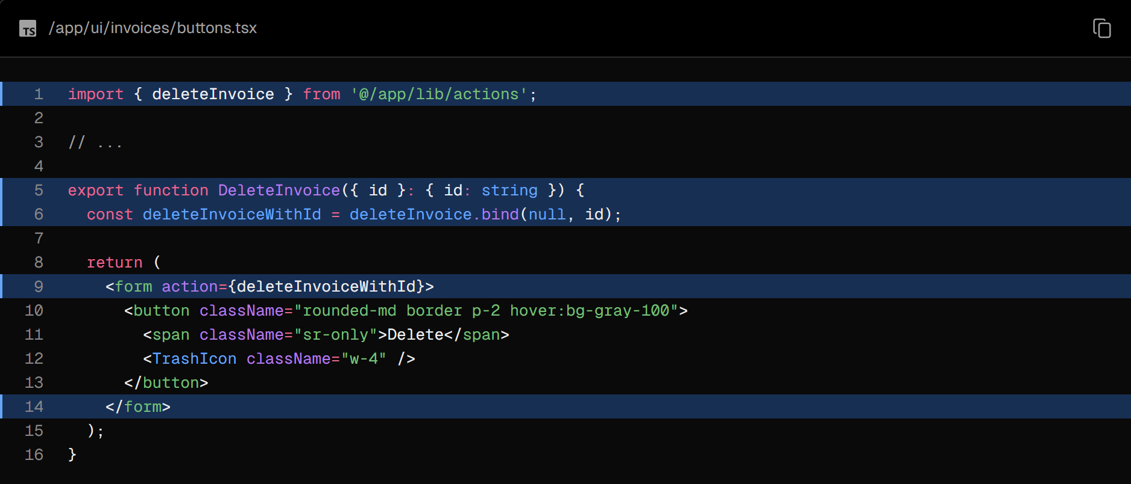

Inside your actions.ts file, create a new action called deleteInvoice.

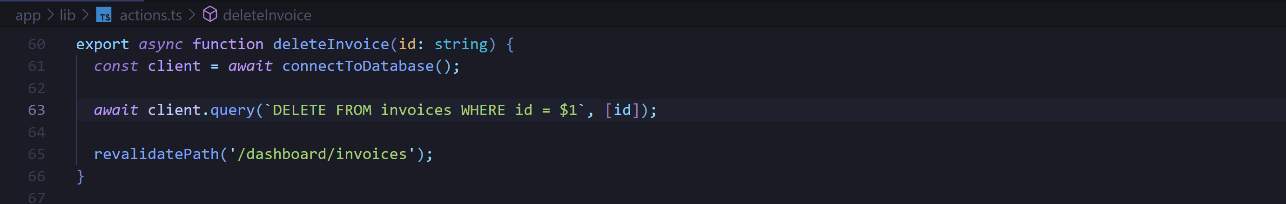

Since this action is being called in the /dashboard/invoices path, you don't need to call redirect. Calling revalidatePath will trigger a new server request and re-render the table.

Further reading

In this chapter, you learned how to use Server Actions to mutate data. You also learned how to use the revalidatePath API to revalidate the Next.js cache and redirect to redirect the user to a new page.

You can also read more about [security with Server Actions](https://nextjs.org/blog/security-nextjs-server-components-actions) for additional learning.

### Chapter 13 - Handling Errors

In the previous chapter, you learned how to mutate data using Server Actions. Let's see how you can handle errors gracefully using JavaScript's try/catch statements and Next.js APIs.

In this chapter...

Here are the topics we’ll cover

* How to use the special error.tsx file to catch errors in your route segments, and show a fallback UI to the user.
* How to use the notFound function and not-found file to handle 404 errors (for resources that don’t exist).

### Adding try/catch to Server Actions

First, let's add JavaScript's try/catch statements to your Server Actions to allow you to handle errors gracefully.

If you know how to do this, spend a few minutes updating your Server Actions, or you can copy the code below:

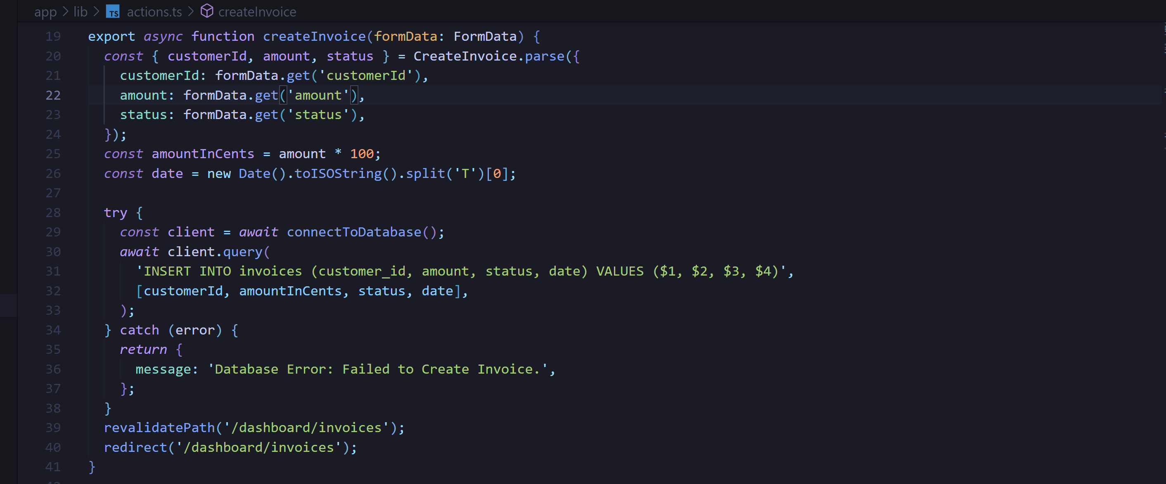

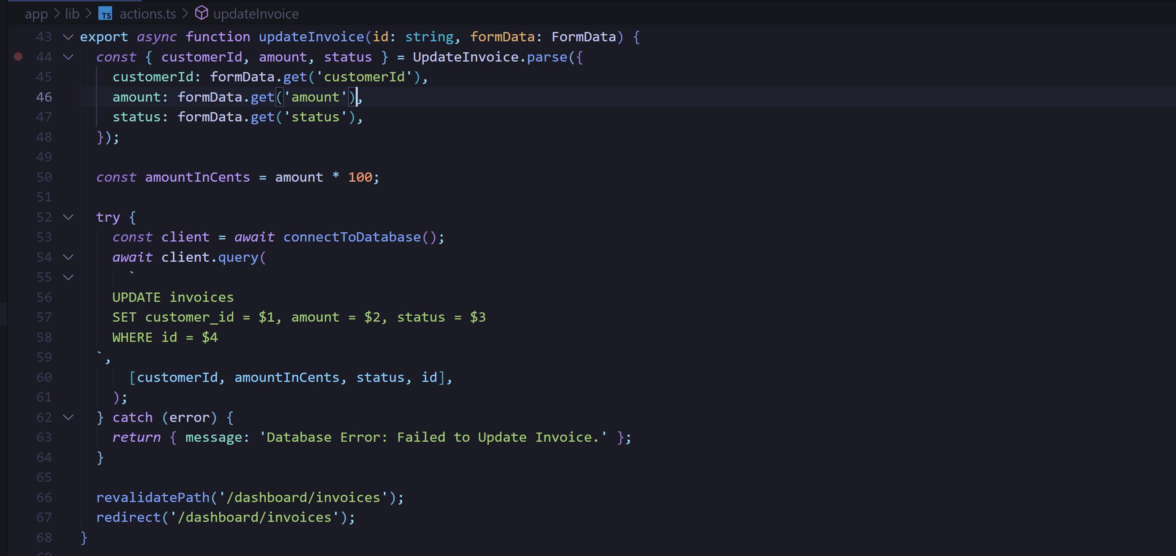

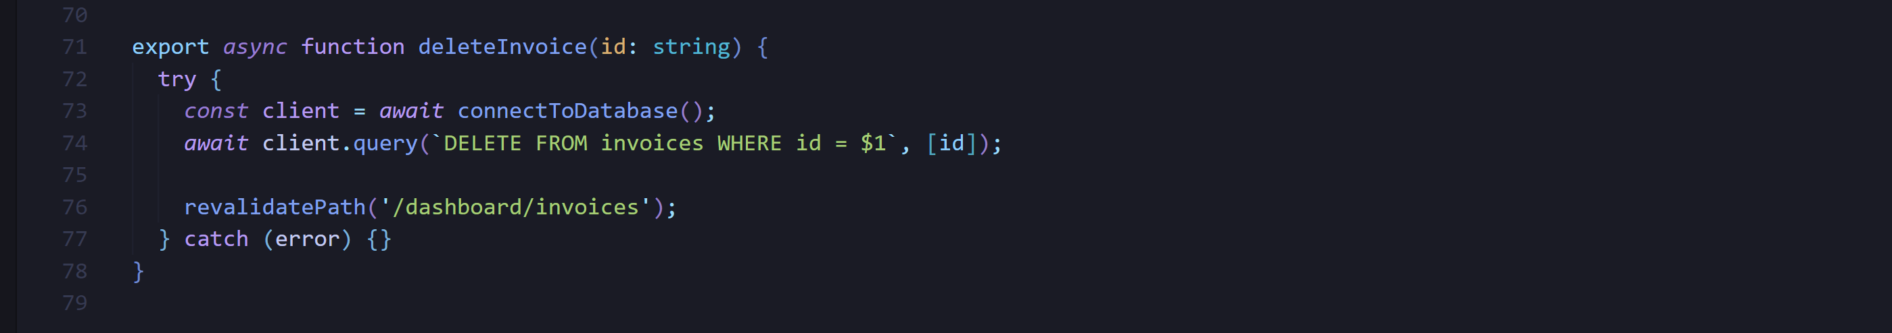

Note how redirect is being called outside of the try/catch block. This is because redirect works by throwing an error, which would be caught by the catch block. To avoid this, you can call redirect after try/catch. redirect would only be reachable if try is successful.

Now, let's check what happens when an error is thrown in your Server Action. You can do this by throwing an error earlier. For example, in the deleteInvoice action, throw an error at the top of the function:

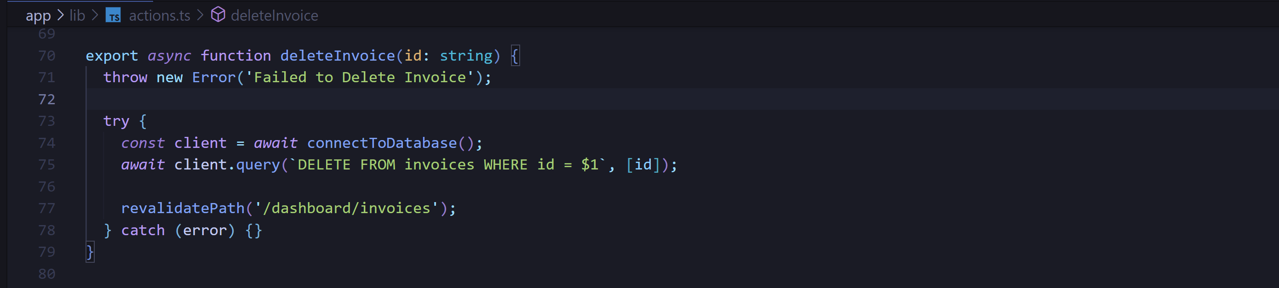

When you try to delete an invoice, you should see an error on localhost.

Seeing these errors are helpful while developing as you can catch any potential problems early. However, you also want to show errors to the user to avoid an abrupt failure and allow your application to continue running.

This is where Next.js error.tsx file comes in.

### Handling all errors with error.tsx

The error.tsx file can be used to define a UI boundary for a route segment. It serves as a catch-all for unexpected errors and allows you to display a fallback UI to your users.

Inside your /dashboard/invoices folder, create a new file called error.tsx and paste the following code:

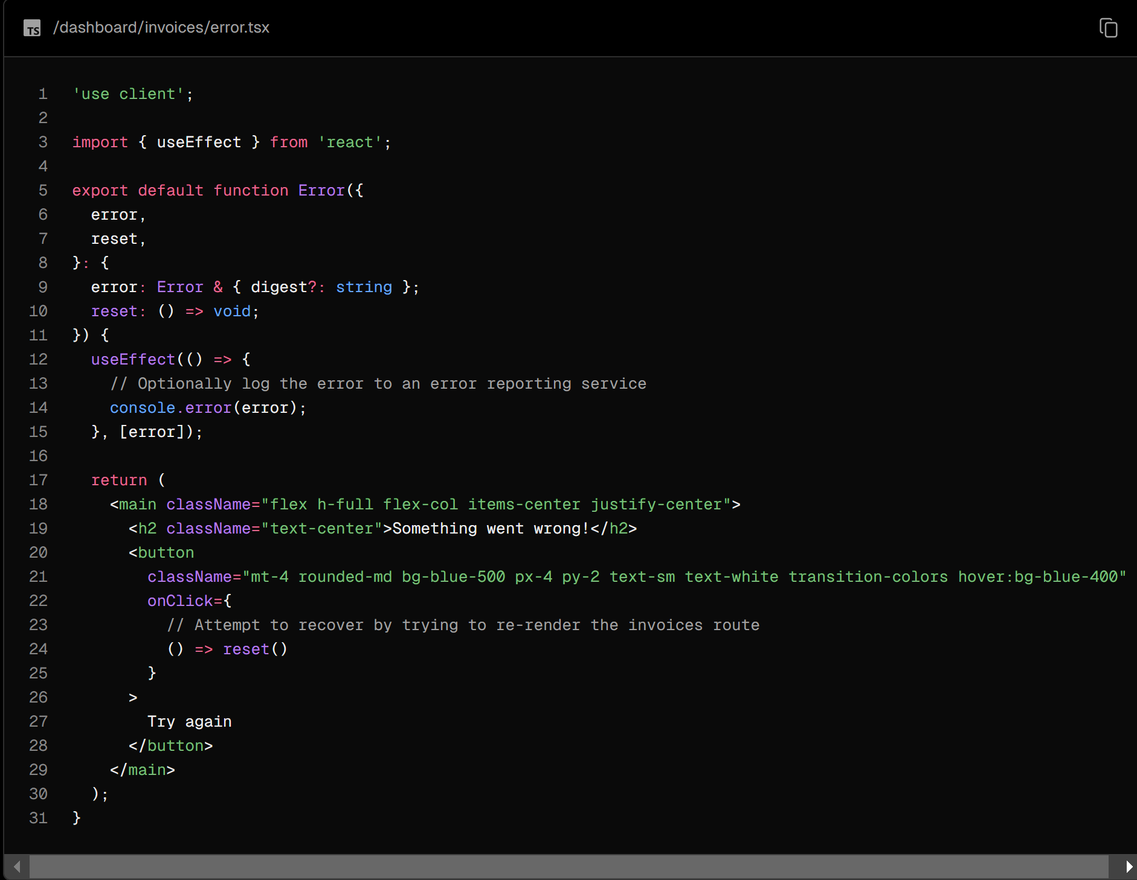

There are a few things you'll notice about the code above:

* "use client" - error.tsx needs to be a Client Component.
* It accepts two props:
  + error: This object is an instance of JavaScript's native Error object.
  + reset: This is a function to reset the error boundary. When executed, the function will try to re-render the route segment.

When you try to delete an invoice again, you should see the following UI:

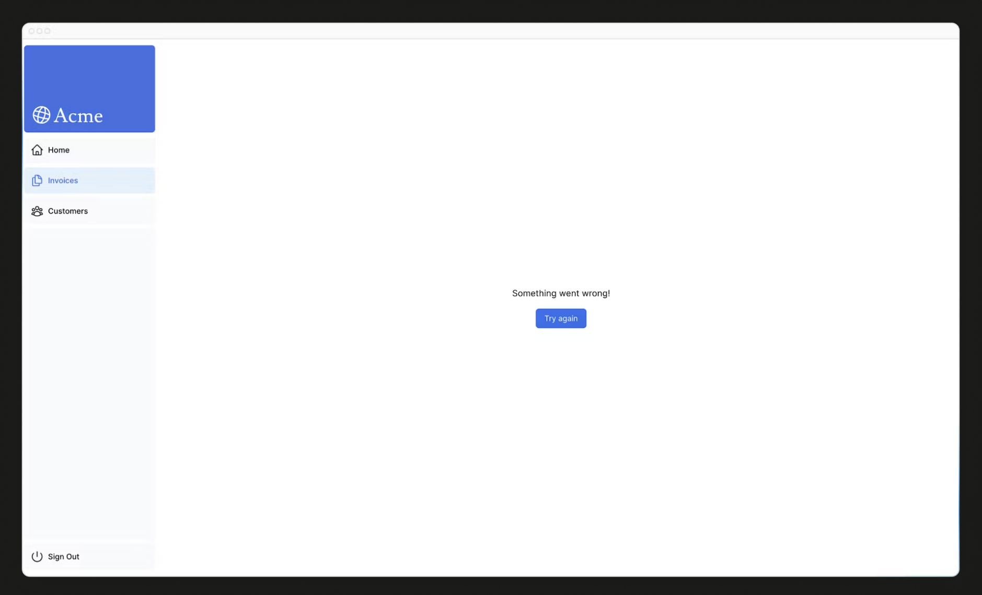

### Handling 404 errors with the notFound function

Another way you can handle errors gracefully is by using the notFound function. While error.tsx is useful for catching all errors, notFound can be used when you try to fetch a resource that doesn't exist.

For example, visit <http://localhost:3000/dashboard/invoices/2e94d1ed-d220-449f-9f11-f0bbceed9645/edit>.

This is a fake UUID that doesn't exist in your database.

You'll immediately see error.tsx kicks in because this is a child route of /invoices where error.tsx is defined.

However, if you want to be more specific, you can show a 404 error to tell the user the resource they're trying to access hasn't been found.

You can confirm that the resource hasn't been found by going into your fetchInvoiceById function in data.ts, and console logging the returned invoice:

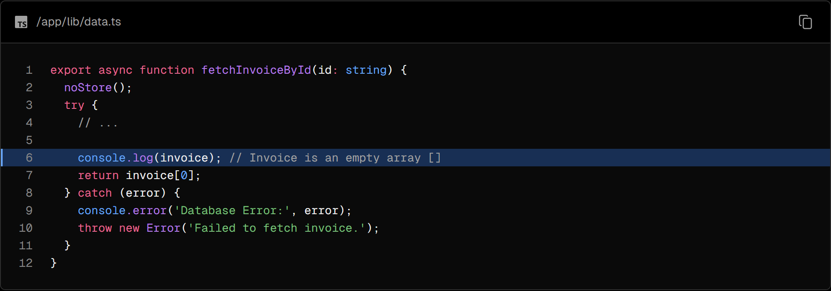

Now that you know the invoice doesn't exist in your database, let's use notFound to handle it. Navigate to /dashboard/invoices/[id]/edit/page.tsx, and import { notFound } from 'next/navigation'.

Then, you can use a conditional to invoke notFound if the invoice doesn't exist:

Perfect! <Page> will now throw an error if a specific invoice is not found. To show an error UI to the user. Create a not-found.tsx file inside the /edit folder.



Then, inside the not-found.tsx file, paste the following the code:

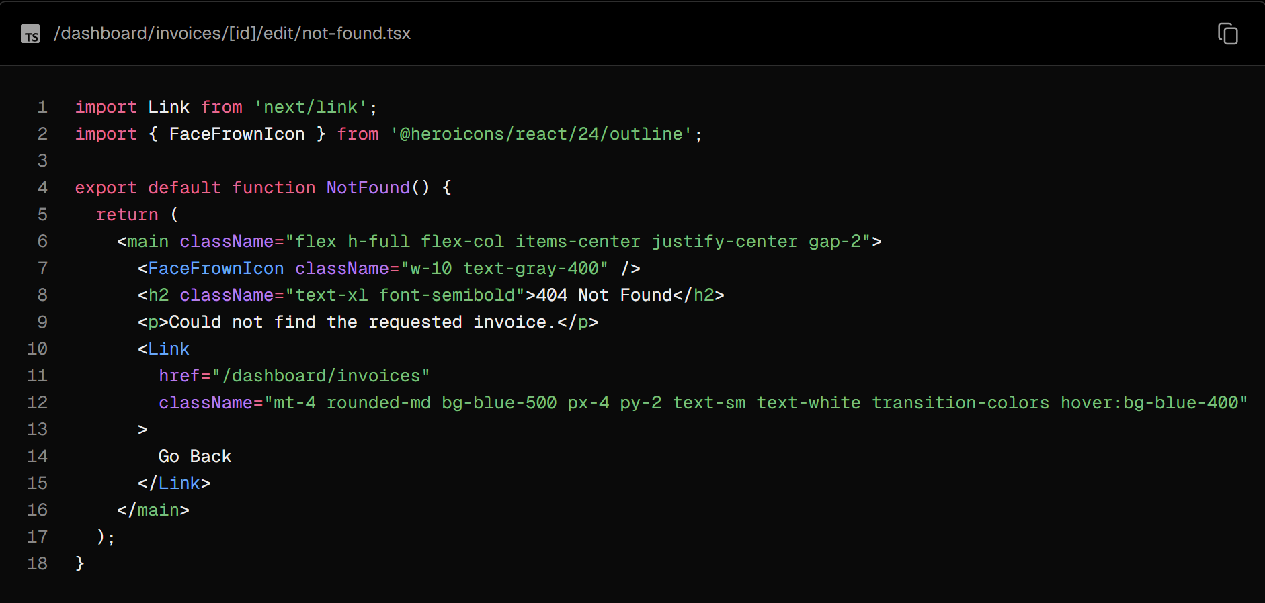

Refresh the route, and you should now see the following UI:

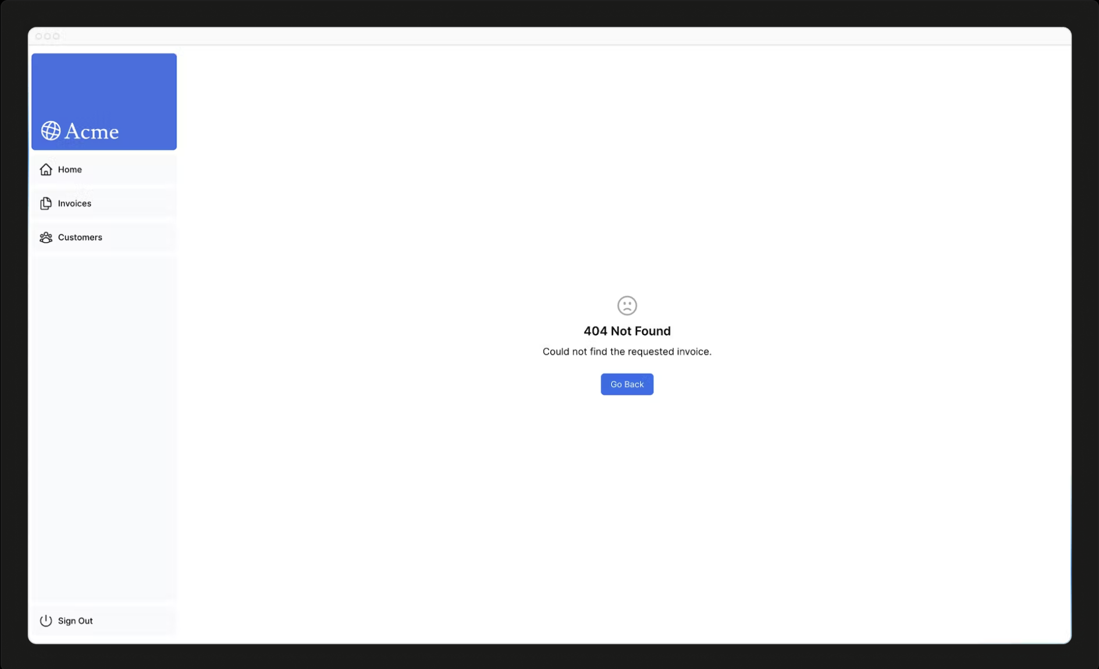

That's something to keep in mind, notFound will take precedence over error.tsx, so you can reach out for it when you want to handle more specific errors!

### Further reading

To learn more about error handling in Next.js, check out the following documentation:

* [Error Handling](https://nextjs.org/docs/app/building-your-application/routing/error-handling)
* [error.js API Reference](https://nextjs.org/docs/app/api-reference/file-conventions/error)
* [notFound() API Reference](https://nextjs.org/docs/app/api-reference/functions/not-found)
* [not-found.js API Reference](https://nextjs.org/docs/app/api-reference/file-conventions/not-found)

### Chapter 14 - Improving Accessibility

In the previous chapter, we looked at how to catch errors (including 404 errors) and display a fallback to the user. However, we still need to discuss another piece of the puzzle: form validation. Let's see how to implement server-side validation with Server Actions, and how you can show form errors using the useFormState hook - while keeping accessibility in mind!

In this chapter...

Here are the topics we’ll cover

* How to use eslint-plugin-jsx-a11y with Next.js to implement accessibility best practices.
* How to implement server-side form validation.
* How to use the React useFormState hook to handle form errors, and display them to the user.

### What is accessibility?

Accessibility refers to designing and implementing web applications that everyone can use, including those with disabilities. It's a vast topic that covers many areas, such as keyboard navigation, semantic HTML, images, colors, videos, etc.

While we won't go in-depth into accessibility in this course, we'll discuss the accessibility features available in Next.js and some common practices to make your applications more accessible.

### Using the ESLint accessibility plugin in Next.js

By default, Next.js includes the [eslint-plugin-jsx-a11y](https://www.npmjs.com/package/eslint-plugin-jsx-a11y) plugin to help catch accessibility issues early. For example, this plugin warns if you have images without alt text, use the aria-* and role attributes incorrectly, and more.

Let's see how this works!

Add next lint as a script in your package.json file:

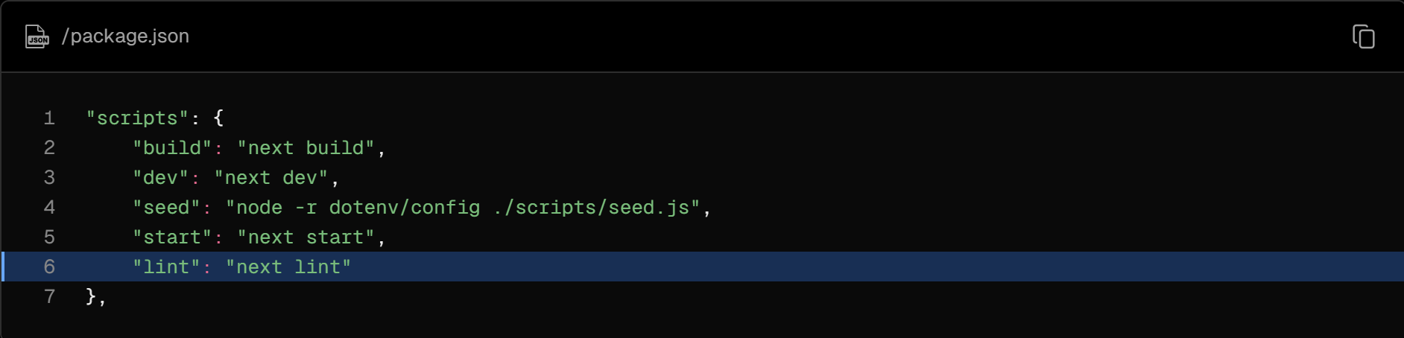

Then run npm run lint in your terminal:

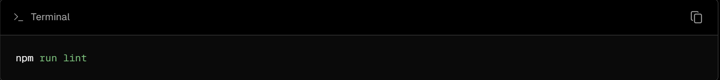

However, what would happen if you had an image without an alt tag? Let's find out!

Go to /app/ui/invoices/table.tsx and remove the alt tag from the image. You can use your editor's search feature to quickly find the image tag:

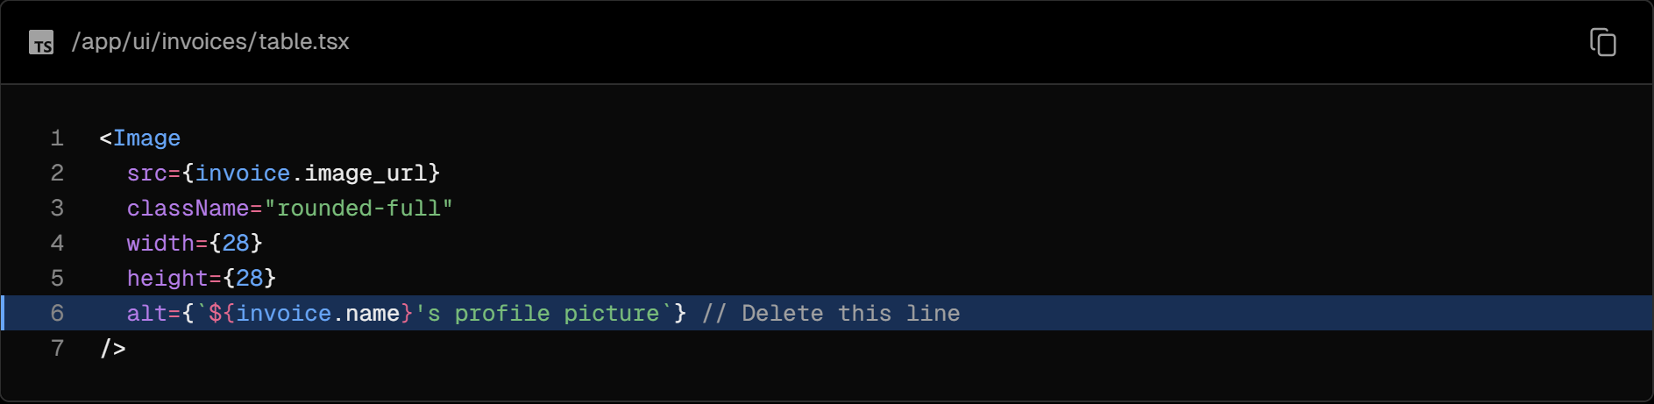

Now run npm run lint again, and you should see the following warning:

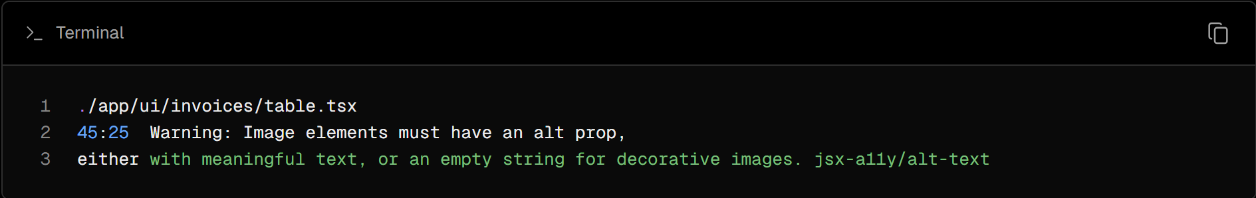

If you tried to deploy your application to Vercel, the warning would also show up in the build logs. This is because next lint runs as part of the build process. So you can run lint locally to catch accessibility issues before deploying your application.

### Improving form accessibility

There are three things we're already doing to improve accessibility in our forms:

* Semantic HTML: Using semantic elements (<input>, <option>, etc) instead of <div>. This allows assistive technologies (AT) to focus on the input elements and provide appropriate contextual information to the user, making the form easier to navigate and understand.
* Labelling: Including <label> and the htmlFor attribute ensures that each form field has a descriptive text label. This improves AT support by providing context and also enhances usability by allowing users to click on the label to focus on the corresponding input field.
* Focus Outline: The fields are properly styled to show an outline when they are in focus. This is critical for accessibility as it visually indicates the active element on the page, helping both keyboard and screen reader users to understand where they are on the form. You can verify this by pressing tab.

These practices lay a good foundation for making your forms more accessible to many users. However, they don't address form validation and errors.

### Form validation

Go to <http://localhost:3000/dashboard/invoices/create>, and submit an empty form. What happens?

You get an error! This is because you're sending empty form values to your Server Action. You can prevent this by validating your form on the client or the server.

### Client-Side validation

There are a couple of ways you can validate forms on the client. The simplest would be to rely on the form validation provided by the browser by adding the required attribute to the <input> and <select> elements in your forms. For example:

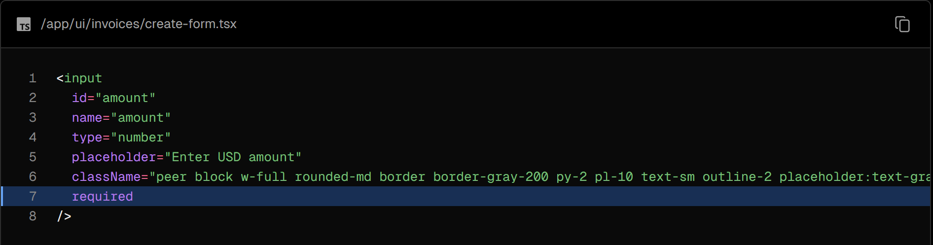

Submit the form again, and you should now see the browser a warning if you try to submit a form with empty values.

This approach is generally okay because some ATs support browser validation.

An alternative to client-side validation is server-side validation. Let's see how you can implement it in the next section. For now, delete the required attributes if you added them.

### Server-Side validation

By validating forms on the server, you can:

* Ensure your data is in the expected format before sending it to your database.
* Reduce the risk of malicious users bypassing client-side validation.
* Have one source of truth for what is considered valid data.

In your create-form.tsx component, import the useFormState hook from react-dom. Since useFormState is a hook, you will need to turn your form into a Client Component using "use client" directive:

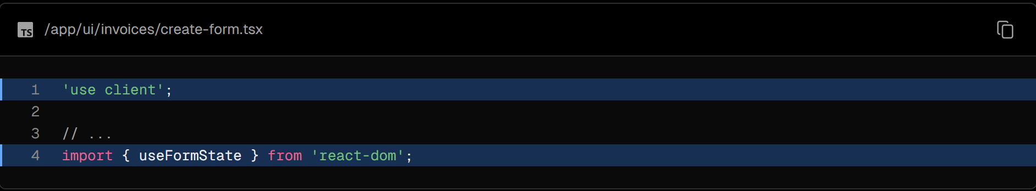

Inside your Form Component, the useFormState hook:

* Takes two arguments: (action, initialState).
* Returns two values: [state, dispatch] - the form state, and a dispatch function (similar to useReducer)

Pass your createInvoice action as an argument of useFormState, and inside your <form action={}> attribute, call dispatch.

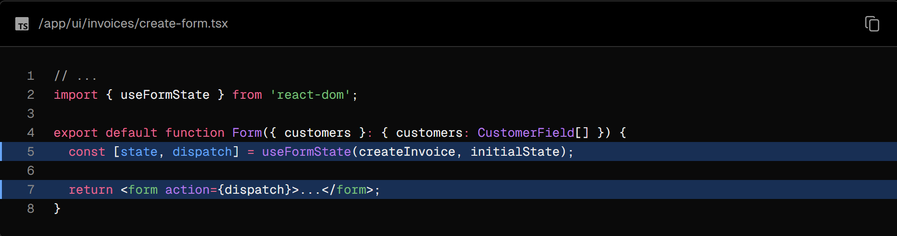

The initialState can be anything you define, in this case, create an object with two empty keys: message and errors.

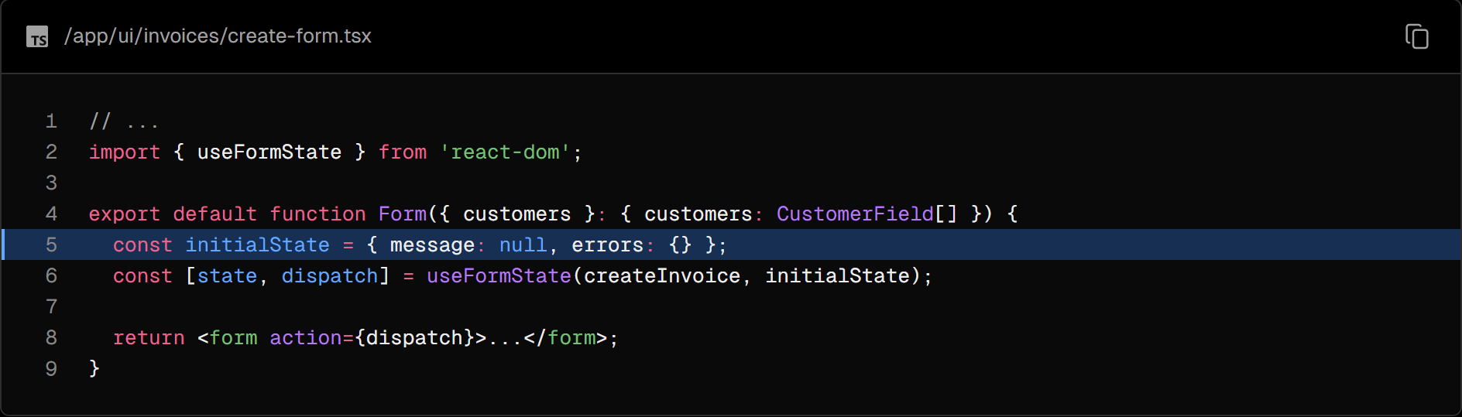

This may seem confusing initially, but it'll make more sense once you update the server action. Let's do that now.

In your action.ts file, you can use Zod to validate form data. Update your FormSchema as follows:

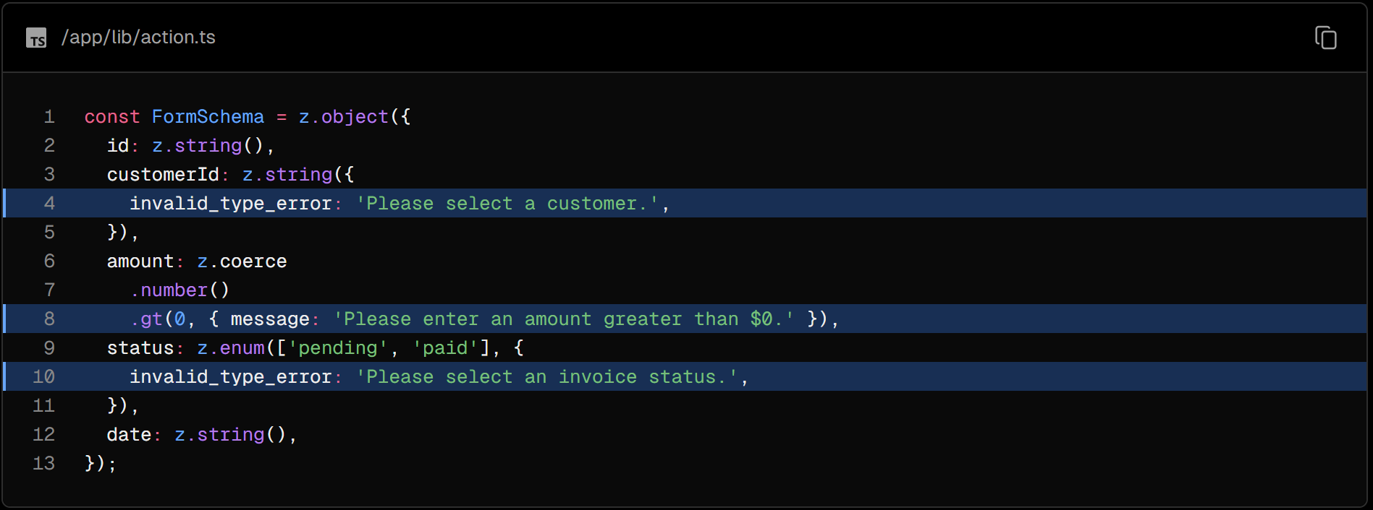

* customerId - Zod already throws an error if the customer field is empty as it expects a type string. But let's add a friendly message if the user doesn't select a customer.
* amount - Since you are coercing the amount type from string to number, it'll default to zero if the string is empty. Let's tell Zod we always want the amount greater than 0 with the .gt() function.
* status - Zod already throws an error if the status field is empty as it expects "pending" or "paid". Let's also add a friendly message if the user doesn't select a status.

Next, update your createInvoice action to accept two parameters:

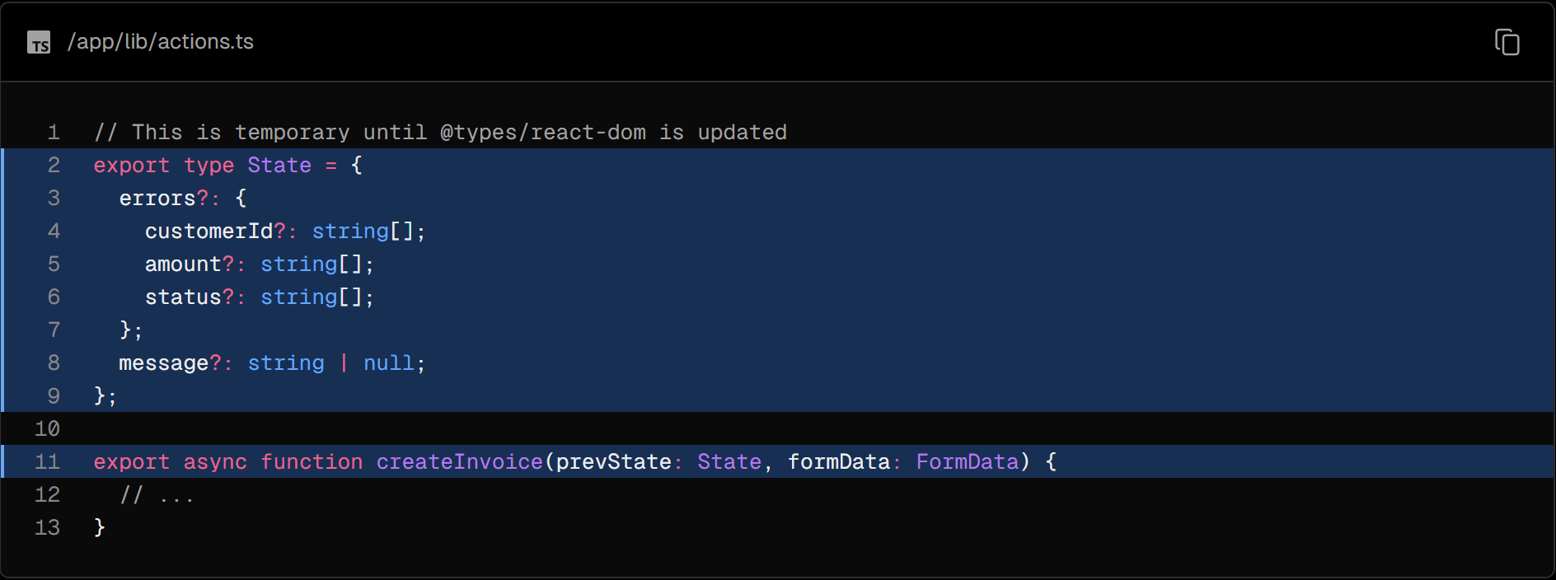

* formData - same as before.
* prevState - contains the state passed from the useFormState hook. You won't be using it in the action in this example, but it's a required prop.

Then, change the Zod parse() function to safeParse():

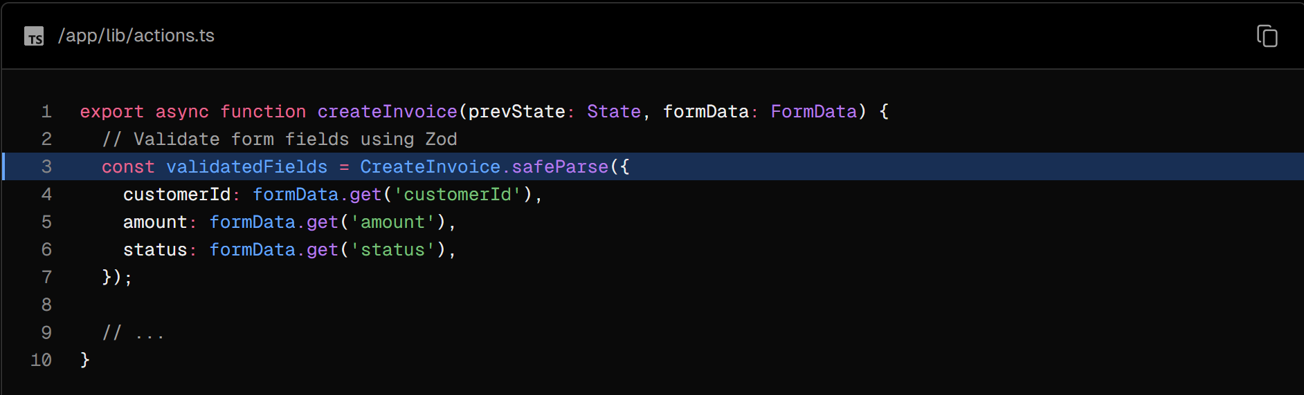

safeParse() will return an object containing either a success or error field. This will help handle validation more gracefully without having put this logic inside the try/catch block.

Before sending the information to your database, check if the form fields were validated correctly with a conditional:

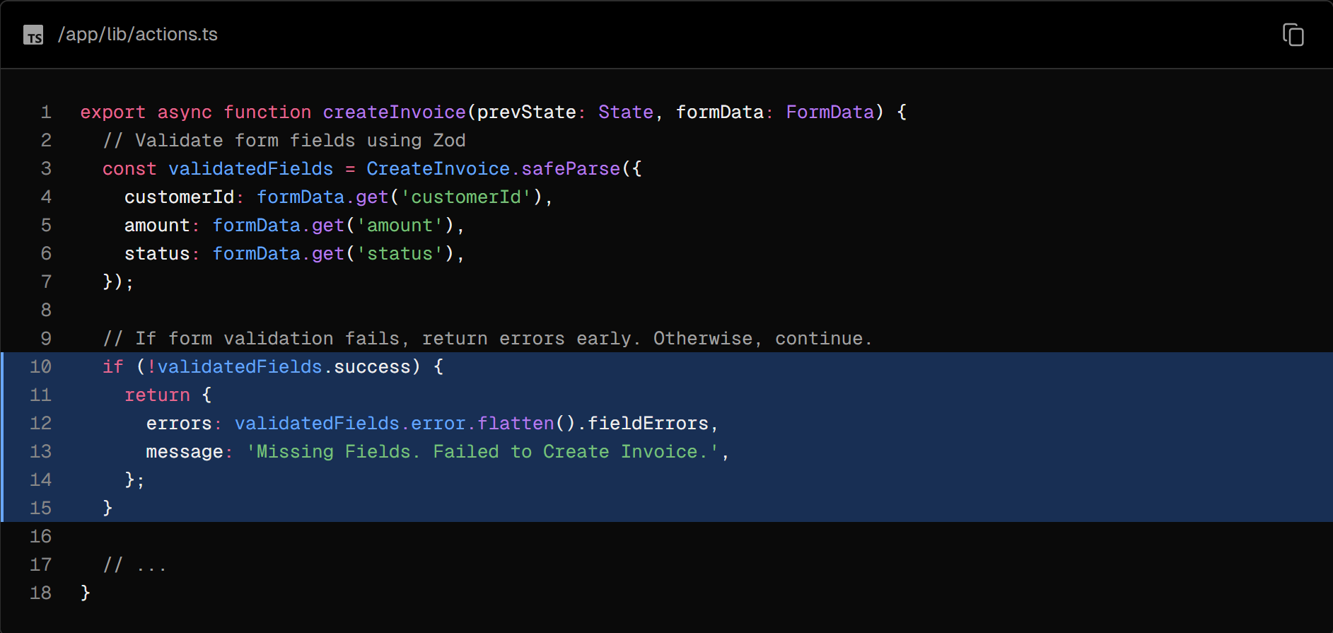

If validatedFields isn't successful, we return the function early with the error messages from Zod.

Tip: console.log validatedFields and submit an empty form to see the shape of it.

Finally, since you're handling form validation separately, outside your try/catch block, you can return a specific message for any database errors, your final code should look like this:

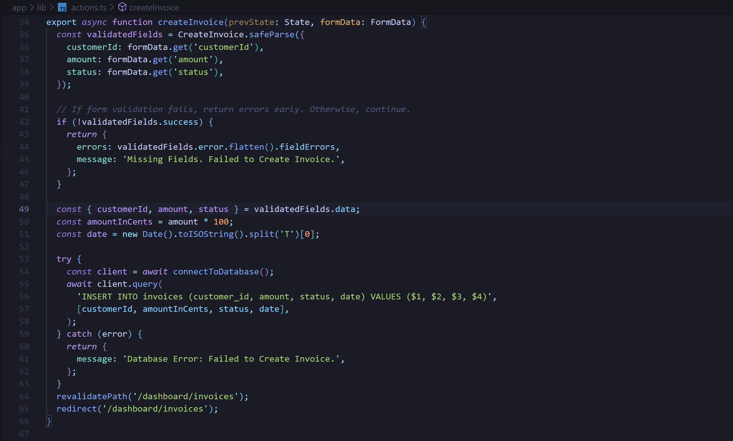

Great, now let's display the errors in your form component. Back in the create-form.tsx component, you can access the errors using the form state.

Add a ternary operator that checks for each specific error. For example, after the customer's field, you can add:

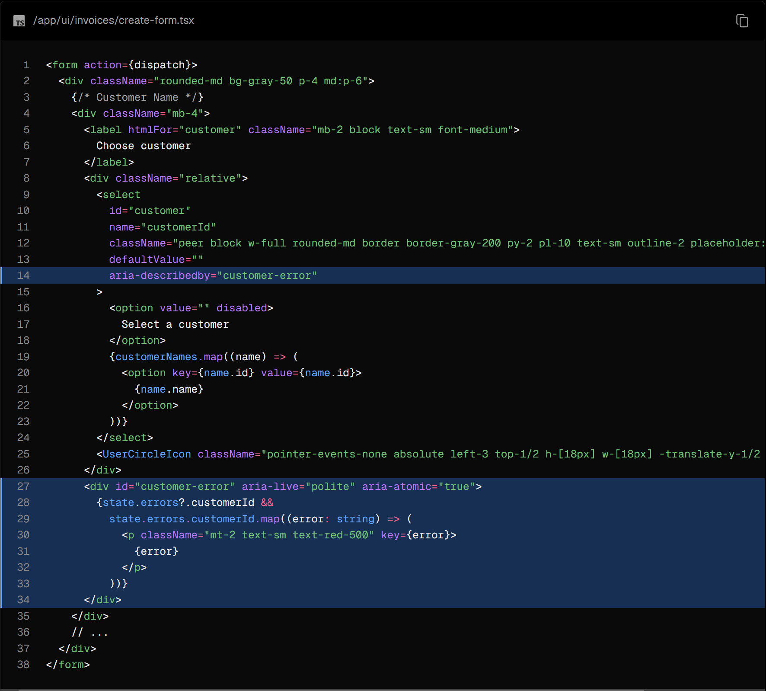

Tip: You can console.log state inside your component and check if everything is wired correctly. Check the console in Dev Tools as your form is now a Client Component.

In the code above, you're also adding the following aria labels:

* aria-describedby="customer-error": This establishes a relationship between the select element and the error message container. It indicates that the container with id="customer-error" describes the select element. Screen readers will read this description when the user interacts with the select box to notify them of errors.
* id="customer-error": This id attribute uniquely identifies the HTML element that holds the error message for the select input. This is necessary for aria-describedby to establish the relationship.
* aria-live="polite": The screen reader should politely notify the user when the error inside the div is updated. When the content changes (e.g. when a user corrects an error), the screen reader will announce these changes, but only when the user is idle so as not to interrupt them.

### Practice: Adding aria labels

Using the example above, add errors to your remaining form fields. You should also show a message at the bottom of the form if any fields are missing. Your UI should look like this:

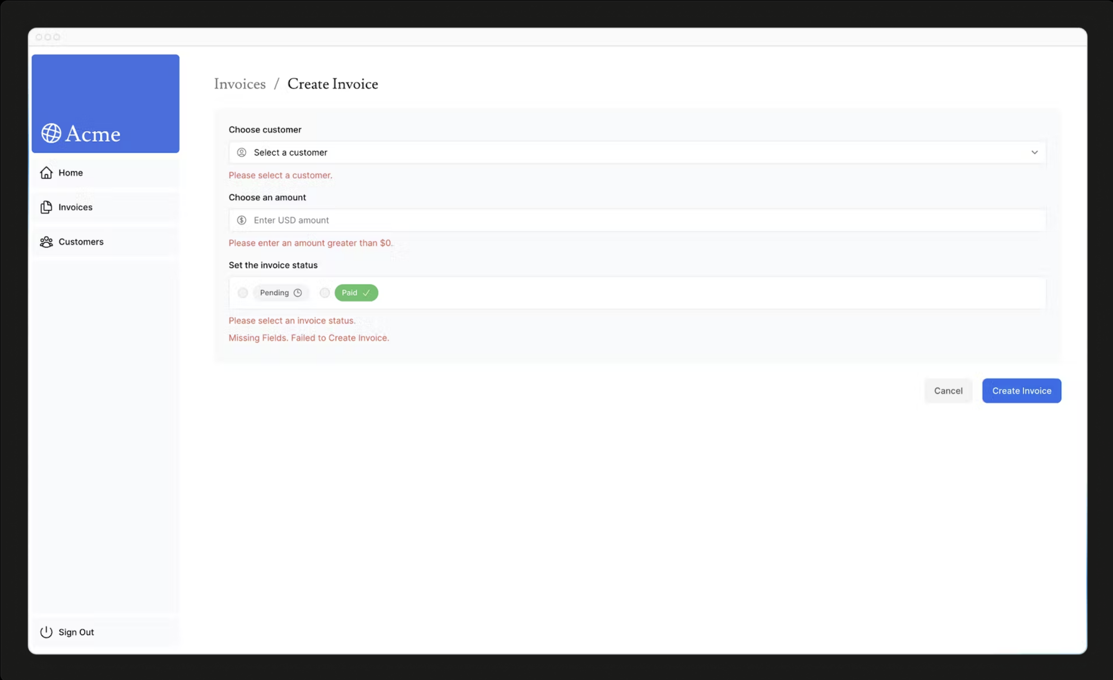

Once you're ready, run npm run lint to check if you're using the aria labels correctly.

If you'd like to challenge yourself, take the knowledge you've learned in this chapter and add form validation to the edit-form.tsx component.

You'll need to:

* Add useFormState to your edit-form.tsx component.
* Edit the updateInvoice action to handle validation errors from Zod.
* Display the errors in your component, and add aria labels to improve accessibility.

Once you're ready, expand the code snippet below to see the solution:

### Edit Invoice Form:

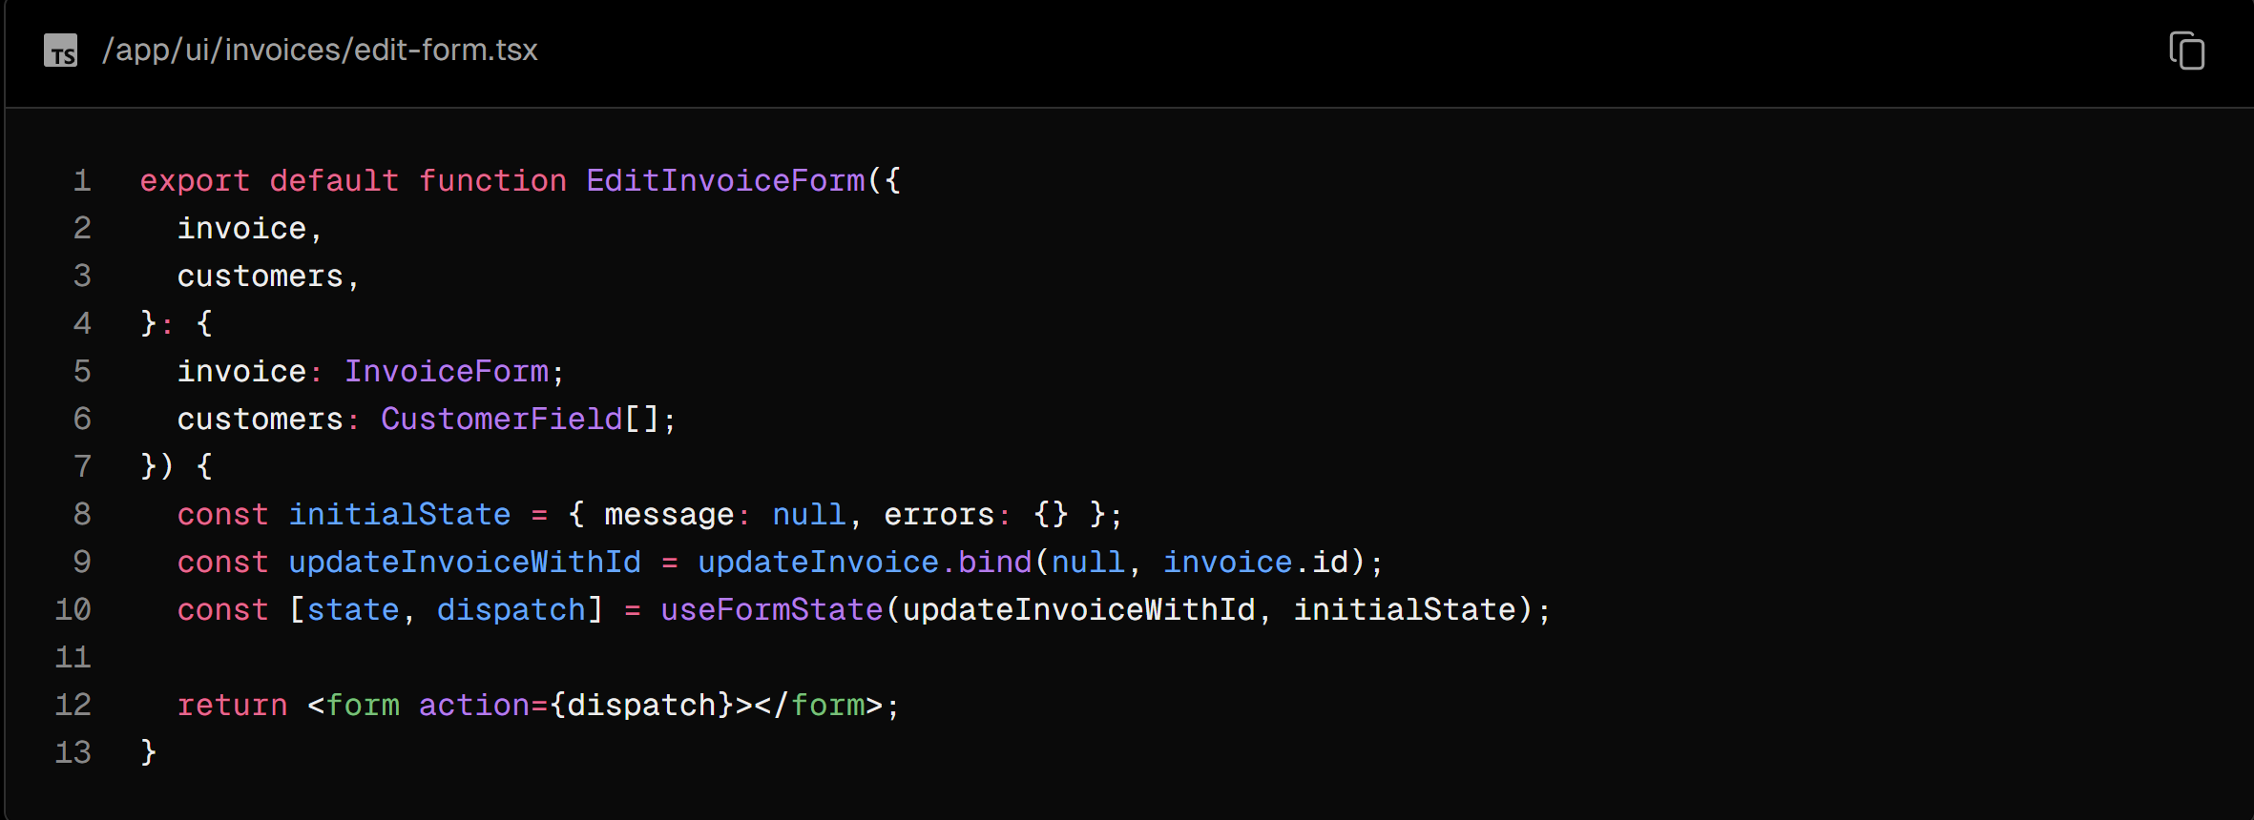

### Server Action:

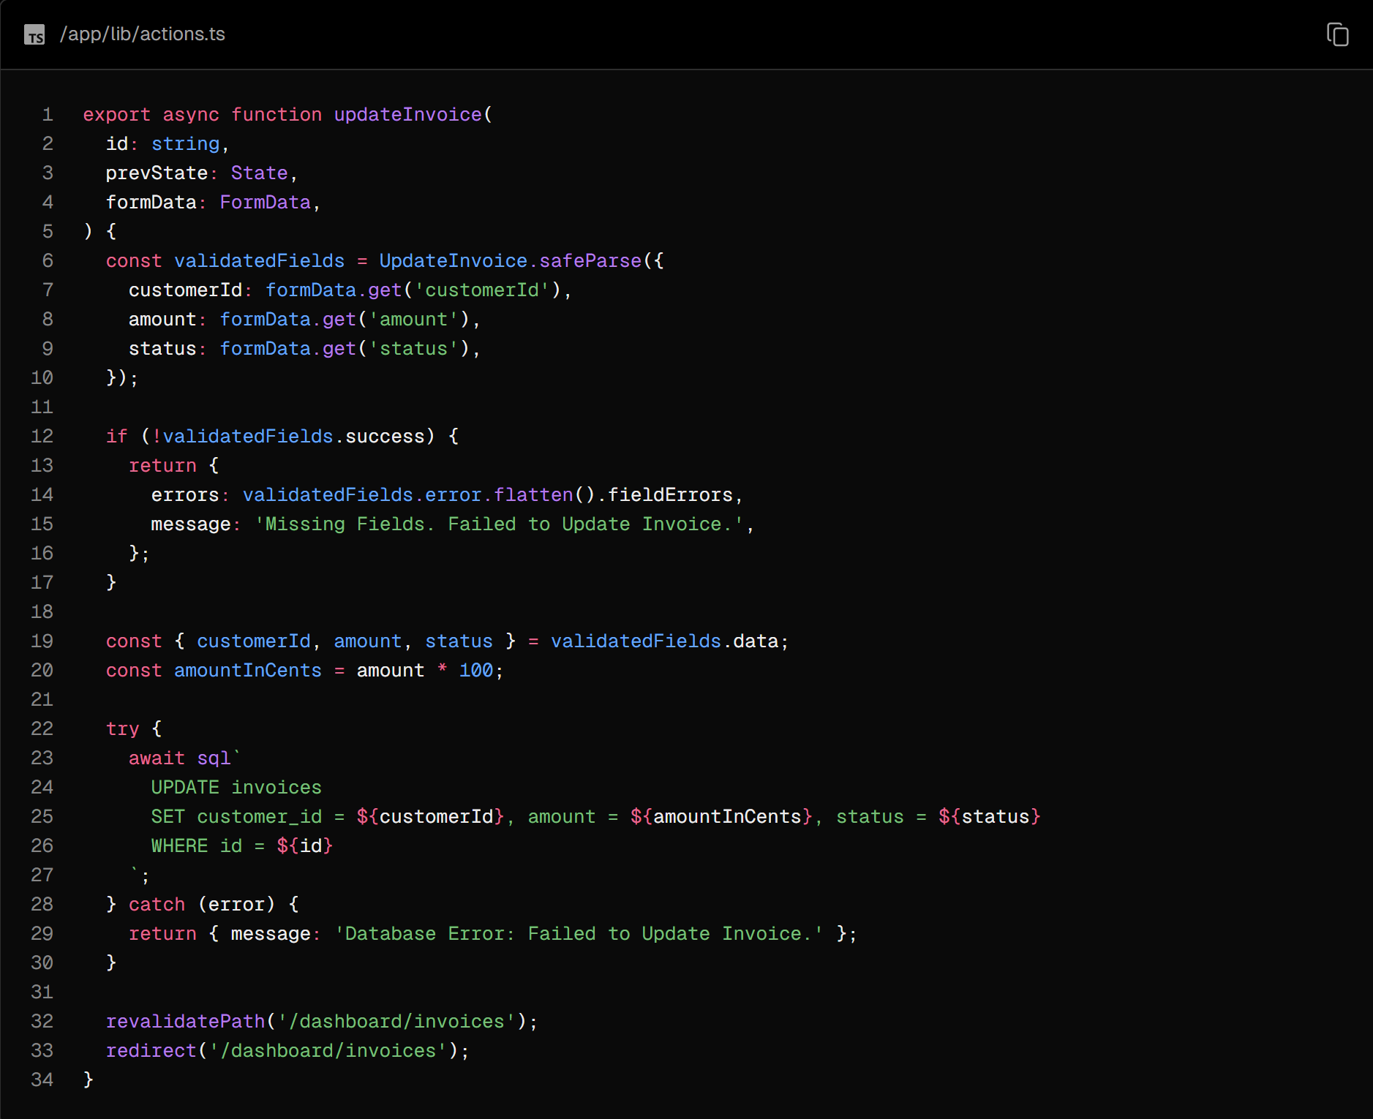

## Chapter 15 - Adding Authentication

In the previous chapter, you finished building the invoices routes by adding form validation and improving accessibility. In this chapter, you'll be adding authentication to your dashboard.

In this chapter...

Here are the topics we’ll cover

* What is authentication.
* How to add authentication to your app using NextAuth.js.
* How to use Middleware to redirect users and protect your routes.
* How to use React's useFormStatus and useFormState to handle pending states and form errors.

### What is authentication?

Authentication is a key part of many web applications today. It's how a system checks if the user is who they say they are.

A secure website often uses multiple ways to check a user's identity. For instance, after entering your username and password, the site may send a verification code to your device or use an external app like Google Authenticator. This 2-factor authentication (2FA) helps increase security. Even if someone learns your password, they can't access your account without your unique token.

### Authentication vs. Authorization

In web development, authentication and authorization serve different roles:

* Authentication is about making sure the user is who they say they are. You're proving your identity with something you have like a username and password.
* Authorization is the next step. Once a user's identity is confirmed, authorization decides what parts of the application they are allowed to use.

So, authentication checks who you are, and authorization determines what you can do or access in the application.

### Creating the login route

Start by creating a new route in your application called /login and paste the following code:

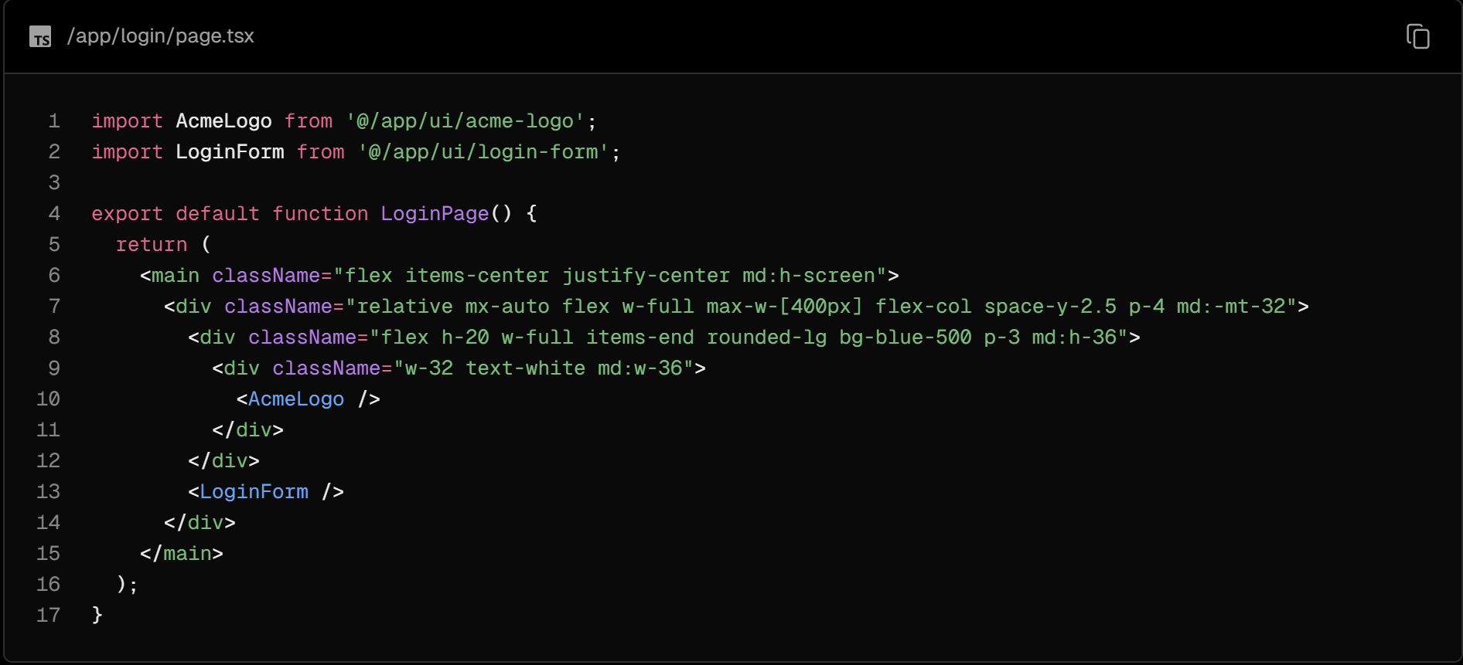

You'll notice the page imports <LoginForm />, which you'll update later in the chapter.

### NextAuth.js

We will be using NextAuth.js to add authentication to your application. NextAuth.js abstracts away much of the complexity involved in managing sessions, sign-in and sign-out, and other aspects of authentication. While you can manually implement these features, the process can be time-consuming and error-prone. NextAuth.js simplifies the process, providing a unified solution for auth in Next.js applications.

### Setting up NextAuth.js

Install NextAuth.js by running the following command in your terminal:

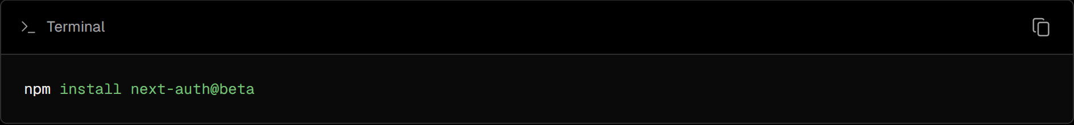

Here, you're installing the beta version of NextAuth.js, which is compatible with Next.js 14.

Next, generate a secret key for your application. This key is used to encrypt cookies, ensuring the security of user sessions. You can do this by running the following command in your terminal:

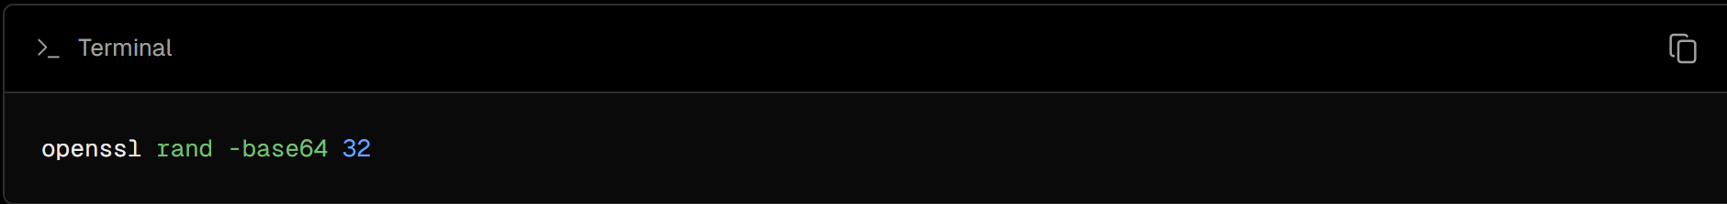

Then, in your .env file, add your generated key to the AUTH_SECRET variable:

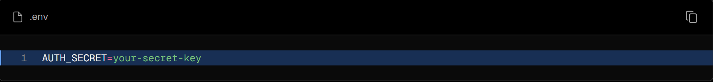

For auth to work in production, you'll need to update your environment variables in your Vercel project too. Check out this guide on how to add environment variables on Vercel.

### Adding the pages option

Create an auth.config.ts file at the root of our project that exports an authConfig object. This object will contain the configuration options for NextAuth.js. For now, it will only contain the pages option:

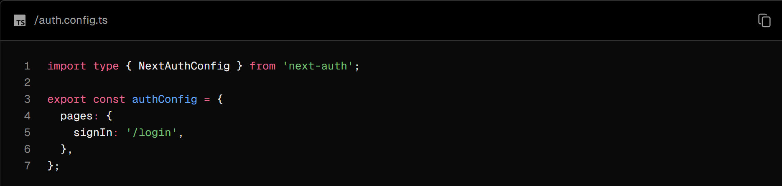

You can use the pages option to specify the route for custom sign-in, sign-out, and error pages. This is not required, but by adding signIn: '/login' into our pages option, the user will be redirected to our custom login page, rather than the NextAuth.js default page.

### Protecting your routes with Next.js Middleware

Next, add the logic to protect your routes. This will prevent users from accessing the dashboard pages unless they are logged in.

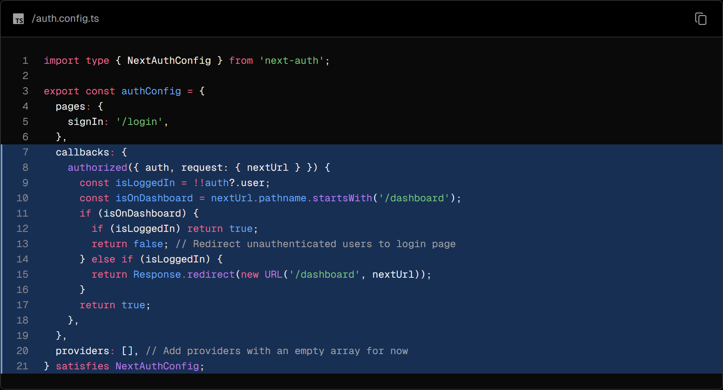

The authorized callback is used to verify if the request is authorized to access a page via Next.js Middleware. It is called before a request is completed, and it receives an object with the auth and request properties. The auth property contains the user's session, and the request property contains the incoming request.

The providers option is an array where you list different login options. For now, it's an empty array to satisfy NextAuth config. You'll learn more about it in the Adding the Credentials provider section.

Next, you will need to import the authConfig object into a Middleware file. In the root of your project, create a file called middleware.ts and paste the following code:

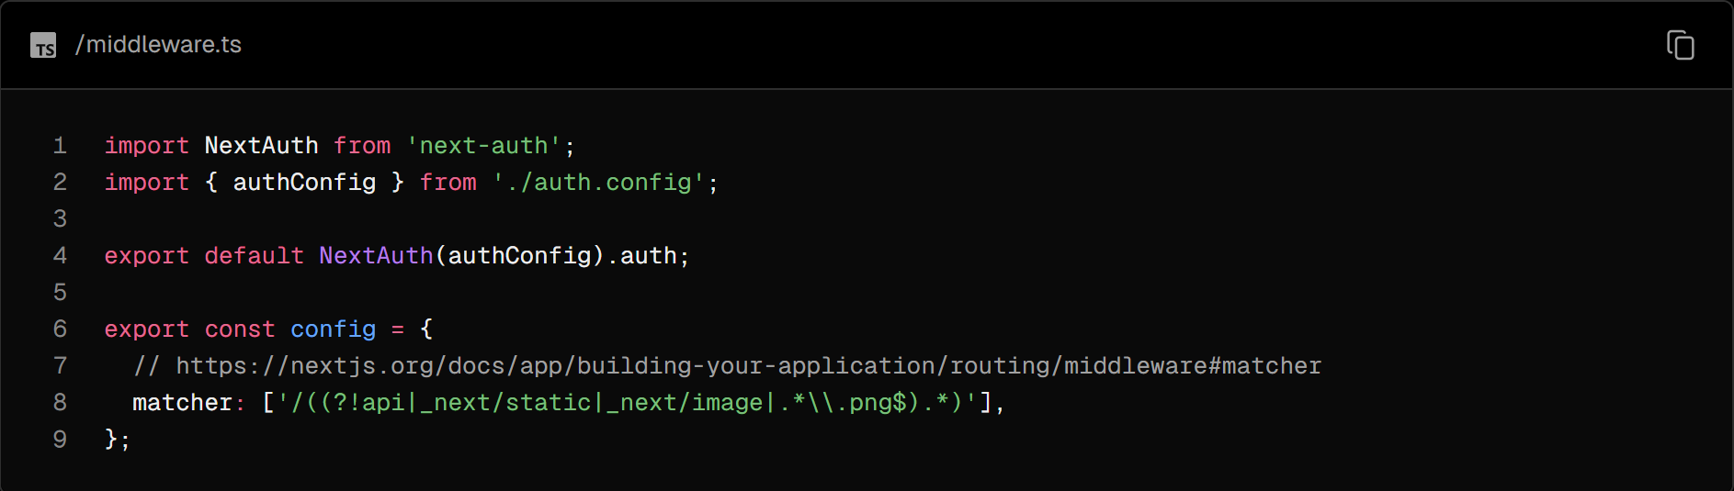

Here you're initializing NextAuth.js with the authConfig object and exporting the auth property. You're also using the matcher option from Middleware to specify that it should run on specific paths.

The advantage of employing Middleware for this task is that the protected routes will not even start rendering until the Middleware verifies the authentication, enhancing both the security and performance of your application.

### Password hashing

It's good practice to hash passwords before storing them in a database. Hashing converts a password into a fixed-length string of characters, which appears random, providing a layer of security even if the user's data is exposed.

In your seed.js file, you used a package called bcrypt to hash the user's password before storing it in the database. You will use it again later in this chapter to compare that the password entered by the user matches the one in the database. However, you will need to create a separate file for the bcrypt package. This is because bcrypt relies on Node.js APIs not available in Next.js Middleware.

Create a new file called auth.ts that spreads your authConfig object:

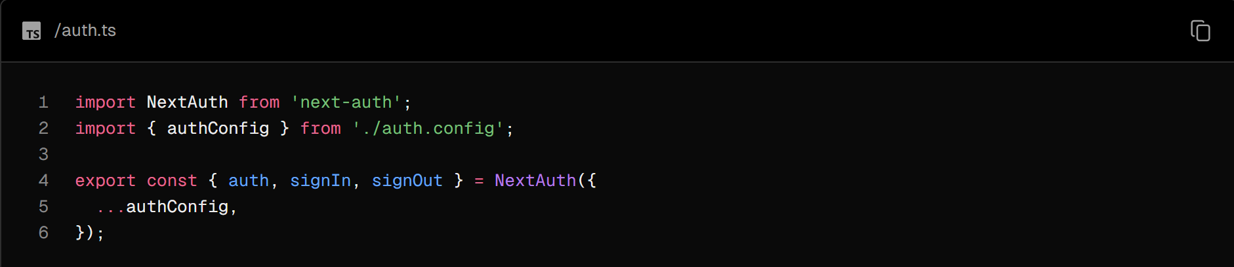

### Adding the Credentials provider

Next, you will need to add the providers option for NextAuth.js. providers is an array where you list different login options such as Google or GitHub. For this course, we will focus on using the Credentials provider only.

The Credentials provider allows users to log in with a username and a password.

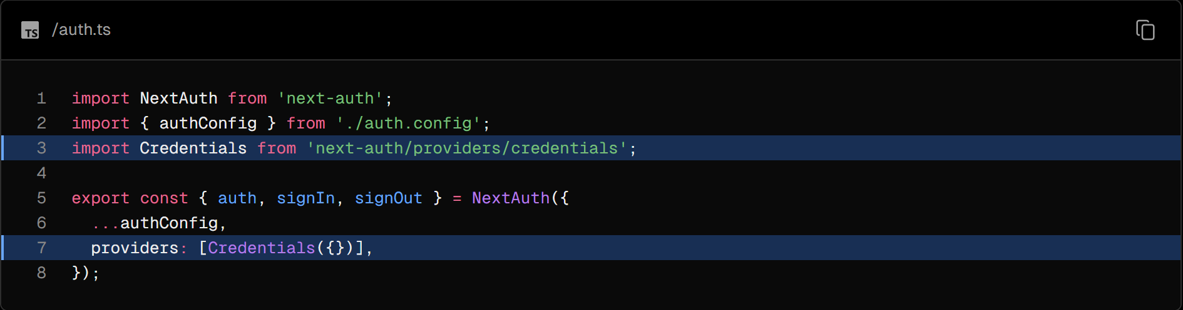

Good to know:

Although we're using the Credentials provider, it's generally recommended to use alternative providers such as OAuth or email providers. See the [NextAuth.js](https://authjs.dev/getting-started/providers) docs for a full list of options.

### Adding the sign in functionality

You can use the authorize function to handle the authentication logic. Similarly to Server Actions, you can use zod to validate the email and password before checking if the user exists in the database:

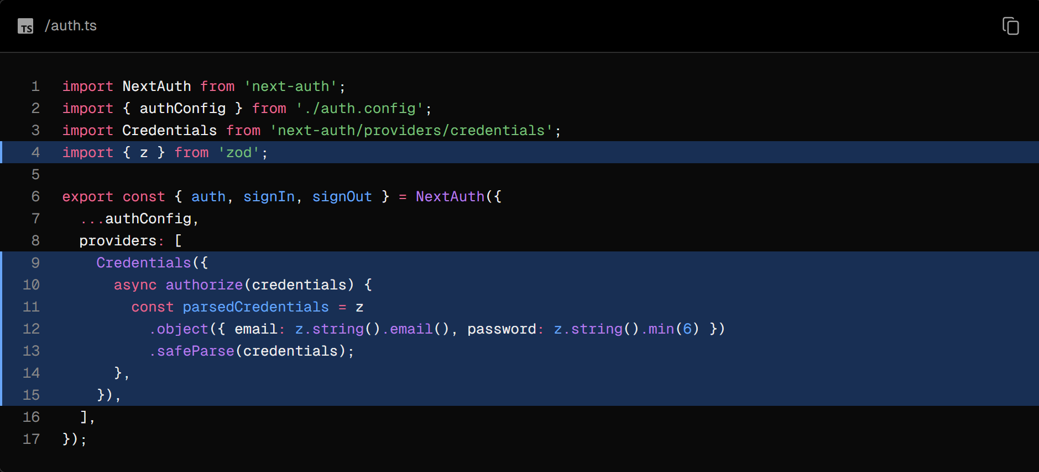

After validating the credentials, create a new getUser function that queries the user from the database.

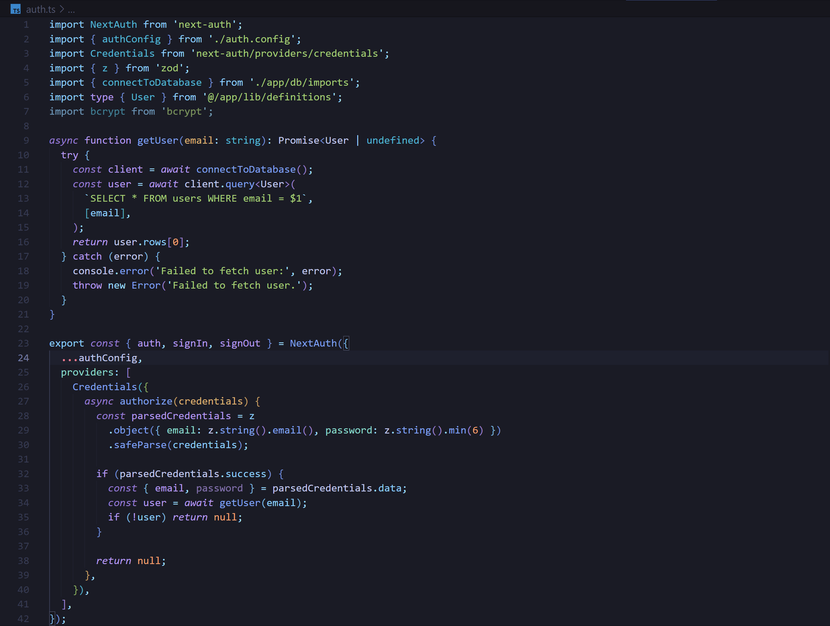

Then, call bcrypt.compare to check if the passwords match:

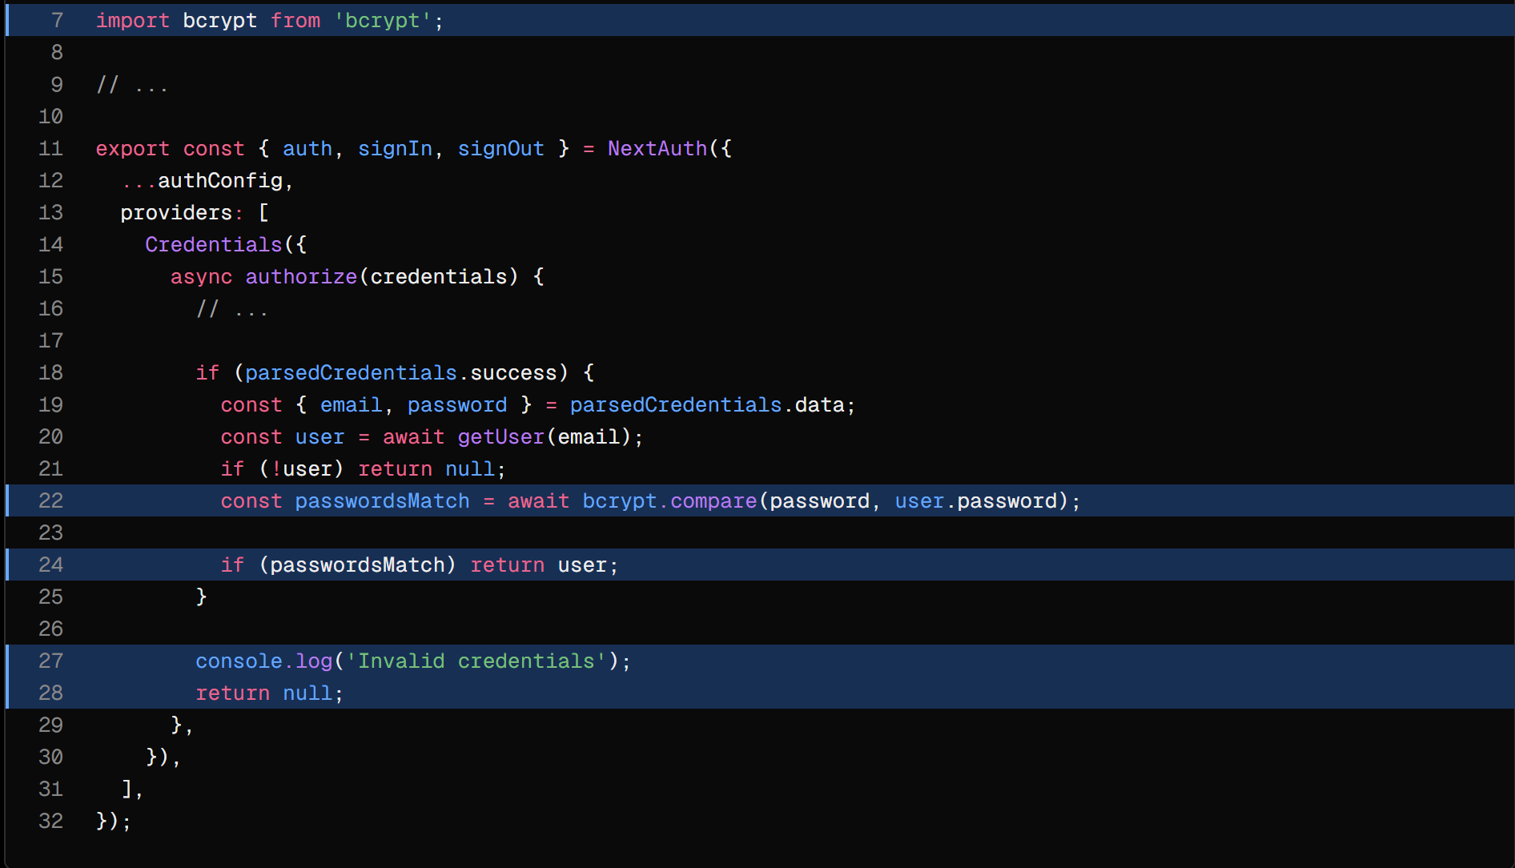

Finally, if the passwords match you want to return the user, otherwise, return null to prevent the user from logging in.

### Updating the login form

Now you need to connect the auth logic with your login form. In your actions.ts file, create a new action called authenticate. This action should import the signIn function from auth.ts:

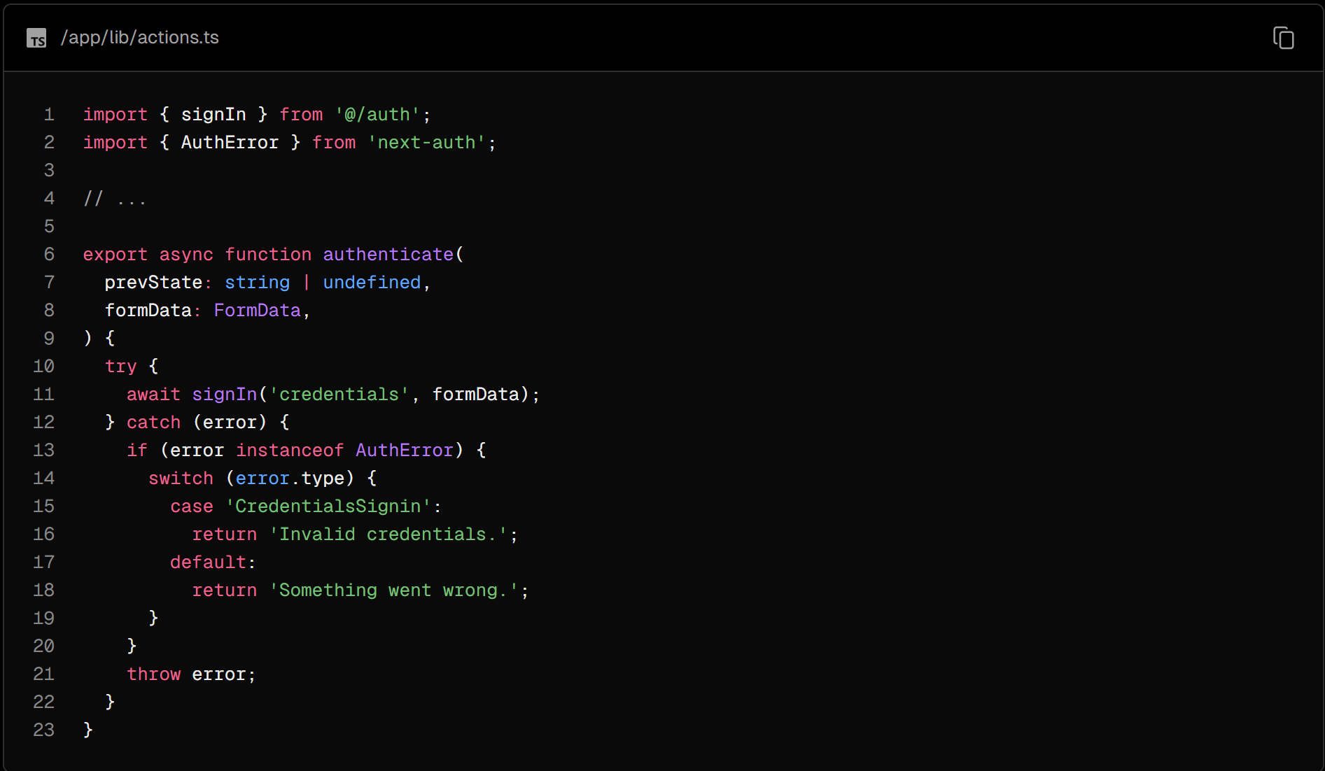

If there's a 'CredentialsSignin' error, you want to show an appropriate error message. You can learn about [NextAuth.js errors](https://errors.authjs.dev/) in the documentation

Finally, in your login-form.tsx component, you can use React's useFormState to call the server action and handle form errors, and use useFormStatus to handle the pending state of the form:

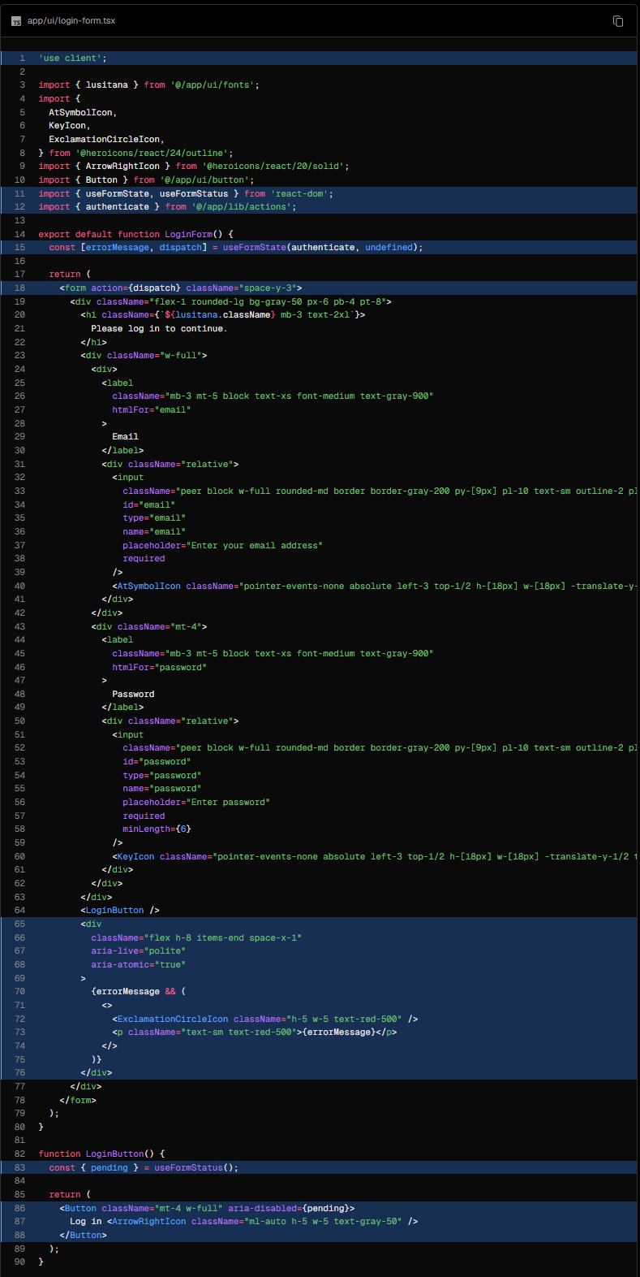

### Adding the logout functionality

To add the logout functionality to <SideNav />, call the signOut function from auth.ts in your <form> element:

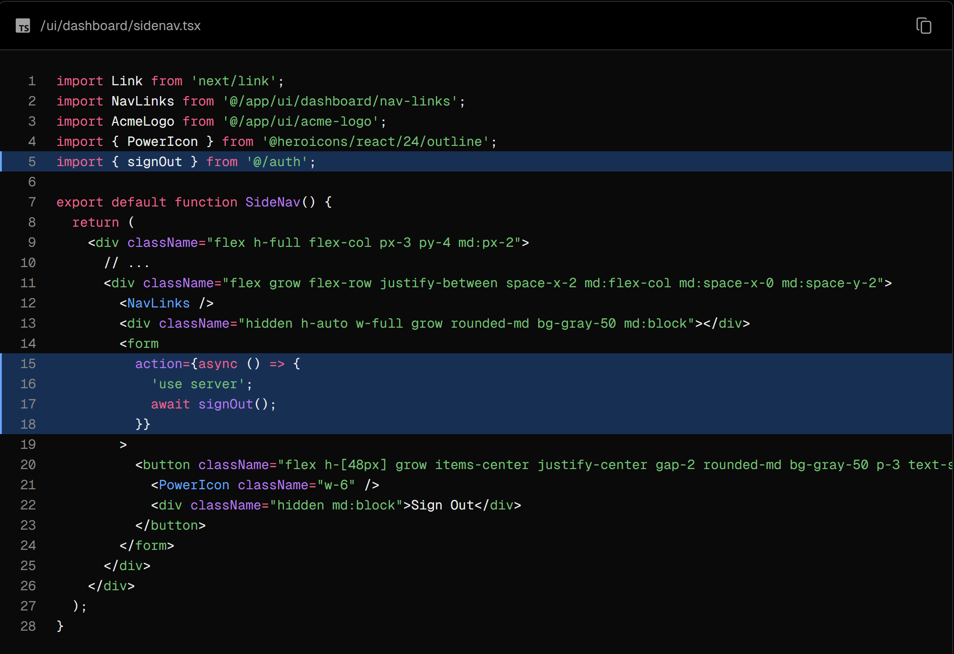

### Try it out

Now, try it out. You should be able to log in and out of your application using the following credentials:

Email: user@nextmail.com

Password: 123456

## Chapter 16 - Adding Metadata

Metadata is crucial for SEO and shareability. In this chapter, we'll discuss how you can add metadata to your Next.js application.

In this chapter...

Here are the topics we’ll cover

* What metadata is.
* Types of metadata.
* How to add an Open Graph image using metadata.
* How to add a favicon using metadata.

### What is metadata?

In web development, metadata provides additional details about a webpage. Metadata is not visible to the users visiting the page. Instead, it works behind the scenes, embedded within the page's HTML, usually within the <head> element. This hidden information is crucial for search engines and other systems that need to understand your webpage's content better.

### Why is metadata important?

Metadata plays a significant role in enhancing a webpage's SEO, making it more accessible and understandable for search engines and social media platforms. Proper metadata helps search engines effectively index webpages, improving their ranking in search results. Additionally, metadata like Open Graph improves the appearance of shared links on social media, making the content more appealing and informative for users.

### Types of metadata

There are various types of metadata, each serving a unique purpose. Some common types include:

**Title Metadata:** Responsible for the title of a webpage that is displayed on the browser tab. It's crucial for SEO as it helps search engines understand what the webpage is about.



**Description Metadata:** This metadata provides a brief overview of the webpage content and is often displayed in search engine results.



**Keyword Metadata:** This metadata includes the keywords related to the webpage content, helping search engines index the page.



**Open Graph Metadata:** This metadata enhances the way a webpage is represented when shared on social media platforms, providing information such as the title, description, and preview image.

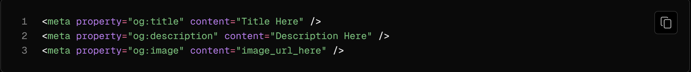

**Favicon Metadata:** This metadata links the favicon (a small icon) to the webpage, displayed in the browser's address bar or tab.



### Adding metadata

Next.js has a Metadata API that can be used to define your application metadata. There are two ways you can add metadata to your application:

* Config-based: Export a static metadata object or a dynamic generateMetadata function in a layout.js or page.js file.
* File-based: Next.js has a range of special files that are specifically used for metadata purposes:
  + favicon.ico, apple-icon.jpg, and icon.jpg: Utilized for favicons and icons
  + opengraph-image.jpg and twitter-image.jpg: Employed for social media images
  + robots.txt: Provides instructions for search engine crawling
  + sitemap.xml: Offers information about the website's structure

You have the flexibility to use these files for static metadata, or you can generate them programmatically within your project.

With both these options, Next.js will automatically generate the relevant <head> elements for your pages.

### Favicon and Open Graph image

In your /public folder, you'll notice you have two images: favicon.ico and opengraph-image.jpg.

Move these images to the root of your /app folder.

After doing this, Next.js will automatically identify and use these files as your favicon and OG image. You can verify this by checking the <head> element of your application in dev tools.

Good to know: You can also create dynamic OG images using the [ImageResponse](https://nextjs.org/docs/app/api-reference/functions/image-response) constructor.

### Page title and descriptions

You can also include a metadata object from any layout.js or page.js file to add additional page information like title and description. Any metadata in layout.js will be inherited by all pages that use it.

In your root layout, create a new metadata object with the following fields:

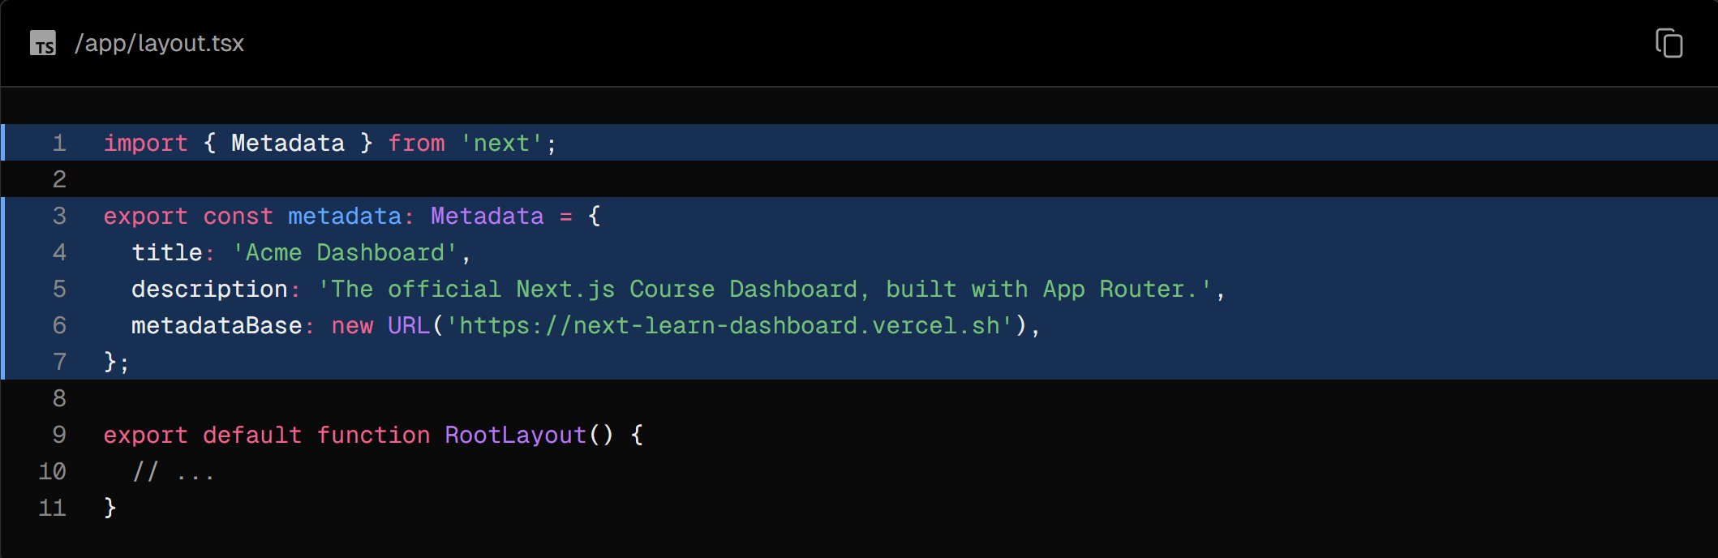

Next.js will automatically add the title and metadata to your application.

But what if you want to add a custom title for a specific page? You can do this by adding a metadata object to the page itself. Metadata in nested pages will override the metadata in the parent.

For example, in the /dashboard/invoices page, you can update the page title:

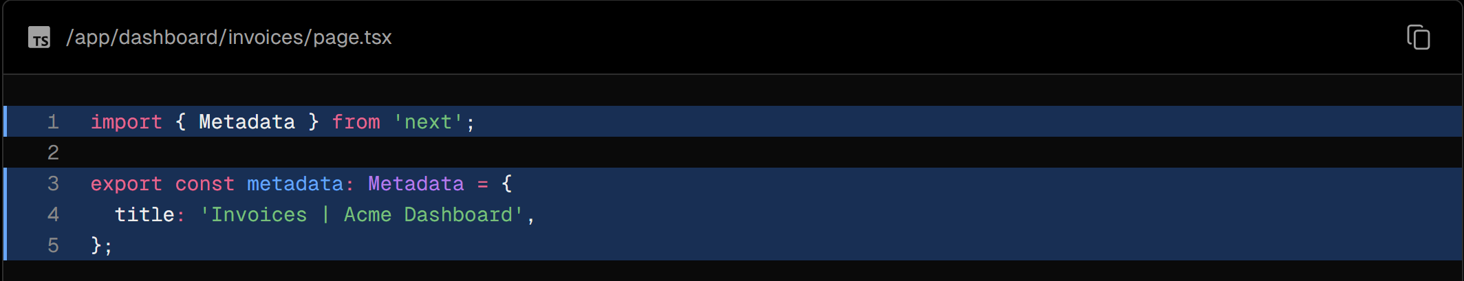

This works, but we are repeating the title of the application in every page. If something changes, like the company name, you'd have to update it on every page.

Instead, you can use the title.template field in the metadata object to define a template for your page titles. This template can include the page title, and any other information you want to include.

In your root layout, update the metadata object to include a template:

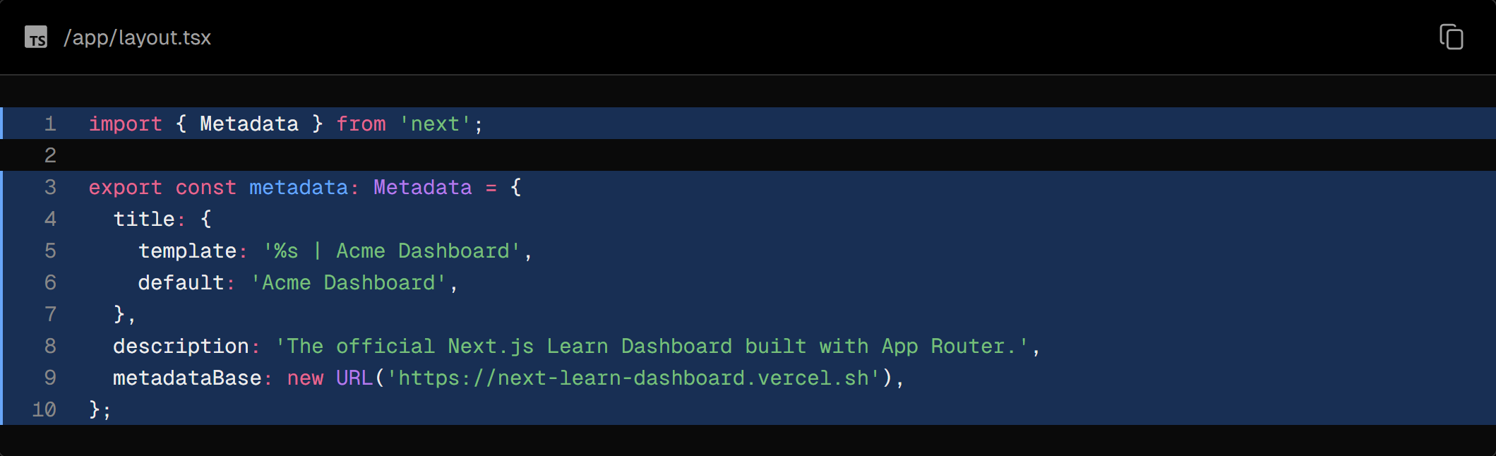

The %s in the template will be replaced with the specific page title.

Now, in your /dashboard/invoices page, you can add the page title:

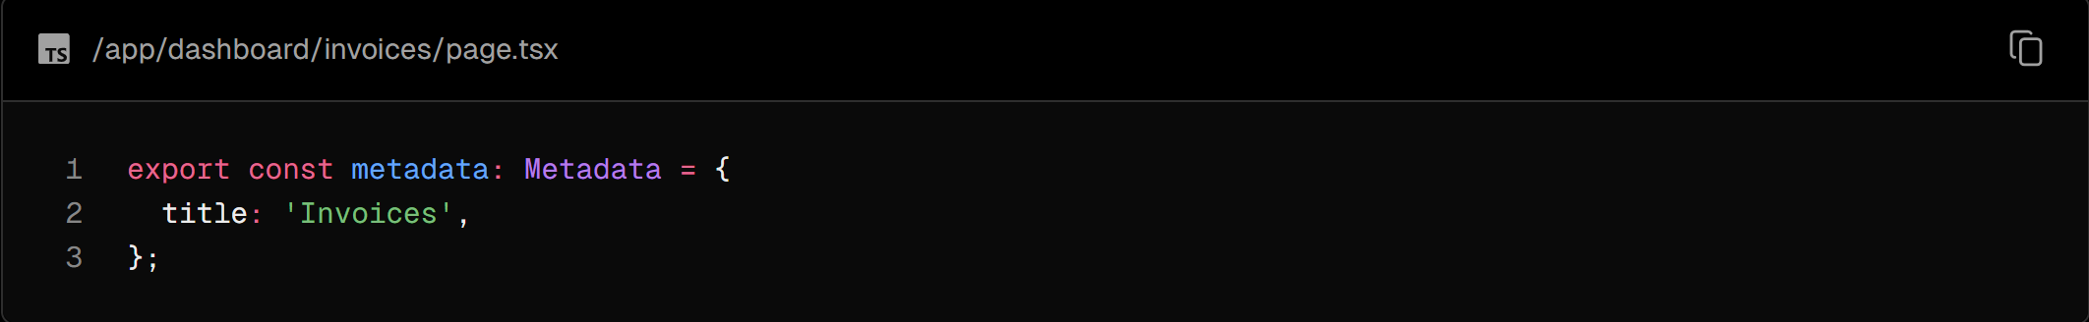

Navigate to the /dashboard/invoices page and check the <head> element. You should see the page title is now Invoices | Acme Dashboard.

### Practice: Adding metadata

Now that you've learned about metadata, practice by adding titles to your other pages:

1. /login page.
2. /dashboard/ page.
3. /dashboard/customers page.
4. /dashboard/invoices/create page.
5. /dashboard/invoices/[id]/edit page.

The Next.js Metadata API is powerful and flexible, giving you full control over your application's metadata. Here, we've shown you how to add some basic metadata, but you can add multiple fields, including keywords, robots, canonical, and more. Feel free to explore the [documentation](https://nextjs.org/docs/app/api-reference/functions/generate-metadata), and add any additional metadata you want to your application.

## Chapter 17 - Next Steps

Congratulations! You've completed the Next.js dashboard course where you learned about the main features of Next.js and best practices for building web applications.

But this is just the beginning—Next.js has many other features. It's designed to help you build small side projects, your next startup idea, or even large-scale applications with your team.

Here are some resources to continue exploring Next.js:

* [Next.js Documentation](https://nextjs.org/docs)
* [Next.js Templates](https://vercel.com/templates?framework=next.js):
  + [Admin Dashboard Template](https://vercel.com/templates/next.js/admin-dashboard-tailwind-planetscale-react-nextjs)
  + [Next.js Commerce](https://vercel.com/templates/next.js/nextjs-commerce)
  + [Blog Starter Kit](https://vercel.com/templates/next.js/blog-starter-kit)
  + [Nextra: Docs Starter Kit](https://vercel.com/templates/next.js/documentation-starter-kit)
  + [Image Gallery Starter](https://vercel.com/templates/next.js/image-gallery-starter)
* [Next.js Repository](https://github.com/vercel/next.js)
* [Vercel YouTube](https://www.youtube.com/@VercelHQ/videos)
  + [Next.js App Router: Routing, Data Fetching, Caching](https://www.youtube.com/watch?v=gSSsZReIFRk)
  + [Performance in React and Next.js (Lydia Hallie)](https://www.youtube.com/watch?v=SqVLqvsiAYQ)
  + [Vercel Product Walkthrough](https://www.youtube.com/watch?v=sPmat30SE4k)

### Share your Next.js app

We encourage you to share the app you built in this tutorial on X. If you do, please mention our team at @nextjs so that we can take a look! We'd love to get your feedback on this course as well.

We hope you enjoyed this course, and we encourage you to continue learning - by building.